The purpose of this user guide is to walk you through all steps necessary to navigate the UEP academic planning template and enter content. Please follow the steps below. Contact the UEP assessment team in IER for additional help.
Follow these steps to navigate the UEP plan template:
Step One: Log into Nuventive Improve operates on the single sign-on so please use the same login credentials you would use to log in to your university email. Once you are logged in, please select the desired template from the drop down shown at the top-center of the page. Your screen should look like this:
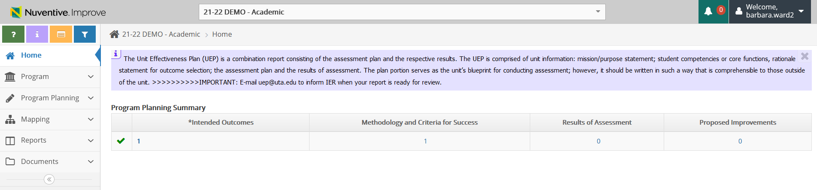
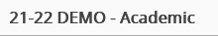
Step Two: Each planning year please update the Rationale statement which may be found in the “Assessment Unit” option in the left menu. ​ Click on “Program” then “General Information” to open the sub-menu which includes three options. To edit the Rationale, click on “General Information” to open the screen that appears like the one in the image below. If the Rationale is correct for the current plan year, you can move on to the next step of this User Guide. If you wish to edit the Rationale statement, click on the (paper & pencil icon) appearing on the right side of the page to add/change the Rationale statement. The Rationale statement should clearly explain​, in 1-2 detailed sentences, the reason why the particular outcomes ​are included in the ​current plan. Make any needed edits, then click “Save” in the top right corner of your screen. Then, continue with Step Three.
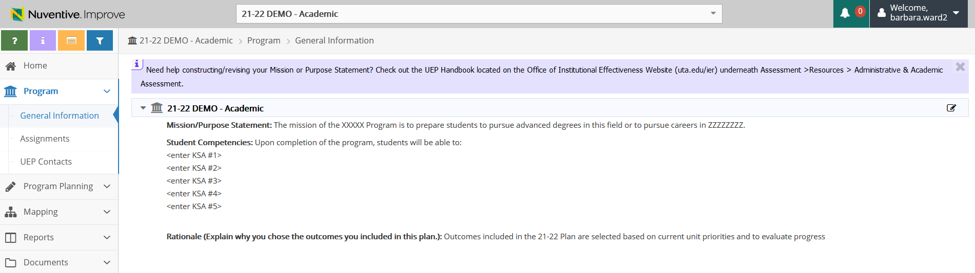
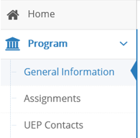
Step Three: To add a plan component, click on “Program Planning” (located on the left hand side of the page with the icon). Clicking that menu option will show a small drop down sub-menu with two options. Your screen should look like this:
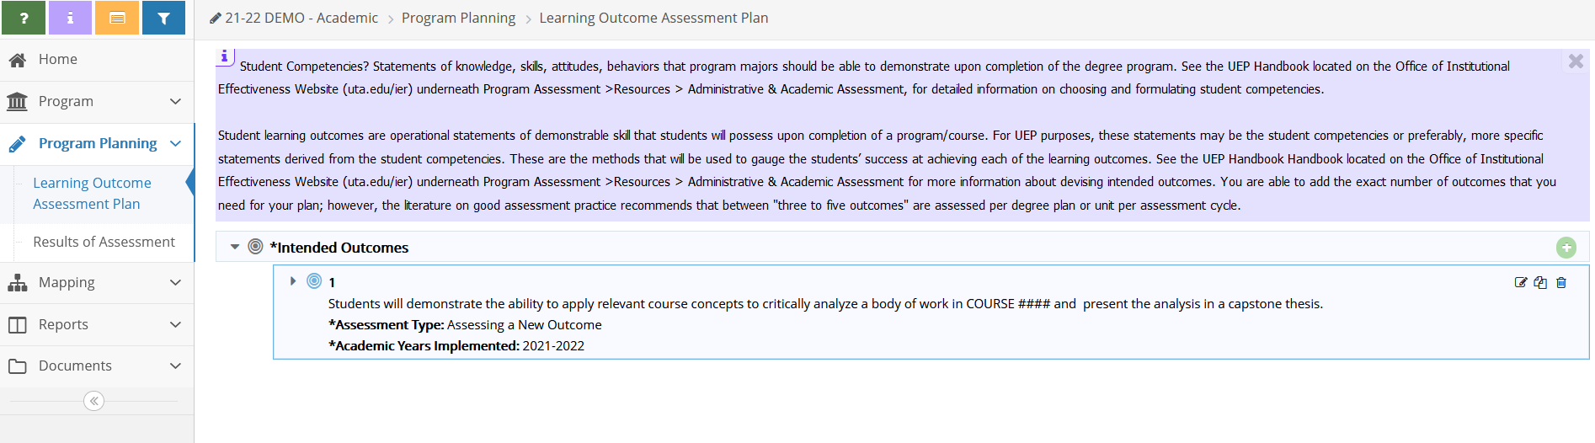
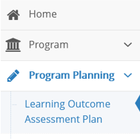
Step Four: Click on the second sub-menu option “Learning Outcome Assessment Plan” (the screen shot below directs you to the sub-menu option to select). Then click the green circle with a white plus sign icon to add intended outcome.
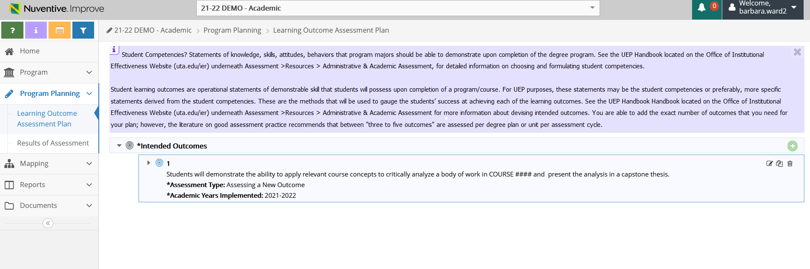
After clicking the green circle with a plus sign icon, your screen should look like this:
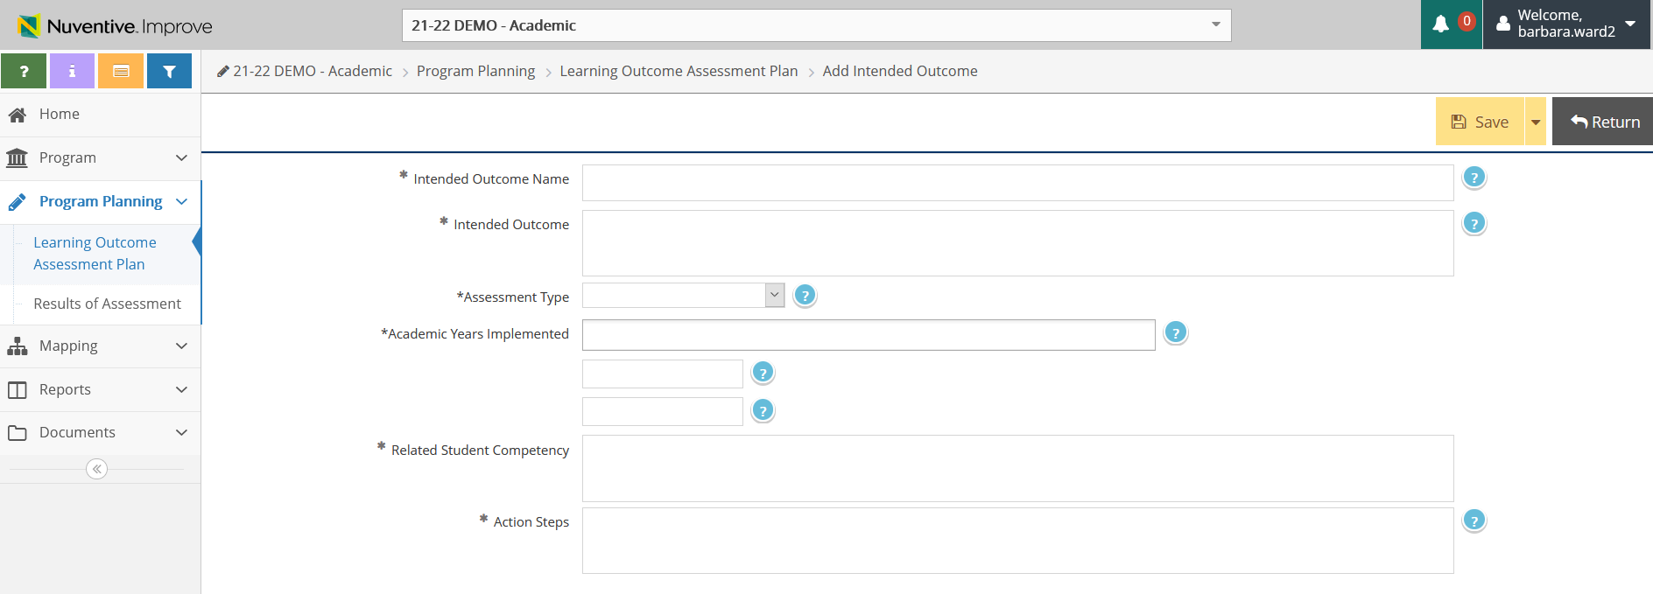

Step Five: Input required information in all of the fields in this area:
- Intended Outcome Name: Add a short descriptive title of the outcome in the field.
- Intended Outcome: Type a one sentence outcome statement in the field. Outcomes are specific, measurable statements describing the desired end-result and quality (e.g., timeliness, accuracy, responsiveness, frequency, etc.) you hope to achieve. For an administrative plan, you might be focusing on the key functions and services of the administrative unit and stakeholders. Outcomes should be directly related to the mission and goals of the unit.
- Assessment Type: Select the appropriate option from the drop-down menu to indicate whether this outcome focuses on assessing a new outcome, assessing an improvement, or reassessing a previous year’s outcome.
- Academic Year Implemented: Select the “year implemented” from the drop-down menu. This should be automatically set for current UEP Cycle (example: 2021-2022).
- Action Steps: In this field, provide a few sentences to describe the Action Steps your unit intends to take during the coming year to work toward achieving the outcome. Action steps should be specific with details provided and should be several sentences long. The Action Steps will vary depending on the outcome being assessed and the work of your unit.

- Related Student Competency: Statements of knowledge, skills, attitudes, behaviors that program majors should be able to demonstrate upon completion of the degree program.
After entering content in each of the fields above, click “SAVE” at the top right corner of your screen to save your work , then click “Return”to go back to the previous screen once you have completed entering your information.
Step Six: Click on the “small triangle” that appears to the left of the outcome statement that you just entered. Clicking on the triangle will show additional options below the outcome content. Your screen should now look like this:
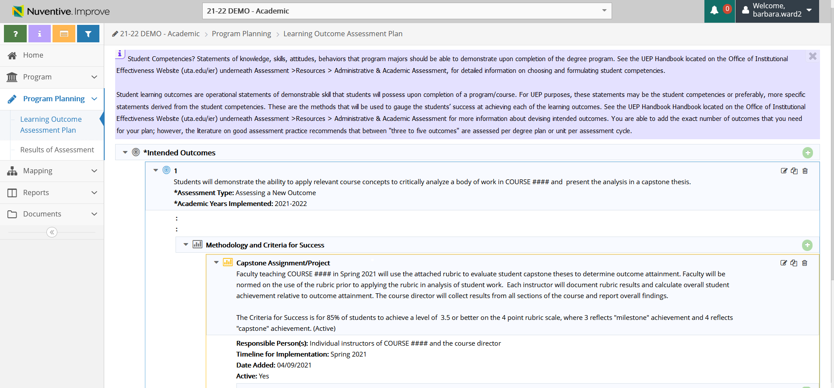
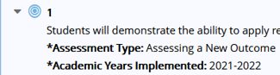
Next you will enter the Methodology (how you plan to measure the outcome to determine attainment) and Criteria for Success (the standard or target you are aiming for). To do this, click on the green circle with a plus sign icon located on the right-hand side of the “Methodology and Criteria for Success” row as depicted in the image above.

Step Seven : Complete the required Methodology and Criteria for Success fields:
Make sure that the “Active” box is checked.
Primary Type of Student Work to Assess: Please select the option from the drop-down menu that best describes your assessment piece. END OF COURSE GRADES are NOT acceptable assessment activities.
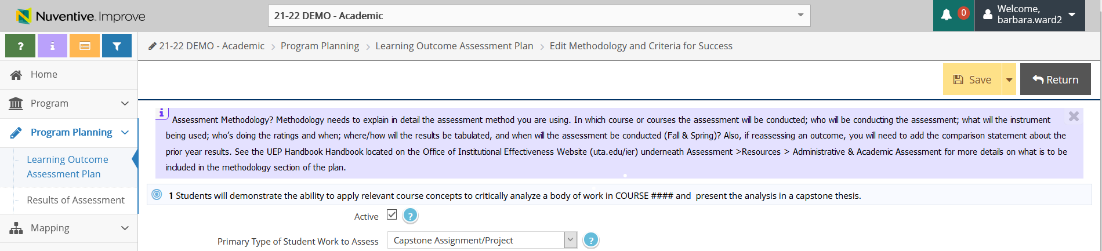

Methodology and Criteria for Success: In this field please provide detail about how you intend to measure/evaluated this outcome to determine if it is achieved. Please also include the Criteria for Success, or, target/standard for which you are aiming. Please also when you plan to conduct the evaluation (e.g. after each training session), and how the evaluation will occur (e.g. online). For example, if your outcome aims to increase a stakeholder group’s comprehension of new rules, your methodology might deliver a training and then following the training, all participants will complete a short quiz, and your Criteria for Success may be that 85% or more of the quiz completers achieve 80% or better in their overall quiz score related to new rule comprehension. At least one direct measure must be used to assess each student learning outcome.

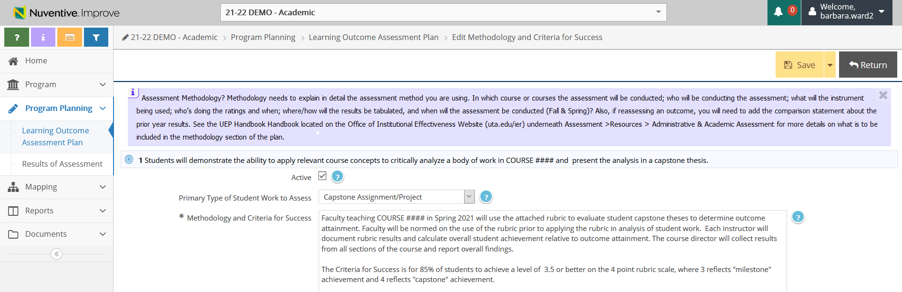
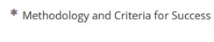

Responsible Person(s): In this field, please list the individuals responsible for leading this outcome’s assessment. Note individuals by title (e.g. Director of Assessment and Accreditation). Be sure that the individual knows that s/he is responsible for assessing the outcome. It is recommended that several personnel are aware of the plan, methodologies, and results in case of turnover.

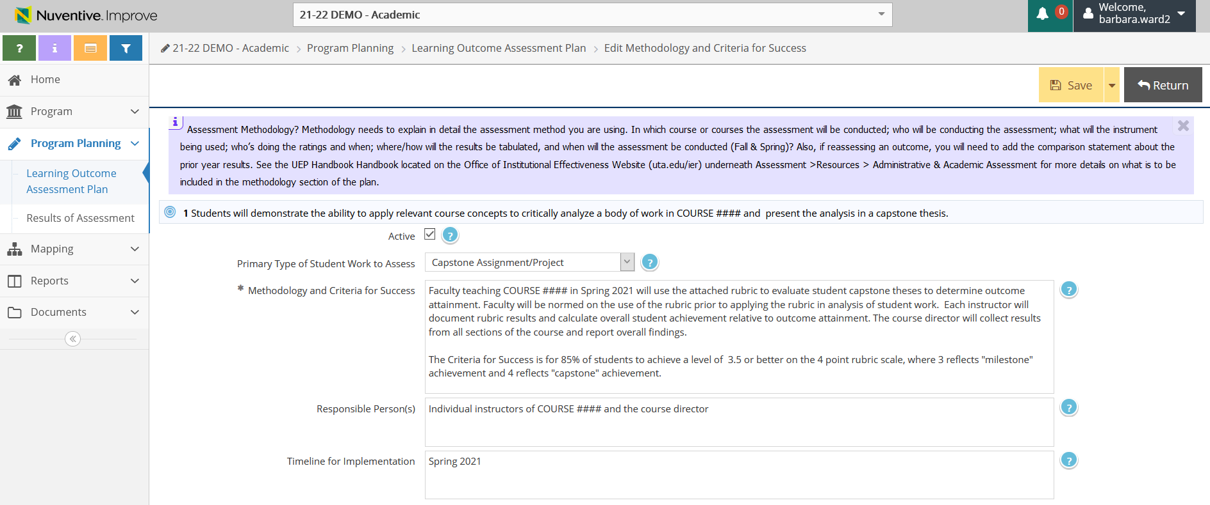

Timeline for Implementation: In this field please indicate the semesters during which the assessment will occur. Be sure that the timeline is within the academic year designated for assessment.

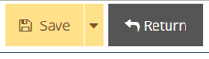

Each time you enter content, click the yellow “Save” and “Return” buttons at the top right corner of your page to save your work.

Step Eight: Relate Documents. Once you have added the information in the methodology section for each outcome you are able to “relate or attach” documents that you have already uploaded to the Documents folder for this plan. You may choose to return to this step later in order to upload all Documents to the folder (by simply clicking on it and then loading). If you already have uploaded documents to the Document Folder in the left menu, you can “relate” or “link” them to this outcome, by clicking the green circle with a white plus sign icon located af the right side of the “Related Documents” row as shown below.
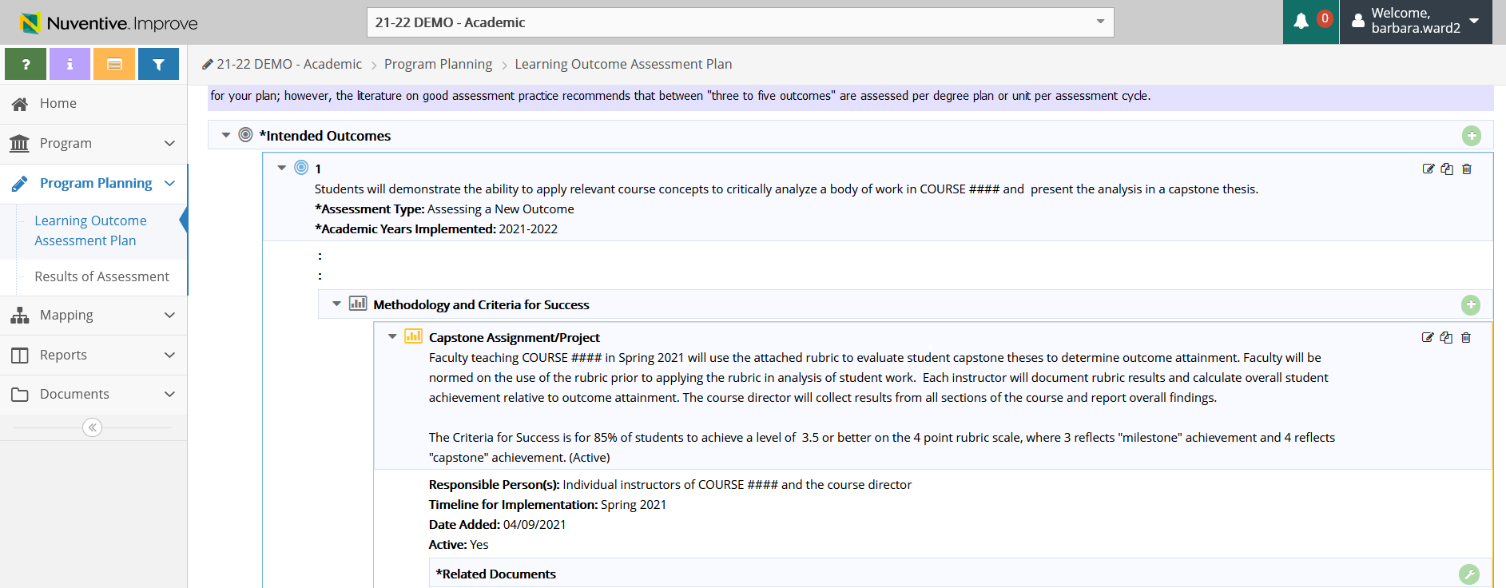

To “relate a document” click on the green circle with a white plus sign icon, then click “browse for files”, select the file off your desktop to upload, then chose “save and relate” and “Complete” (as shown below).
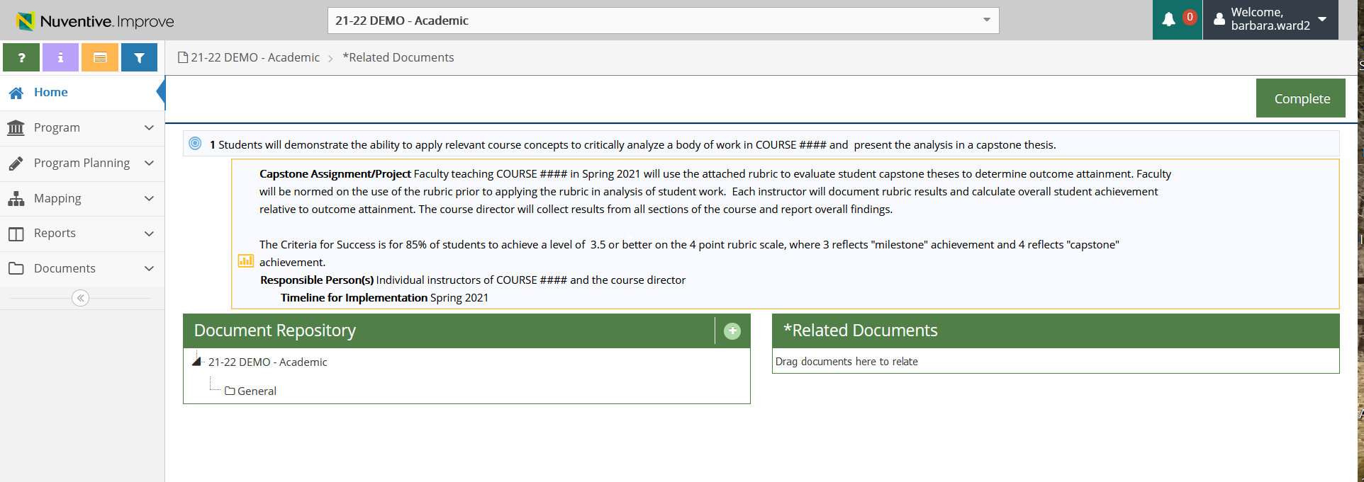

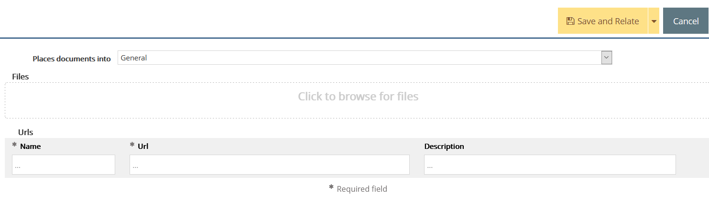
Once you have completed relating documents for this outcome, click the “Save” button at the top right corner of your screen and “Return” to go back to the main screen. Click on green “Complete” button to enter your next outcome.
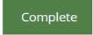

**Repeat each of the steps above to add additional outcomes to the plan. We request a minimum of 3 outcomes and up to 5 outcomes for all plans.
Step Nine: The final step in the process is to map each of the outcomes to the “Core Curriculum Objectives” and the “Strategic Plan Guiding Principles” goals. Mapping outcomes simply means that you will check on cells shown on a table to indicate an alignment between one of your outcomes.
- Click on “Mapping” on the right-hand side of the screen. Then, select “Intended Outcomes Mapping” from the left sub-menu. Your screen should now look like this:
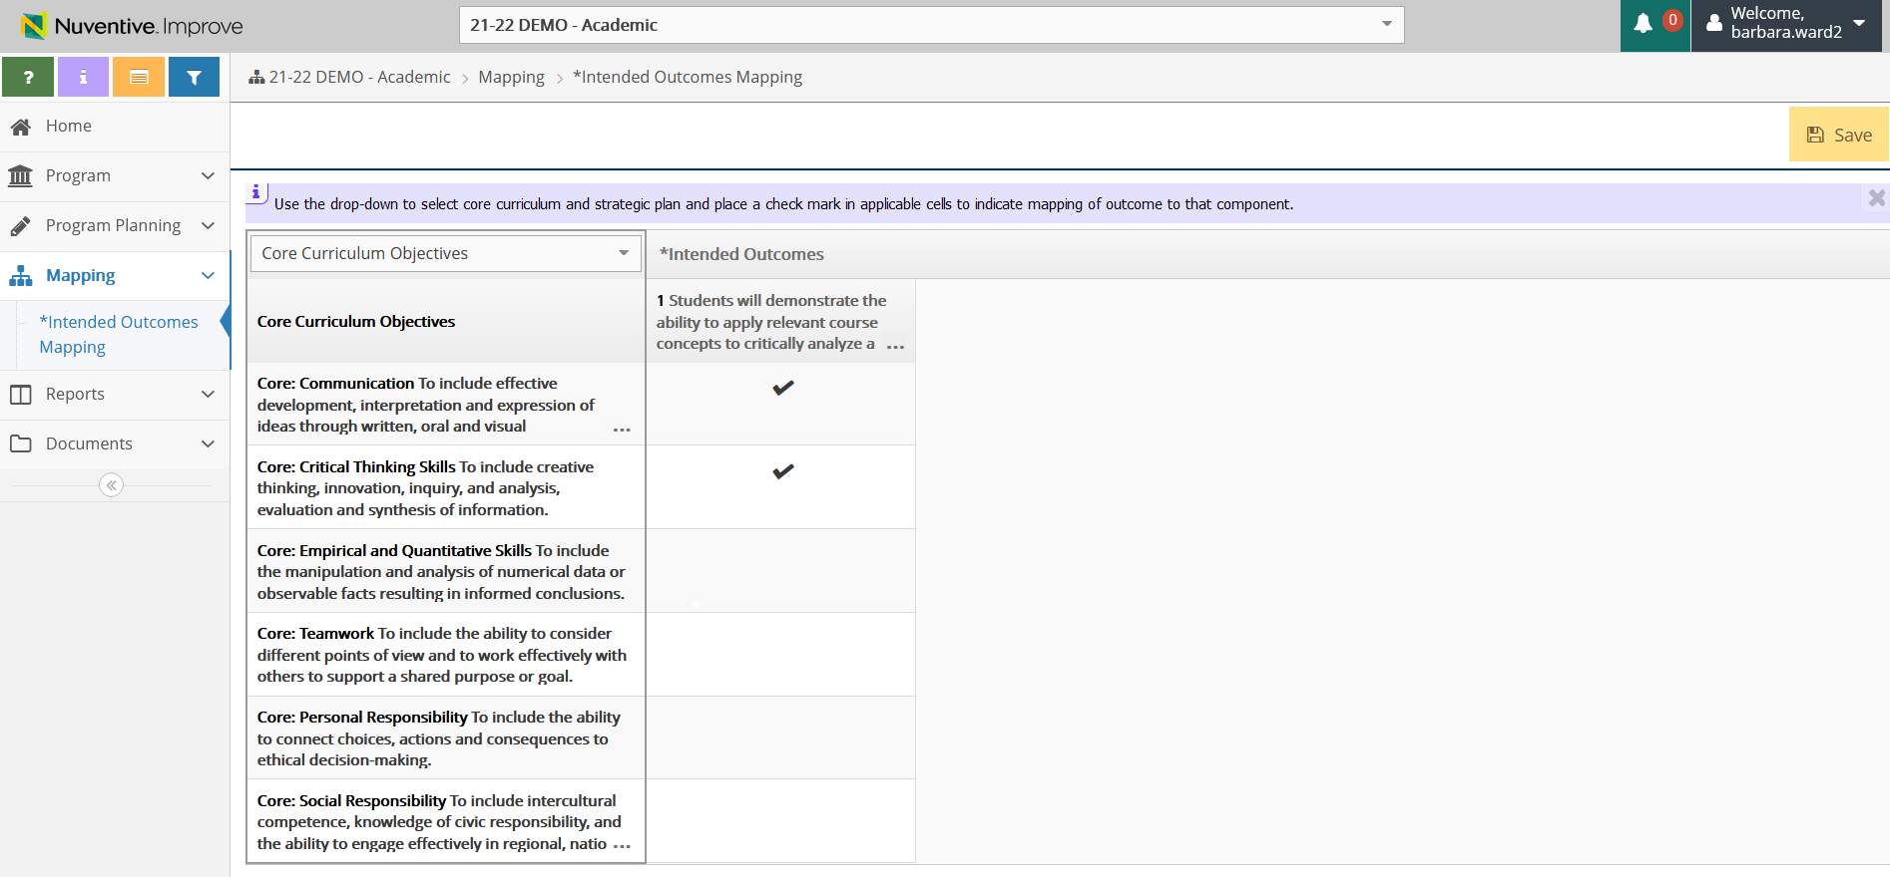
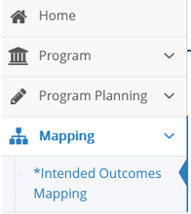
From the drop-down first select the “Core Curriculum Objectives” to which each outcome maps or aligns by simply clicking in a cell on the screen. When you click on the cell, a checkmark will appear.
After you map, your screen should look like this. Click “SAVE”.
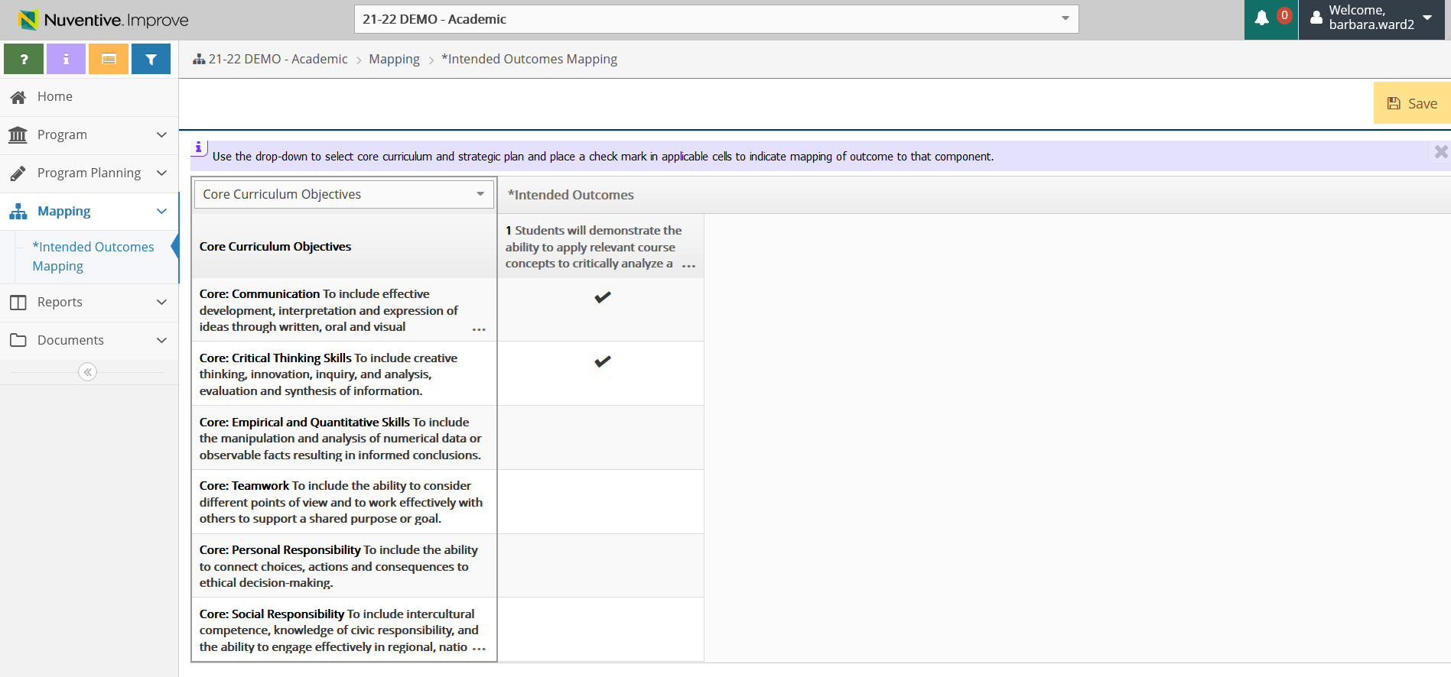
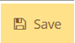
Next, select the “Strategic Plan Guiding Principle” goal(s) to which each outcome maps or aligns by simply clicking in a cell on the screen. When you click on the cell, a checkmark will appear.

After you map, your screen should look like this. Click “SAVE”.
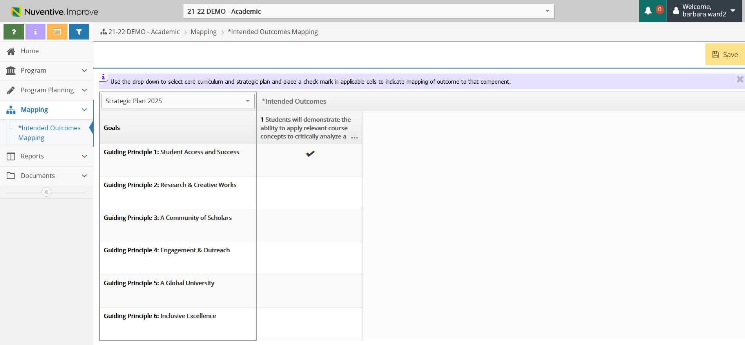

We encourage you print or save a copy of your results report. You can do this by clicking the Reports option on the left menu, then select Standard Reports from the sub-menu.
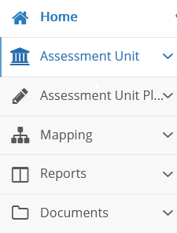
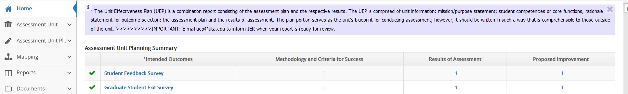

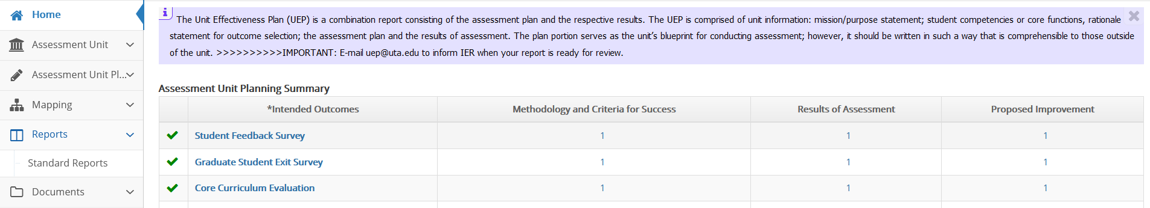
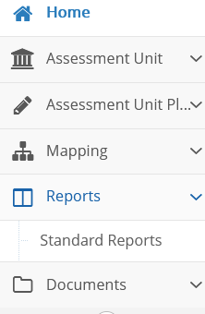

Next, click the blue hyperlink Assessment Activity Report, which will open a screen with options for the report appearance.
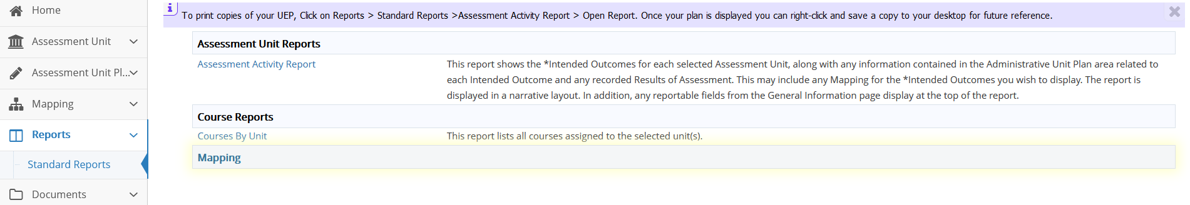
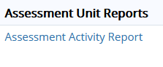
All you need to select is the “format” drop-down option under Layout for your choice of a PDF, Word, or HTML format for the report.
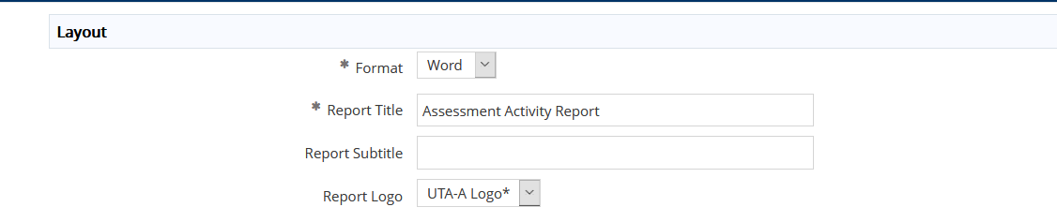
Once you select the drop down, click the yellow Open Report button at the top right of your screen and then the desired report will open. Look for it to appear along the bottom of your screen. If it does not appear, then you will need to check your browser pop-up settings. If you have enabled a pop-up blocker, you will need to disable it to generate the report. Once the report is generated, you can save and/or print the report.

When you finish entering all results and if needed, the proposed improvements, please email the UEP staff that your report is ready for review.

