The purpose of this user guide is to walk you through all steps necessary to navigate the UEP improvement reporting template and enter data and narrative. Please follow the steps below. Contact the UEP assessment team in IER for additional help.
Follow these steps to navigate the UEP template and enter improvement related data and narrative:
Step One: Log into Nuventive Improve. Nuventive operates on the single sign-on so please use the same login credentials you would use to log in to your university email. Once you are logged in, please select the desired template from the drop down shown at the top-center of the page. Your screen should look like this:
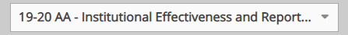
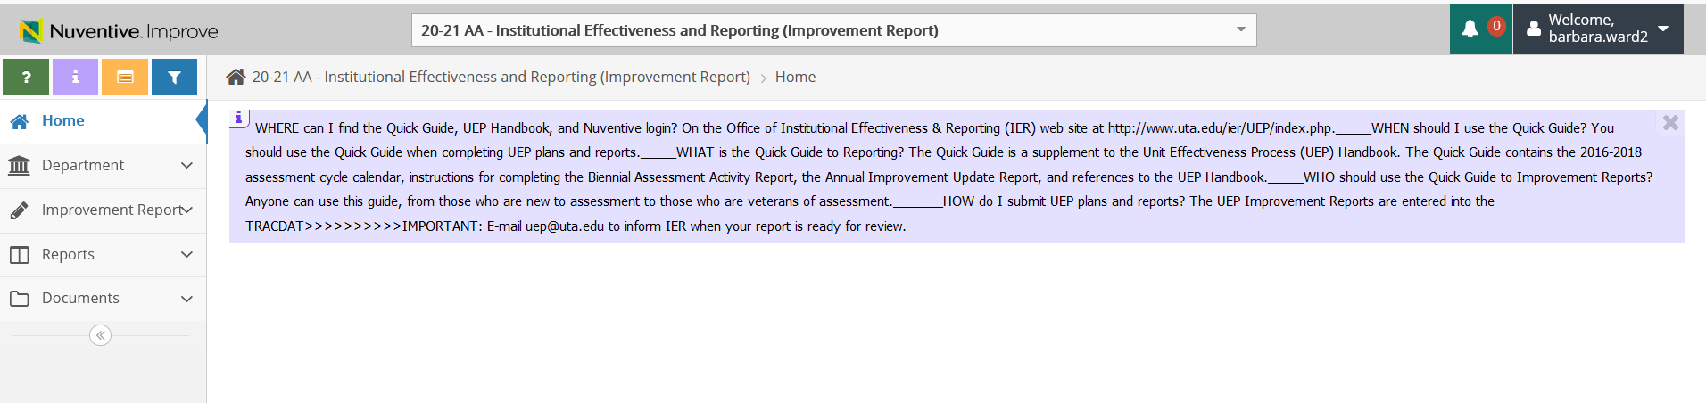
Step Two: Click on “Improvement Report” (located on the left hand side of the page with the icon). Clicking that menu option will show a small drop down sub-menu with two options. Your screen should look like this:
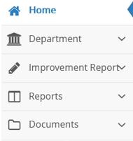
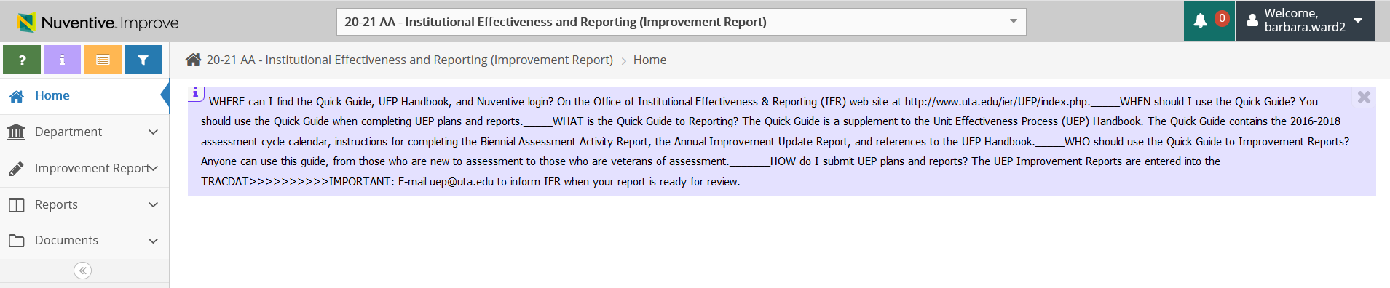
Step Three: Click on the second “Improvement Report” option on the left sub-menu. Click on the green circle with a plus (+) sign that appears on the right side of your screen to begin adding your information.
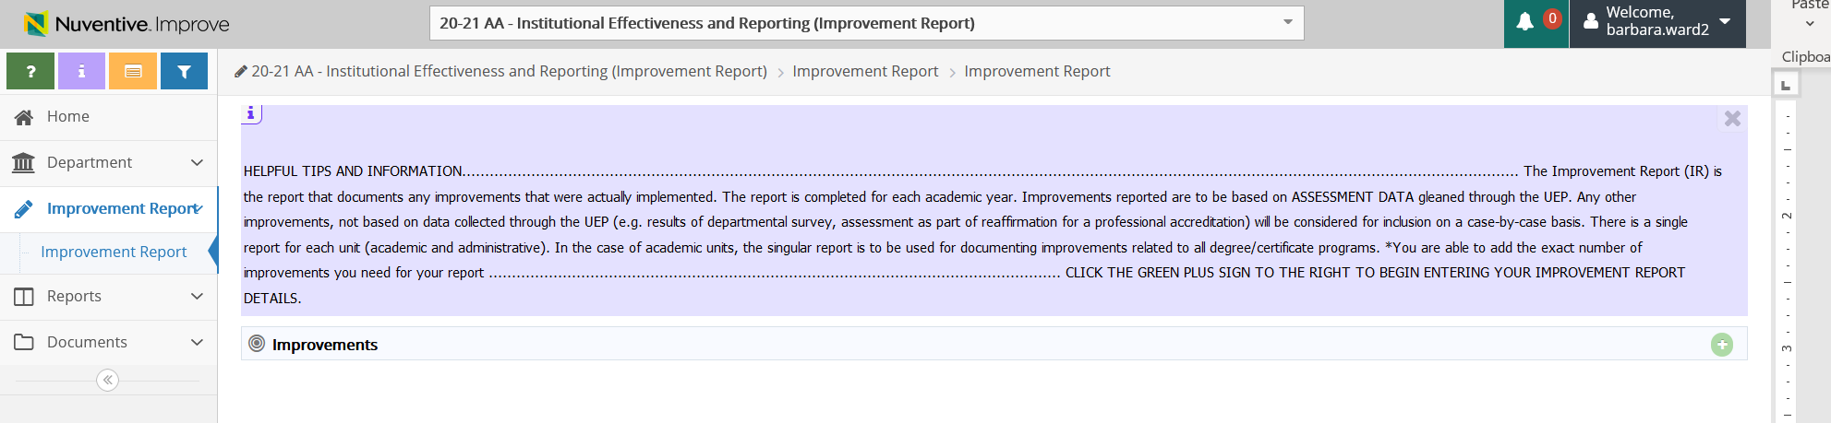
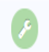
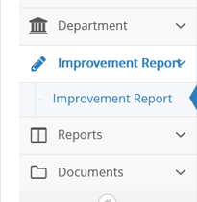
After clicking the green circle with a plus sign, your screen should look like this:
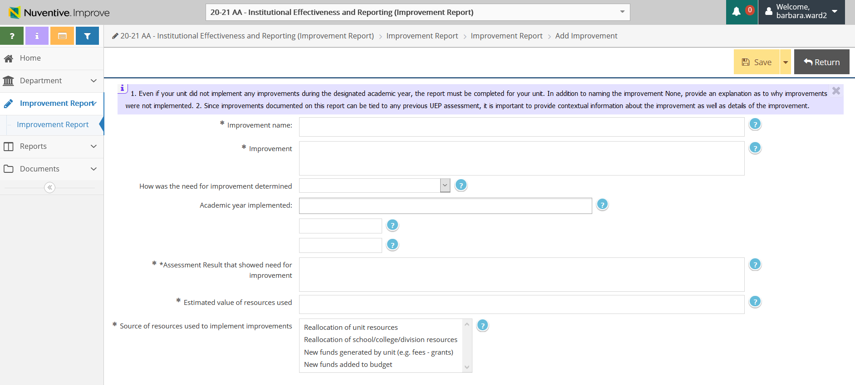
Step Four: Input required information in all of fields on this page:
- Improvement Name: Name the improvement by assigning a number (1, 2, 3, etc.) or with descriptive language.

- Improvement: Describe the specific actions taken by your unit to affect improvement. Be sure to provide sufficient detail so that your actions could be clear to someone outside of the unit.

- How was the need for improvement determined: Use the dropdown options to indicate if the improvement made is based on UEP-related assessment or if it is based on some other non-UEP related assessment. A non-UEP related assessment can be other data or information that your unit systematically collected and reviewed and based on the results of that review, determined that an improvement was needed. Improvements may also be based on any prior set of UEP results but should not be repetitive with anything already reported for the current year.

- Assessment Result that showed need for improvement: In a few sentences, please describe the assessment findings that suggested the need for improvement. The findings may be UEP-related or non-UEP related. If they are UEP-related, in addition to the findings please also mention the reporting year in which the finding occurred. If they are non-UEP findings from any other type of systematic collection and review of data or information, please provide a few sentence explanation of what was examined, how that examination occurred and what the findings were.

- Estimated value of resources used: Please provide a number to indicate the dollar value of the improvements made—an approximation is fine. If the improvement required faculty/staff time beyond their usual responsibilities, estimate the time spent and multiply by approximate hourly rate (suggested rate is $60/Hour). If resources were simply moved around within the normal budget and/or staff time, the dollar value may be 0.

- Source of resources used to implement improvements: Indicate the source of resources by selecting the best option from the list provided Click on the option to highlight and select it.
Be sure to click “SAVE” at the top right corner of your screen to save your work , then click “Return”to go back to the previous screen once you have completed entering your information.
We encourage you print or save a copy of your results report. You can do this by clicking the Reports option on the left menu, then select Standard Reports from the sub-menu.
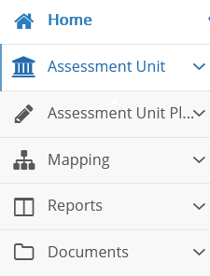
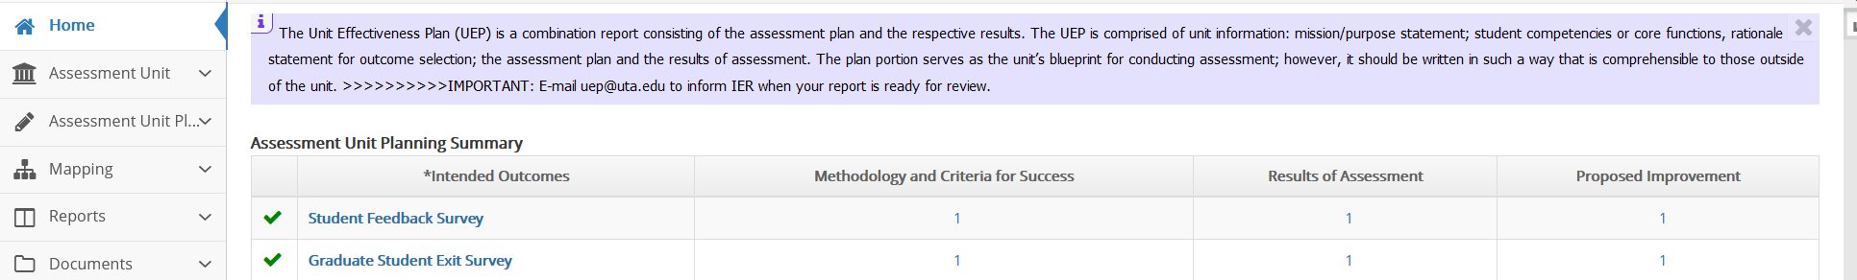

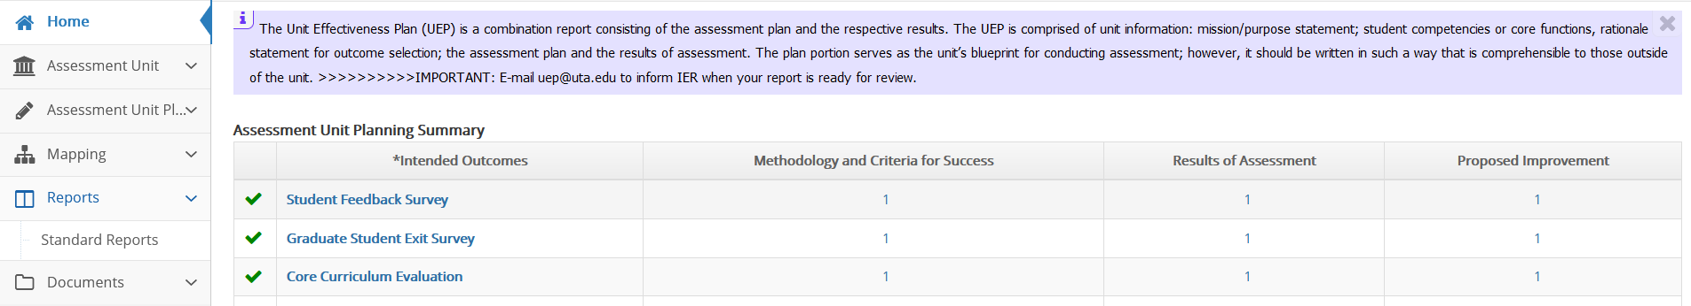
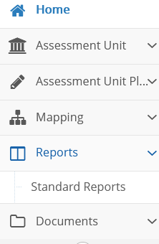

Next, click the blue hyperlink Assessment Activity Report, which will open a screen with options for the report appearance.
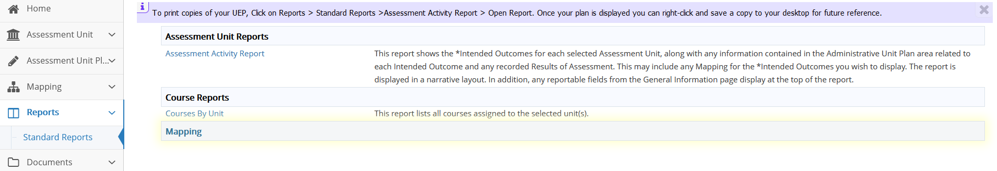
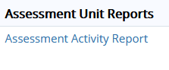

All you need to select is the drop-down option under Layout for your choice of a PDF, Word, or HTML format for the report.
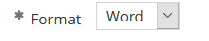
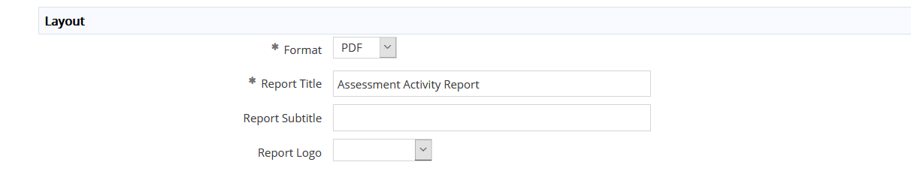
Once you select the drop down, click the yellow Open Report button at the top right of your screen and then the desired report will open. Look for it to appear along the bottom of your screen. If it does not appear, then you will need to check your browser pop-up settings. If you have enabled a pop-up blocker, you will need to disable it to generate the report. Once the report is generated, you can save and/or print the report.

When you finish entering all results and if needed, the proposed improvements, please email the UEP staff that your report is ready for review.

