The purpose of this user guide is to walk you through all steps necessary to navigate the UEP results reporting template and enter content. Please follow the steps below. Contact the UEP assessment team in IER for additional help.
Follow these steps to navigate the UEP template and enter results data and narrative:
Step One: Log into Nuventive Improve. Nuventive operates on the single sign-on authentication scheme, so please use the same login credentials you use to log in to your university email account. Once you are logged in, select the desired reporting unit template from the drop down list shown at the top-center of the page.
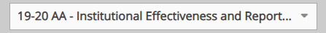
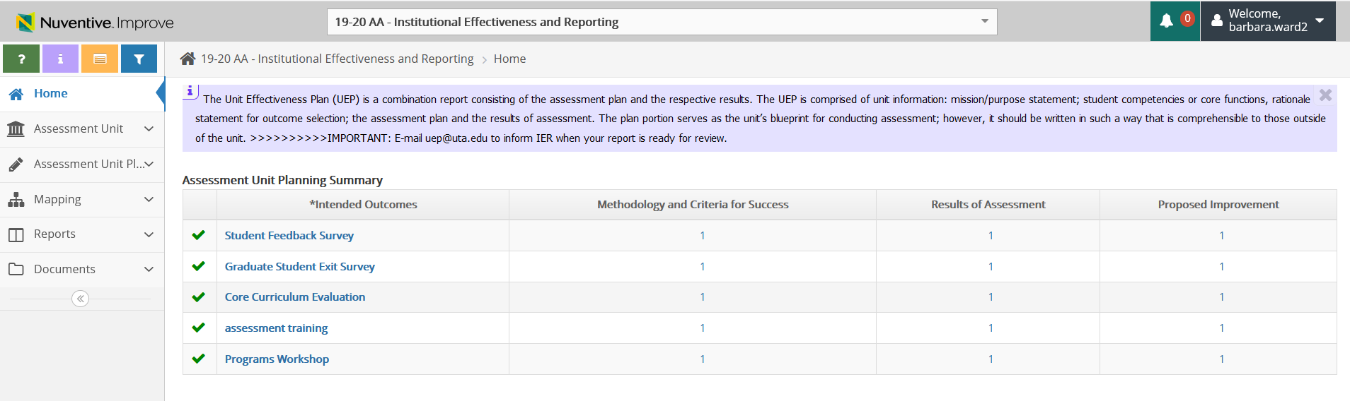
Step Two: Click on Assessment Unit Plan (located on the left hand side of the page with the icon). Clicking that menu option will open a small drop down sub-menu with two options. Your screen should look like this:
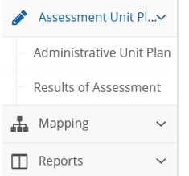

Step Three: Click on the second sub-menu option Results of Assessment (the screen shot below directs you to the sub-menu option to select).
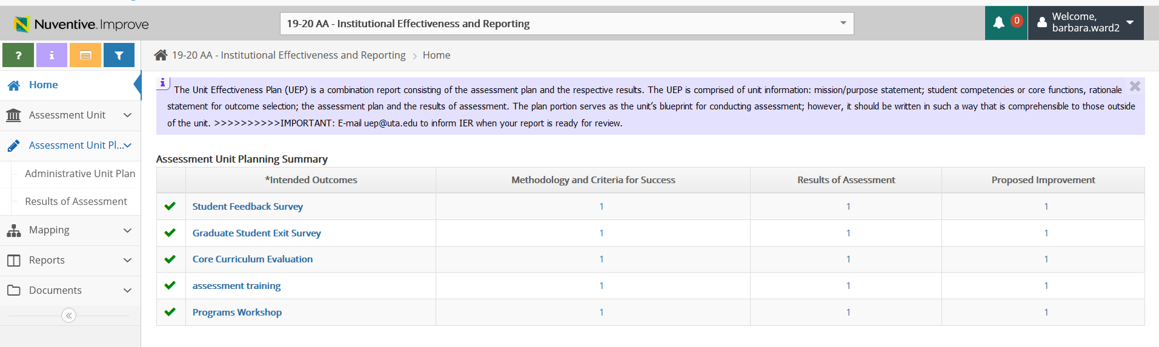
Step Four: Once you click the Results of Assessment sub-menu option, you will see each outcome bulleted with a right-pointing small arrow. Your screen should now look like this:
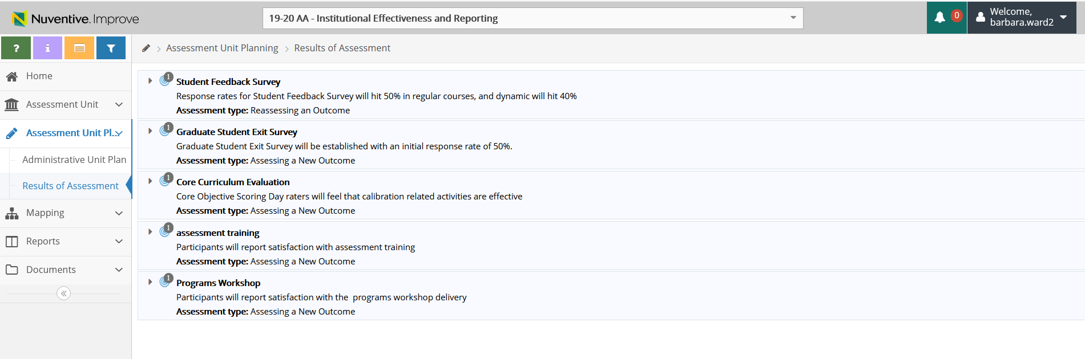
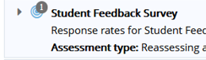
Click on the small arrow to expand the content, including the methodology section of the plan, and give you the option to enter results. You will see a green circle with a white plus sign (+) icon on the right-hand side of page as this icon appears on the right of each methodology section for each outcome on the plan template.
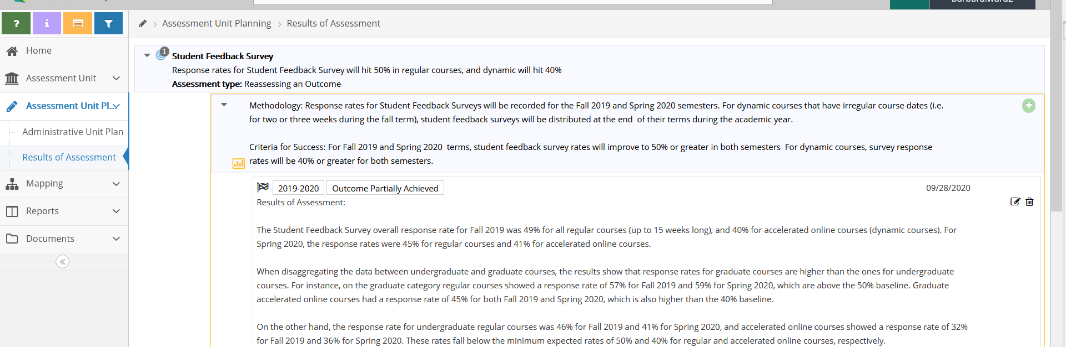
Step Five: Click the green circle with a white plus sign icon to expand the results reporting fields for that outcome. Once you click the icon, the screen should look like this:
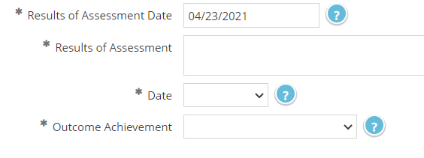
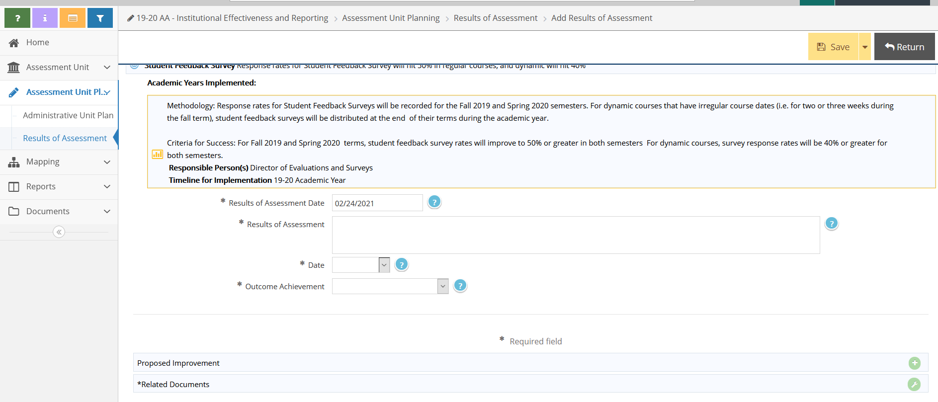
Step Six: Add your results. Minimally, you should complete the Results of Assessment field, select the appropriate Date of when the assessment occurred using the dropdown, and then select the Outcome Achievement dropdown to indicate whether the outcome was Fully Achieved, Partially Achieved, etc. In the Results of Assessment field, please enter the data you obtained in summary and provide a few sentences to draw a conclusion about whether the criterion/criteria shown in the Criteria for Success field (in the methodology) was attained. The 1-2 sentence analysis should compare your results data to the Criteria for Success in the methodology (i.e., if you are measuring in a round figure, compare results using a round figure and if you are using a percentage, please compare results using a percentage).
If you met the criterion/criteria of success and have selected the Fully Achieved option on the Outcome Achievement dropdown, then you are finished entering your results for that outcome. Click the yellow Save button on the top right of your screen and then Return button to go back to the prior screen showing all outcomes.
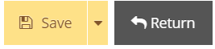
**Please remember: If you select any Outcome Achievement option other than Fully Achieved you will need to add a proposed improvement or provide a rationale as to why a proposed improvement is not warranted (in the results section). To add a proposed improvement, click the green circle with a plus sign icon appearing at the right side of your screen. A field will open and then you can enter a sentence or two that describes, with some specificity, the actions you propose to facilitate future outcome achievement. Once you enter the proposed improvement, then you can click the yellow Save button at the top right and then click the Return button to go back to the main results screen.
Step Seven: If you have already uploaded documents to the Documents folder (in the left menu) that you want to associate with this year’s results report (e.g., a dataset or rubric), you can link of those documents to a specific set of outcome results using the Related Documents option below.
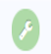
To link documents, click the green circle with the white wrench icon that appears on the right side of the screen.
Your screen should look like this: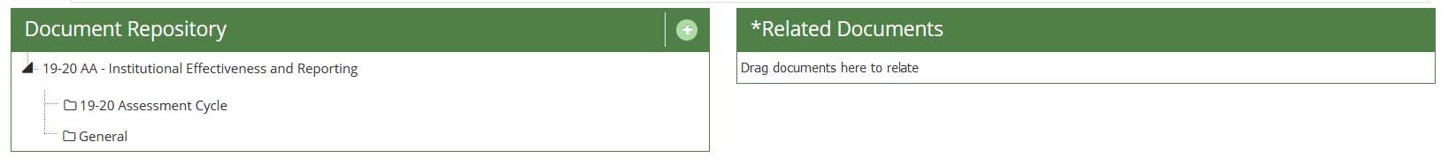
To add a document, click on the green circle with a white plus sign (+).
Your screen should look like this:
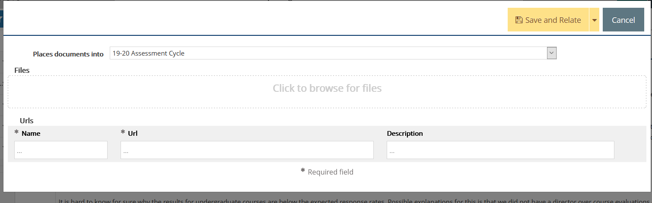
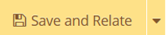
Click to Browse for Files box as shown above. Locate the file you need to attach, then click on the yellow Save and Relate button and then click on green Complete button.
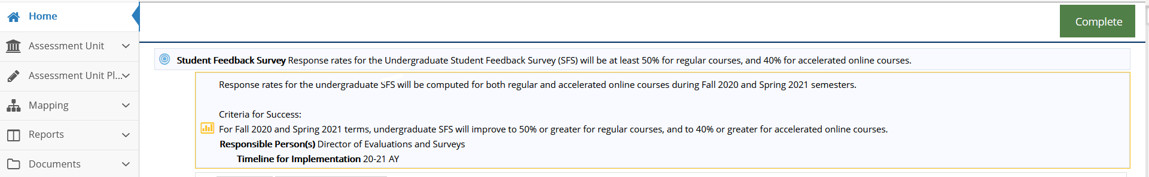
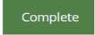
To finish the results report, please repeat each of the steps above for each outcome you have included on the plan. Remember, each time you enter content, click the yellow Save button at the top right corner of your page to save your work. Click the Return button to go back to the main results screen.
We encourage you print or save a copy of your results report. You can do this by clicking the Reports option on the left menu, then select Standard Reports from the sub-menu.
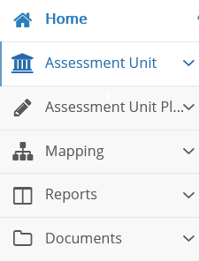
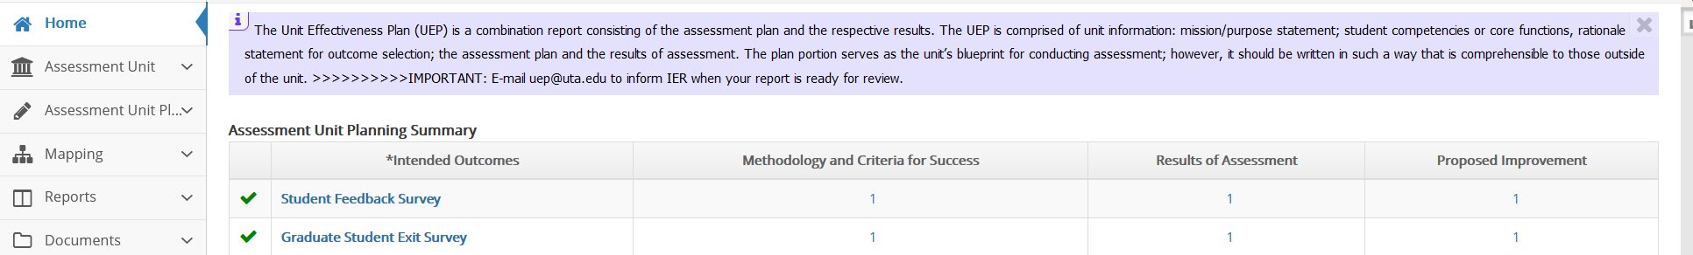

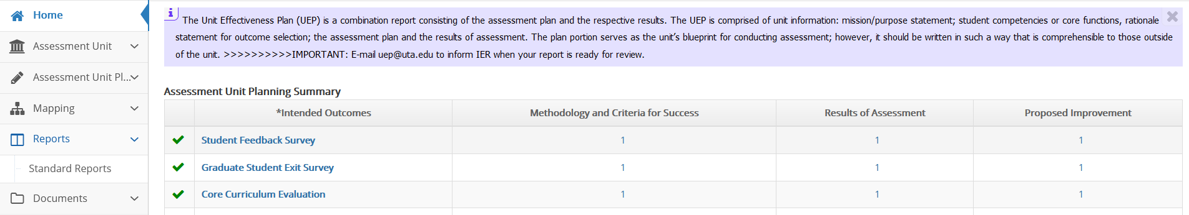
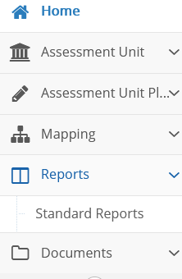

Next, click the blue hyperlink Assessment Activity Report, which will open a screen with options for the report file format.
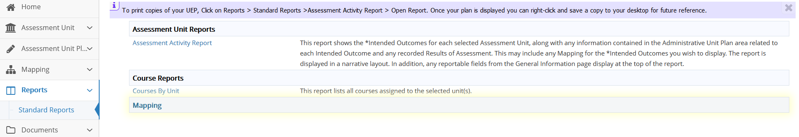
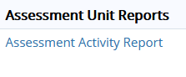

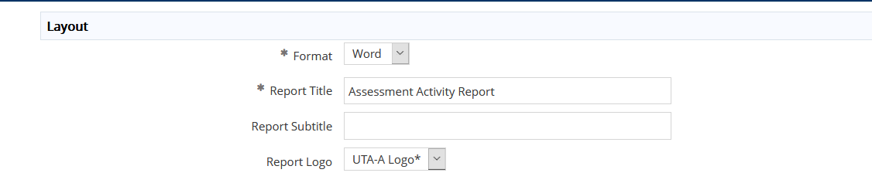
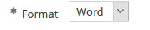
All you need to select is the “format” drop-down option under Layout for your choice of a PDF, Word, or HTML format for the report.

Once you select the desired format, click the yellow Open Report button at the top right of your screen and then the report will open in your selected format. Look for it to appear along the bottom of your screen. If it does not appear, then you will need to check your browser pop-up settings. If you have enabled a pop-up blocker, you will need to disable it to generate the report. Once the report is generated, you can save and/or print the report.

When you finish entering all results and if needed, the proposed improvements, please email the UEP staff that your report is ready for review.

