SmartEvals:
Faculty Results Dashboard & Reporting Guide
SmartEvals is a web-based software that UT Arlington utilizes to launch, administer, and compile reports on the Student Feedback Survey (SFS).
The guide provides faculty with useful information to quickly access their results dashboard in SmartEvals.
SmartEvals can be accessed in three different ways:
- By going to utarlington.smartevals.com;
- By clicking on the links provided with the SFS e-mails; and
- Through Canvas.

Accessing SmartEvals through utarlington.smartevals.com
Type the URL utarlington.smartevals.com on your preferred browser, and use your Net ID username and password to access SmartEvals.
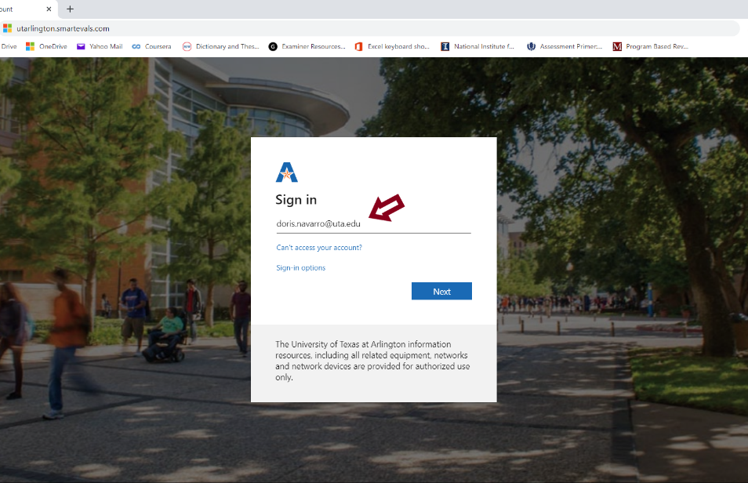 | 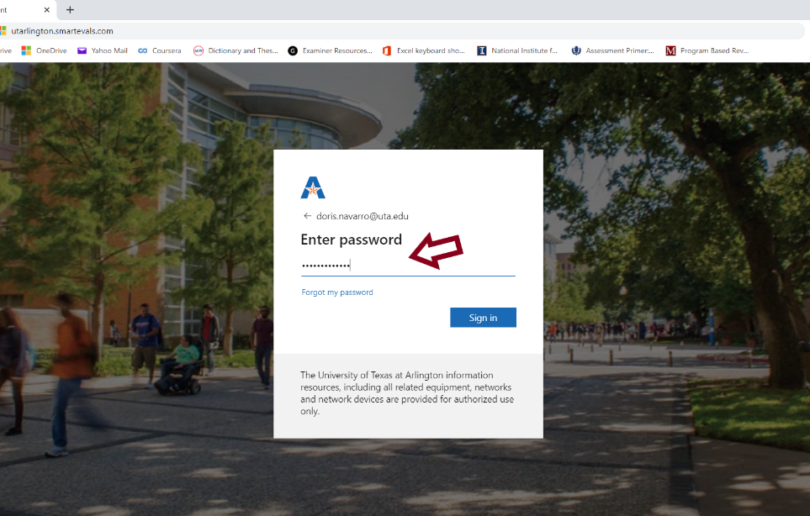

Assessing SmartEvals through the links in the SFS e-mails
When a course is issued a survey (one week before the last day of class if course meets for less than 15 weeks; two weeks before the last day of class if it meets for 15 weeks or more), an e-mail is sent to both students and instructors notifying them that the SFS is available. The e-mails are sent directly from SmartEvals.
The faculty e-mail will look like this:
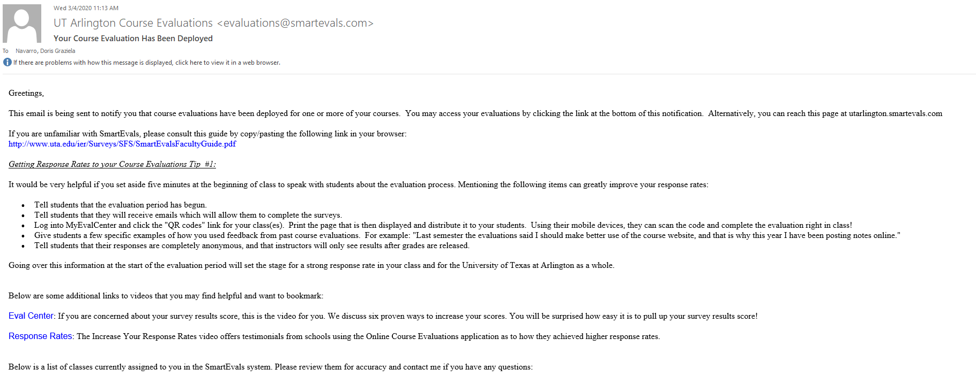
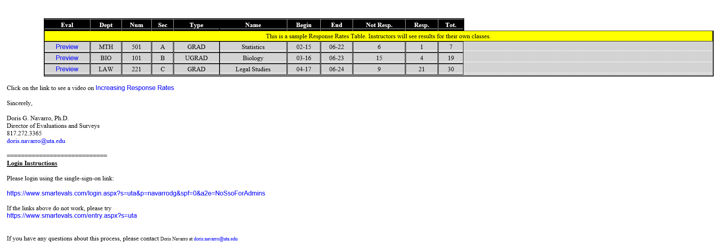

Accessing SmartEvals through Canvas
Faculty can also access the reports for their courses through Canvas. After logging into Canvas, select the course you are teaching, and click on the course evaluations tab.
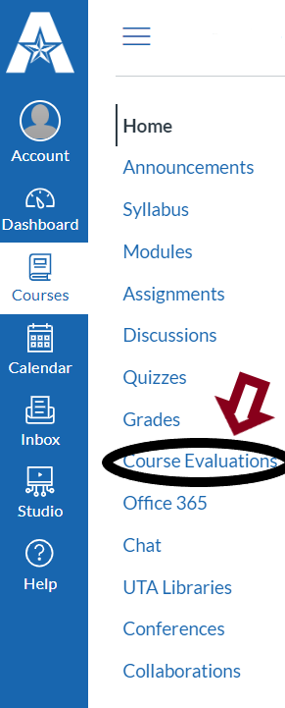
myEvalCenter
myEvalCenter is the home page of SmartEvals, and contains all the functions faculty will need to monitor active surveys and create customized reports of results. In the image below, you will notice that the overall response rate is readily visible in the center of the header; this shows the faculty’s combined response rates for all their courses for which surveys have been issued.
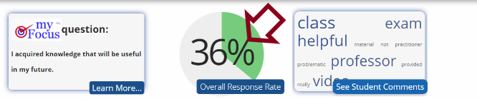 | 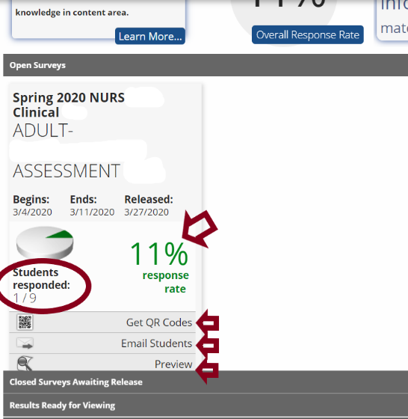

Contacting Students for Higher Response Rates
Instructors will also receive e-mails periodically, alerting them of their current response rates, and providing tips on how to improve them. One way to boost response rates is to utilize class time to complete the SFS. This can be done by printing out a QR code for students to use. By clicking get QR codes or selecting handouts on the dropdown arrow at the top menu, and then choosing QR Handouts, instructors will be able to print QR codes that students can scan to take their surveys. The same QR code can be used for multiple students, so there is no need to print out a code for every student in the course.
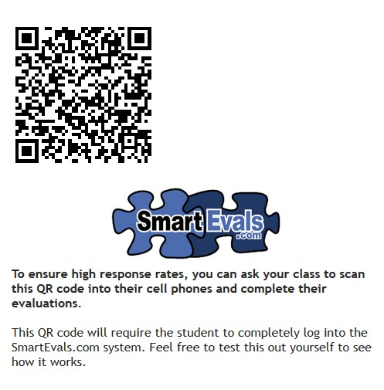
Although students will receive automatic reminders to complete their evaluations, faculty are greatly encouraged to remind their students as well. This can be done by setting up e-mails to students from the SmartEvals platform. By clicking on email students (see picture on the center, at the bottom of page above), the instructor will be given the option either to set up repeated automatic reminder e-mails, or to send a single email to his/her students. This process can also be done by clicking the Edit dropdown arrow at the top menu, then clicking Email Students. E-mail templates with customizable message will be available as well.
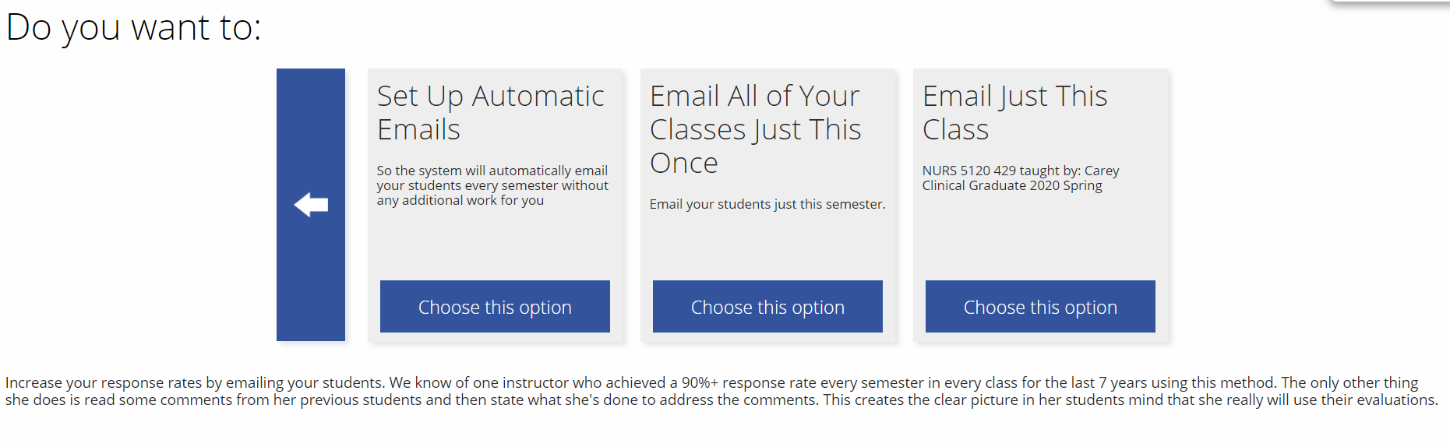
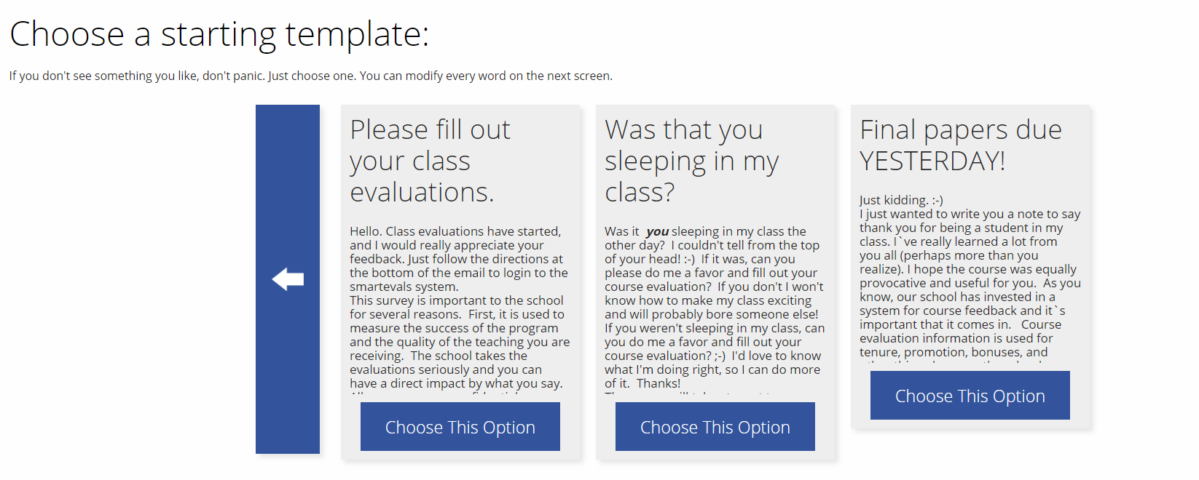
Instructors can also let their students know their feedback is valued by sending them a thank you note. This can be done by going to the Edit dropdown arrow at the top menu, and selecting Thank You Note.
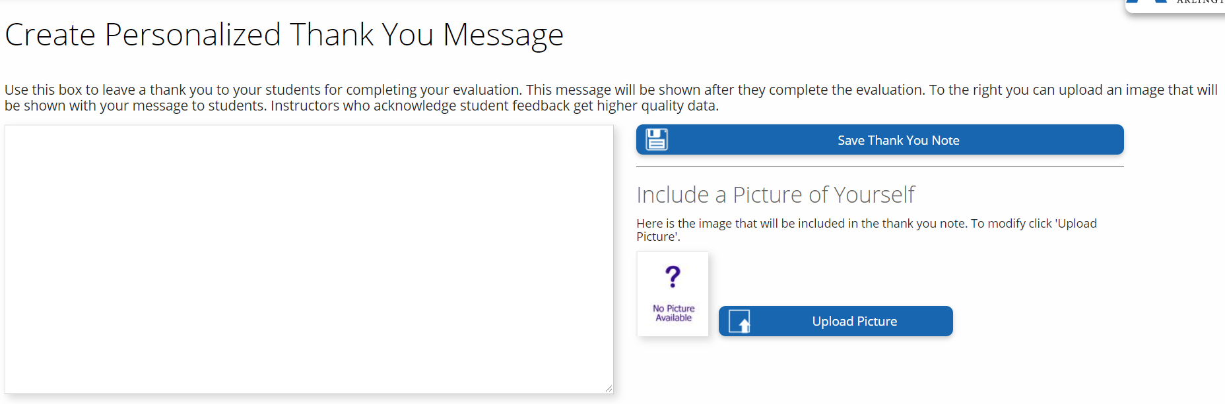

Accessing Results and Reports
The body of the page contains course information and results available on-demand, such as the number of responses received and the total response rate.
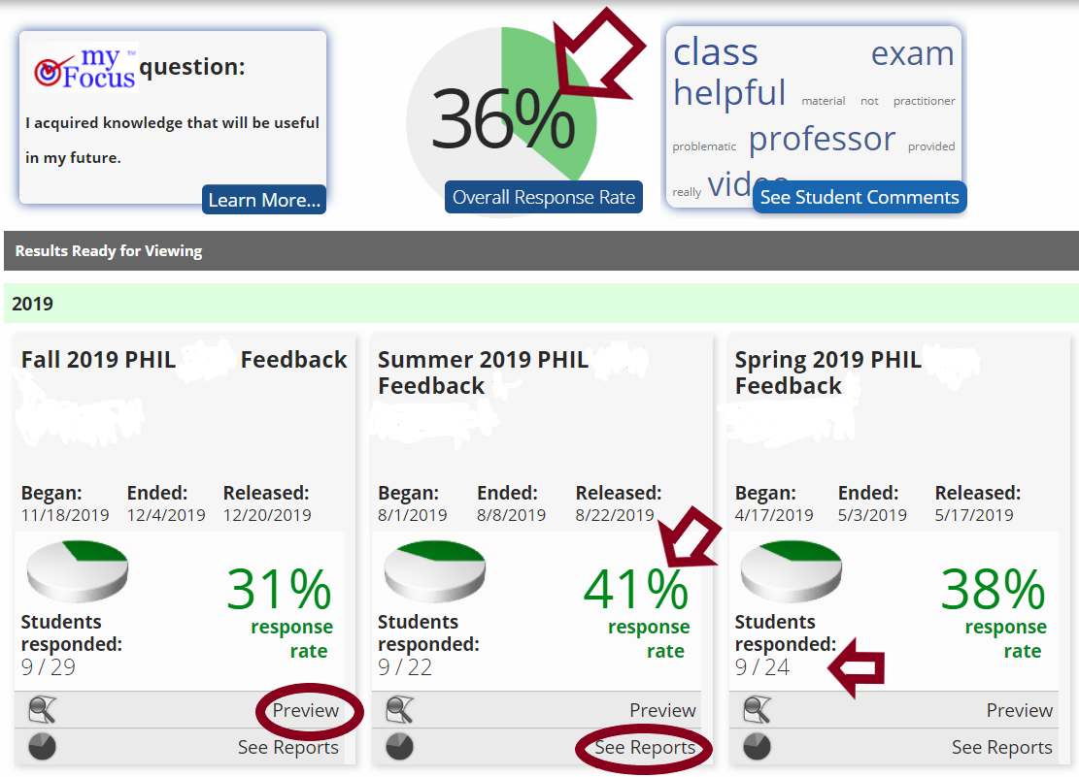
Through these dashboard, faculty are able to preview the questions that students were asked in the survey, as well as see their results reports when those are available (see picture above). By clicking on see reports, faculty will be directed to the custom report page shown below. In this page, instructors are able to select the term and specific courses (if different from the one they have selected in the previous screen) they want to export into a pdf, csv, html, xml, or doc formats.
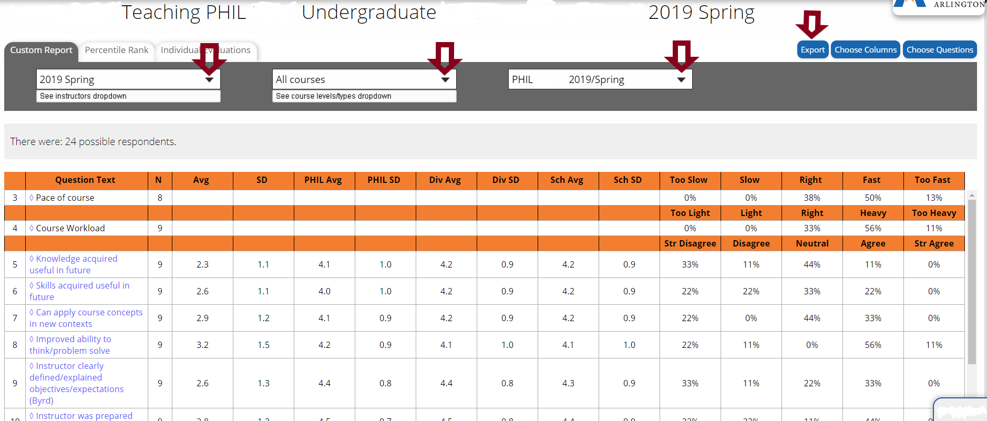

Under the dropdown box for term, instructors will have the option to select a specific term or run a report for a whole academic year, as well as past three, five, or more years. Up to this date, we only have data from Spring 2019 forward in SmartEvals, and the migration of previous years data into this new system is scheduled to take place in the next year or so. If you need data prior to Spring 2019, please fill in the missing report form, and we will provide those reports to you as soon as possible.
On the second dropdown box, instructors can select a specific course, while on the third dropdown box they are able to choose one course section, all section of a specific course, or export each section to a pdf.
In addition, the reporting interface allows instructors to generate custom tables and reports. By default, each question on the evaluation is displayed, along with average score, standard deviation, and the averages of the instructor’s department. These settings can be changed by clicking the Choose Columns and Choose Questions buttons on the top left of the page. Using the dropdown arrows at the top of the screen, instructors have the ability to select multiple courses as well.

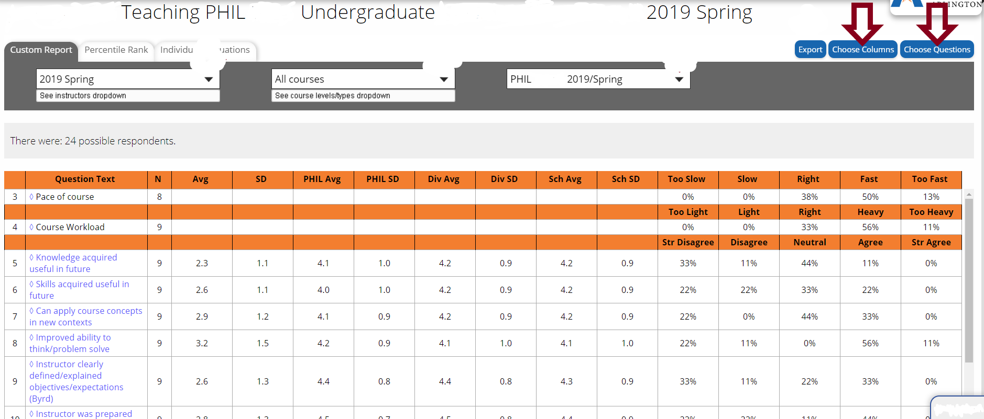

In the percentile rank tab, faculty will find their individual scores for the survey questions. These scores are in comparison to the ones obtained by other faculty at UTA. This is a graphic representation that allows instructor to visually see where they scored above the average (green, between 70-100%), or below average (red, between 1-29%). Comparison groups can be customized.
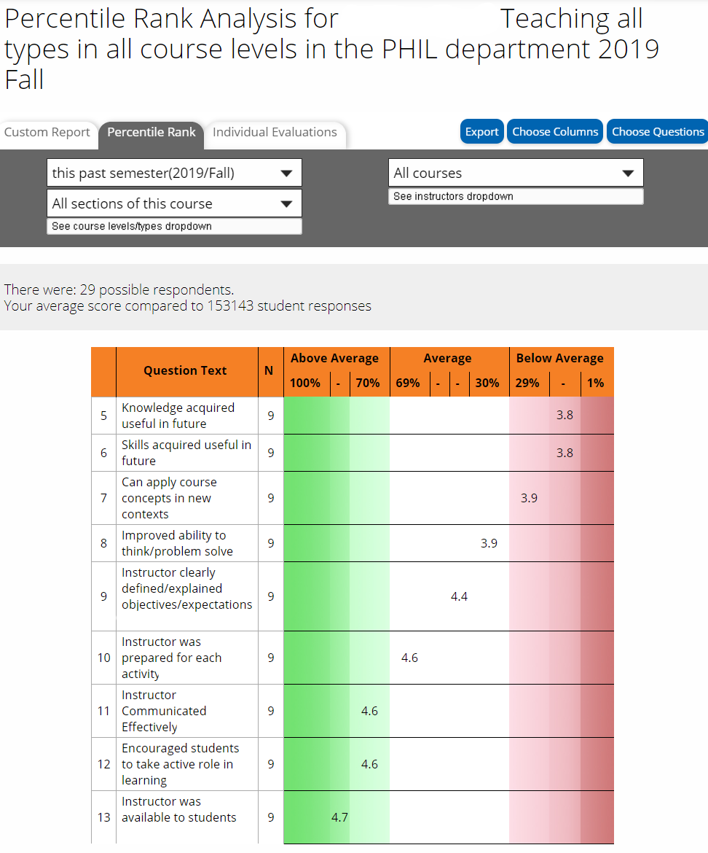 | 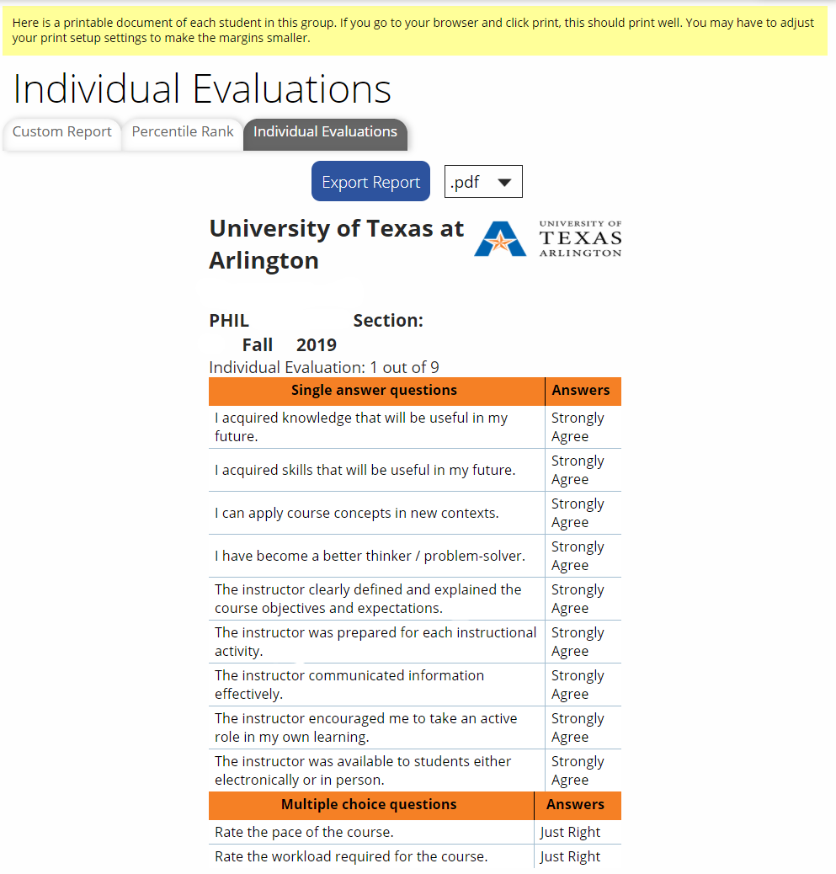

If desired, faculty can also see and print the individual responses from students by clicking on the individual evaluations tab, export, and then pdf (or other format of choice). This can be very helpful when the instructor is interested in identifying common themes brought by his/her students.
Faculty can also see results from multiple years and courses at once by clicking historical reporting under the reports dropdown tab on the top menu. Once opened, they will have access to a dashboard with the results for all courses taught over time displayed in one screen.
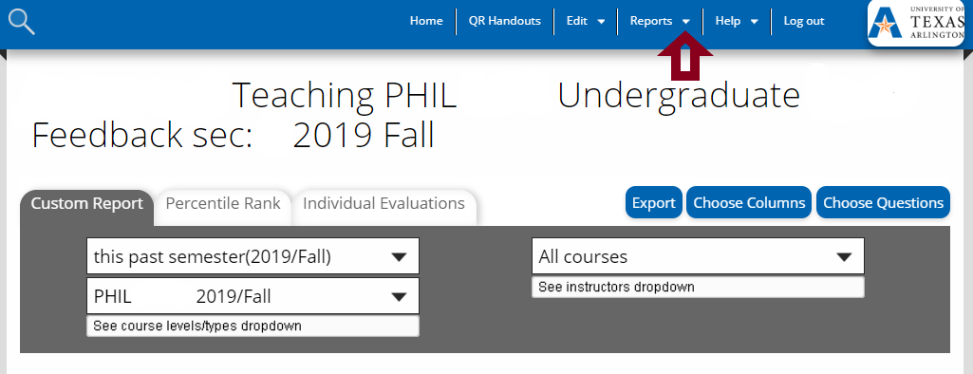
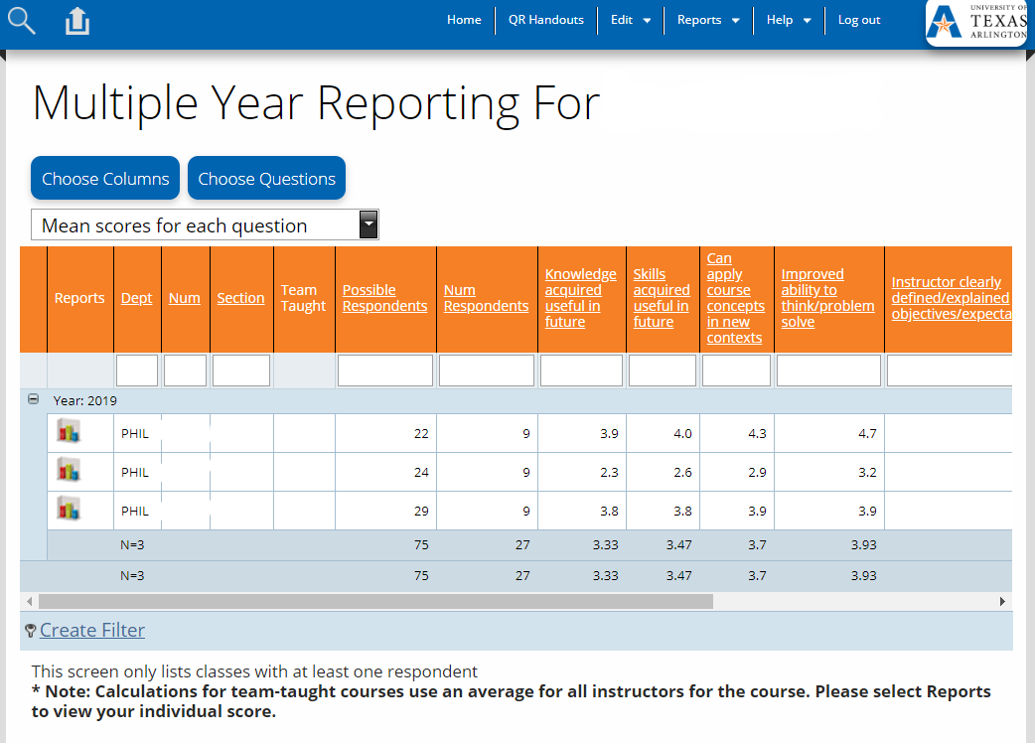

A series of video tutorials can be found on the SmartEvals website. We highly recommended these tutorials, as they are informative and easy to follow. Clicking the link below will provide access to the tutorials:
SmartEvals Faculty Tutorials

For any issues and questions regarding the SFS and SmartEvals, contact:
Doris G. Navarro, Ph.D.
Director of Evaluations and Surveys
iersurveys@uta.edu
817-272-3481

