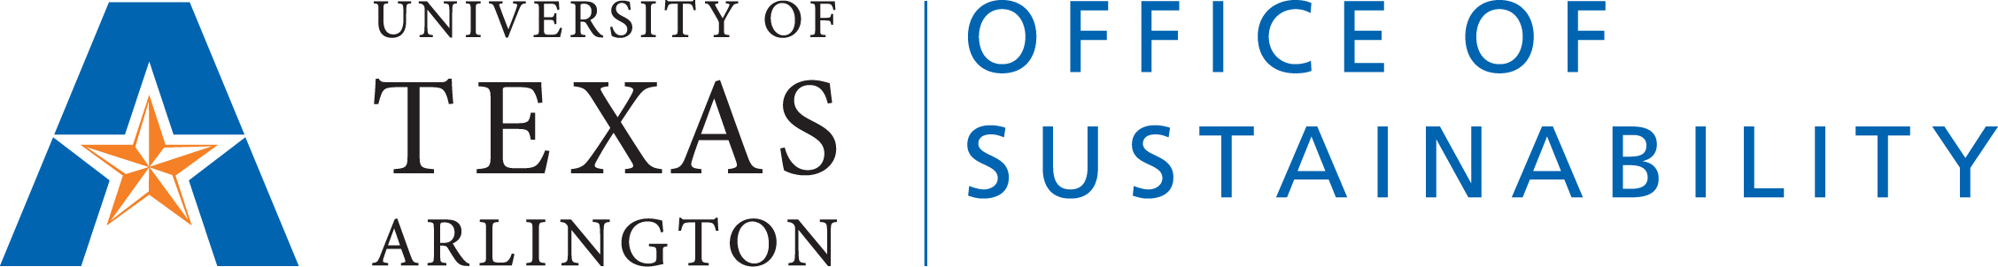

Faculty Advisory Network on Sustainability

Integrating Sustainability in Curriculum Template

Instructor Name:

Email:

Department/College:

Semester/Year: Fall 2021

Course Name:

Description

In a brief paragraph, describe the changes to the course you have revised.

Required Texts

Learning Outcomes aligned with sustainability

Alignment with the UN Sustainable Development Goals
Please describe which SDGs align with the course teachings- https://sdgs.un.org/goals
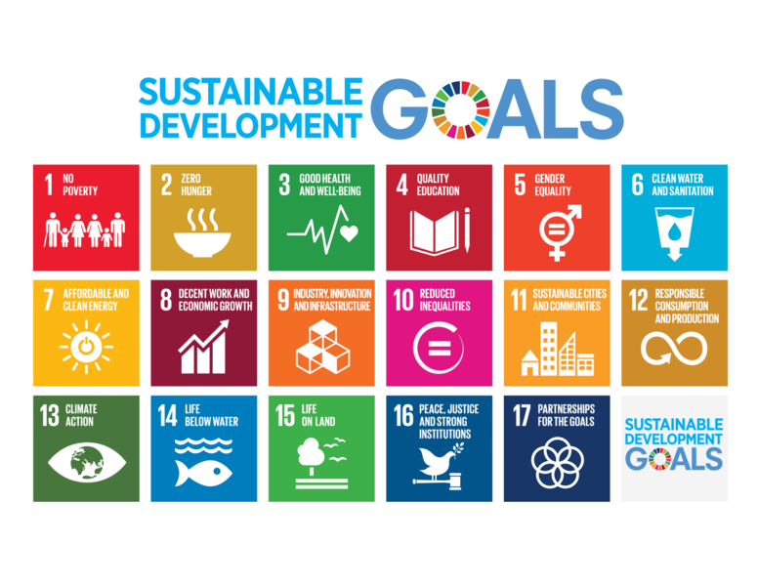

SDG 1- No Poverty
SDG 2- Zero Hunger
SDG 3- Good Health and Well Being
SDG 4- Quality Education
SDG 5- Gender Equality
SDG 6- Clean Water & Sanitation
SDG 7- Affordable & Clean Energy
SDG 8- Decent work & Economic Growth
SDG 9- Industry Innovation & Infrastructure
SDG 10- Reduced Inequalities
SDG 11- Sustainable Cities & Communities
SDG 12- Responsible Consumption & Production
SDG 13- Climate Action
SDG 14- Life Below Water
SDG 15-Life on Land
SDG 16- Peace, Justice, & Strong Institutions
SDG 17- Partnerships for the Goals

Additional Information and Resources

