Faculty Advisory Network on Sustainability

Integrating Sustainability in Curriculum Template

Instructor Name: Michael Bozlar

Email: bozlar@uta.edu

Department/College: Mechanical & Aerospace Engineering/College of Engineering

Semester/Year: Fall 2022

Course Name: MAE 3324-002 Structure and Mechanical Behavior of Materials

Description
This course introduces the interrelationships between processing, structure (crystal and microstructure), and the physics and chemistry of materials, with emphasis on the mechanical behavior of metals, polymers, and composite materials.
The Material covered will include the following sections of the textbook. Students are responsible for material in these sections and lecture content unless otherwise instructed in class.
Chapter | Title
1 | Introduction
2 | Atomic Structure and Interatomic Bonding
3 | The Structure of Crystalline Solids
4 | Imperfections in Solids
5 | Diffusion
6 | Mechanical Properties of Metals
7 | Dislocations and Strengthening Mechanisms
8 | Failure
9 | Phase Diagrams
10 | Phase Transformations: Development of Microstructure and Alteration of Mechanical Properties
11 | Applications and Processing of Metal Alloys
14 | Polymer Structures
15 | Characteristics, Applications, and Processing of Polymers
16 | Composites

In a brief paragraph, describe the changes to the course you have revised.

This physics and chemistry course covers the broad field of materials science from macroscopic objects or devices down to atomic scale. Whether it is the keyboard of our computer or the desk we are using at work, materials are everywhere around us and therefore strongly affect human activity in the framework of sustainability.
Among all 17 Sustainable Development Goals adopted by the United Nations (UN) in 2015, several of them can be directly and easily linked to this course. For each chapter (16 in total) that will be covered in this course, we will briefly discuss at the beginning of each lecture, which Sustainable Development Goals are the most relevant and provide a few examples to support our statements. For instance, “Clean Water and Sanitation”, or “Affordable and Clean Energy”, or “Industry, Innovation and Infrastructure” are examples of goals that are directly related to this course. Indeed, to achieve these goals, it is necessary to have a good understanding of the physics and chemistry of materials used in these domains. Therefore, when students will learn about “The Structure of Crystalline Solids” (Chapter 3) they will learn how the arrangement of atoms in space (to form 3D crystals) affects the chemical and physical stability of materials we employ every day. And eventually, students will be able to make connections between stability of a material and the ease with which the material can or cannot be recycled. Finally, students will have multiple opportunities in class to visualize lab specimen and video demos to better understand the relationship between materials science (learned in class) and Sustainable Development Goals.

Required Textbook

Materials Science and Engineering, an Introduction, 10th ed. William Callister and David Rethwisch. This is available as an e-text, with print version add-on.

Learning Outcomes aligned with sustainability

Throughout the semester, the students will learn the fundamentals (physics-chemistry) of materials with an emphasis on metals and polymers. Thus, this knowledge will prepare mechanical and aerospace engineering students to effectively select, design, and engineer devices, equipment, etc toward a sustainable environment. As illustrated in the Supplemental Section (page 4), the material learned in this course will provide them with an in-depth understanding of the physical and chemical composition of a given material (e.g., plastics) such that they will be able to better recycle them and ultimately achieve the Sustainable Development Goals 6, 7, 8, 9, 11, 12, 13, 14, 15, 17.

Alignment with the UN Sustainable Development Goals
Please describe which SDGs align with the course teachings- https://sdgs.un.org/goals
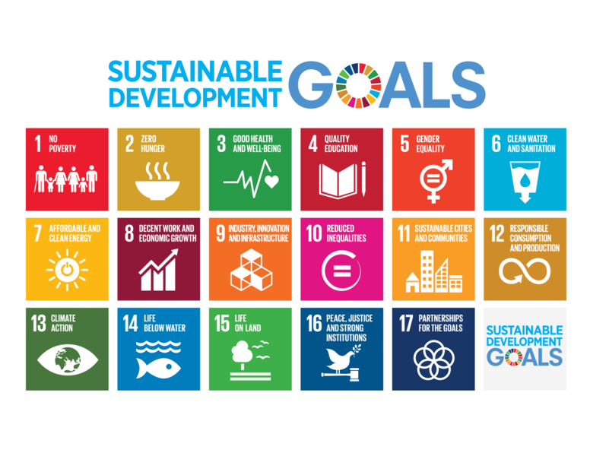

SDG 1- No Poverty | Aligns indirectly
SDG 2- Zero Hunger | Aligns indirectly
SDG 3- Good Health and Well Being | Aligns directly
SDG 4- Quality Education | Aligns directly
SDG 5- Gender Equality | Aligns indirectly
SDG 6- Clean Water & Sanitation | Aligns directly
SDG 7- Affordable & Clean Energy | Aligns directly
SDG 8- Decent work & Economic Growth | Aligns directly
SDG 9- Industry Innovation & Infrastructure | Aligns directly
SDG 10- Reduced Inequalities | Aligns indirectly
SDG 11- Sustainable Cities & Communities | Aligns directly
SDG 12- Responsible Consumption & Production | Aligns directly
SDG 13- Climate Action | Aligns directly
SDG 14- Life Below Water | Aligns directly
SDG 15-Life on Land | Aligns directly
SDG 16- Peace, Justice, & Strong Institutions | Aligns indirectly
SDG 17- Partnerships for the Goals | Aligns directly

Additional Information and Resources
The figure below describes the identification codes used to classify different types of plastics (polymers). Such a diagram will be used in class to illustrate the relationship between the physical and chemical stability of plastics and their potential to be easuly recycled or not.

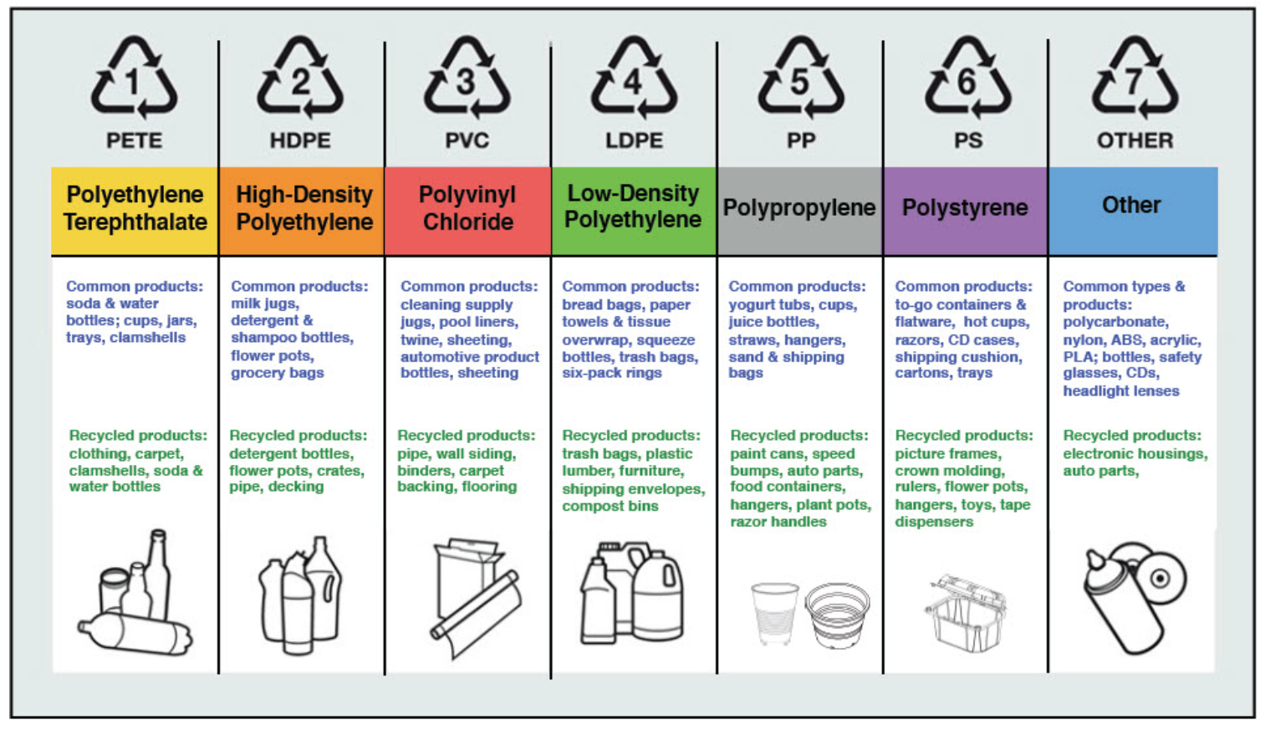
Figure A: Plastic Identification Code

