2019-2020 GREENHOUSE GAS EMISSIONS INVENTORY AND REDUCTION STRATEGIES
University of Texas at Arlington

Final Report
by
Dravid Sabarish, Villavan Kothai
Melanie Sattler, Ph.D., P.E.
Meghna Tare, M.S.

May 2021

ACKNOWLEDGEMENTS:

Estimating the carbon footprint of the UTA required data from several departments and operational areas throughout the university. We would like to thank the following individuals for their contributions which made this work possible.

Name | Department
Mr. Bobby Childress | Business Analytics
Ms. Becky Valentich | Office of Sustainability
Mr. David Aldape | Senior Executive, Compass Group
Ms. Patty Goodloe | Office of Facilities Management
Mr. Shelby Boseman | UTA Office of Public Records
Ms. Tiffany Gonzalez | UTA Office of Public Records

TABLE OF CONTENTS:

ACKNOWLEDGEMENTS…………………………………………………………………………………………………………………..….i

EXECUTIVE SUMMARY…………………………………………………………………………………………………………..….….iii -iv

CHAPTER 1: INTRODUCTION…………………………………………………………………………………………………………..….1

CHAPTER 2: HISTORY AND BACKGROUND……………………………………………………………………….……………..1-2

CHAPTER 3: METHODOLOGY…………………………………………………………………………………………..………..……2-9

CHAPTER 4: RESULTS AND DISCUSSION………………………………………………………………………..……….…...10-16

CHAPTER 5: RECCOMENDATIONS FOR REDUCING GHG EMISSIONS……………………………………………17-25

CHAPTER 5: CONCLUSIONS AND FUTURE WORK ……………………….……………………………………….………25-26

REFFERENCES……………………………………………………………………………………………………………………….…….27-29

APPENDIX A…………………………………………………………………………………………………………………………..…………30

APPENDIX B…………………………………………………………………………………………………………………………..…………31

EXECUTIVE SUMMARY
This report presents the results of the greenhouse gas emissions inventory at UTA. Data on the University’s major carbon-emitting activities were gathered in 3 areas: indirect campus emissions, indirect transportation emissions, and direct campus emissions.
The inventory was conducted using SIMAP (Sustainability Indicator Management and Analysis Platform), offered by the Sustainability Institute at the University of New Hampshire. SIMAP guides universities in estimating emissions in 3 major areas or scopes: direct campus emissions (Scope 1), indirect campus emissions due primarily to purchased electricity (Scope 2), and indirect transportation emissions (Scope 3). SIMAP’s emissions factors are taken from US Environmental Protection Agency and other documented sources. Input data was collected from various sources like UTA’s Office of Sustainability, Data Analytics team, Office of Facilities Management, food outlet managers, and students, faculty, and staff.
The major contributors to UTA’s 2019 GHG emissions were: Indirect Campus Emissions (electricity consumption): 51%, Indirect Transportation Emissions (e.g. commuting): 27%, Direct Campus Emissions (e.g. stationary fuel): 21%.
UTA’s 2019 emissions were 2.0 metric tons of carbon dioxide equivalents (MTCDE) per full-time equivalent (FTE) student, which compares favorably with other universities (Table E1). Emissions for 8 other universities world-wide ranged from 1.5 to 36.4 MTCDE per FTE student, with an average of 11.7.

Table E1. Comparison of UTA’s 2019 GHG emissions per full time equivalent student with several universities around the world
University | Metric tons CO₂-eq. (MTCDE) per FTE student
The University of Texas at Arlington | 2.0
University of Cape Town¹ (Pablo Yañez, 2020) | 4.0
Norwegian University of Science and Technology (Pablo Yañez, 2020) | 4.6
University of Delaware (Pablo Yañez, 2020) | 7.9
University of Pennsylvania (Pablo Yañez, 2020) | 13.1
Yale University¹ (Pablo Yañez, 2020) | 24.6
Massachusetts Institute of Technology (Pablo Yañez, 2020) | 36.4
National Autonomous University of Mexico (Pablo Yañez, 2020) | 1.5
Western University (Alghamdi, 2019) | 1.7
Overall mean (excluding UTA) | 11.7
Terminology used in this report is described in Appendix A

UTA emissions decreased from 2017 to 2019, despite increased student enrollment and a 7% increase in building area. Although UTA consumption of electricity increased during this period, emissions from electricity decreased, due to reduced coal generation and increased wind power. In addition, emissions from commuting decreased, due to a 9% increase in on-line enrollment, coupled with a 6% decrease in on-campus enrollment.
Several options were explored for reducing emissions from electricity consumption, the major contributor to GHG emissions at UTA. It was found that implementation of solar panels on 14 major UTA buildings would reduce emissions due to purchased electricity by 6.3%. The initial investment would pay for itself in savings in 1.7 years.
It was found that about 23.9% of UTA’s campus is covered with trees, which absorb 467 tonnes of CO₂ emissions annually. Traditional air pollutants are also removed, providing an estimated $10,000 in benefits. UTA’s trees also provide benefits of almost $9000 per year in terms of avoided runoff. Planting the 20.7% of UTA’s land currently covered by soil or grass would approximately double the tree benefits at UTA.

1.0 Introduction and Objectives
The University of Texas at Arlington has inspired administration, faculty, staff, and students on campus to embrace environmental responsibility and help UTA become a leader in sustainability among academic institutions. Following the establishment of the Office of Sustainability in 2010, UTA has developed programs and principles that foster sustainability practices across the university.
While UTA continues to grow and transform, its goal is to simultaneously reduce energy intensity and greenhouse gas (GHG) emissions. To this end, the Office of Sustainability is maintaining a carbon inventory for each year to track GHG emissions and provide information to guide reduction strategies.
The primary objectives of this project were:
- To update UTA’s greenhouse gas emissions inventory to include 2017-2019,
- To suggest short-term and long-term greenhouse gas emission reduction strategies.
The inventory was conducted using SIMAP (Sustainability Indicator Management and Analysis Platform), offered by The Sustainability Institute at the University of New Hampshire. SIMAP was used in this study for the following reasons:
- Ease of use: the tool has several options to input data, and has a convenient user interface, including an online data account for every user which can be used for import and export of data,
- Complete coverage of emissions calculations in three areas or scopes,
- Graphical output,
- Free for the first two months,
- Calculation of emissions based on carbon dioxide, methane, nitrogen dioxide, along with carbon dioxide equivalent,
- Used by a number of universities for AASHE stars reporting.

2.0 History and Background
As shown in Figure 1.0, in 2008, UTA conducted its first GHG emissions inventory using ICELI’s Clean Air and Climate Protection (CACP) software, a tool intended for local government entities that calculates emissions associated with electricity, fuel use, and waste disposal. In 2010, UTA’s Sustainability Committee (USC) conducted a second GHG analysis using the Clean Air-Cool Planet calculator, which offers a Campus Greenhouse Gas Emissions Inventory Calculator.
In 2012, UTA adopted a series of environmental performance targets as part of the development of a broader Campus Master Plan. Using the 2010 GHG analysis, the USC developed environmental performance goals in five goal areas: energy, buildings, transportation, waste, and water. Each goal was established with a 2005 base year and a target year of 2020. By 2020, UTA committed to reduce:
UTA contracted with The Cadmus Group to update its Scope 1 and Scope 2 GHG inventory for fiscal year 2016.

Figure 1. Timeline of UTA carbon inventory reporting

3.0 Methodology for Emissions Inventory

3.1 Software
The SIMAP software uses an Excel-based format to calculate the carbon inventory of a campus. All the emissions factors which are used in SIMAP are taken from US EPA (Environmental Protection Agency) official website and other references document sources, as mentioned at the end of this report. For more information see https://unhsimap.org/home.
SIMAP guides universities in estimating emissions in 3 areas or scopes:

Scope 1: Direct campus emissions
- Stationary and mobile sources (energy used in buildings and fleets)
- Fugitive emissions (from fertilizers, animal husbandry and chemicals)

Scope 2: Indirect campus emissions
- Purchased electricity.
- Purchased and sold renewable energy.

Scope 3: Indirect transportation emissions
- Daily commutes to/from campus by students, faculty, and staff,
- Air travel associated with campus study abroad programs.
- Production, distribution, and/or provision of specific goods or services purchased by the university. These include business trips (by ground and air); food production and distribution; paper production (several types).
- Fugitive emissions generated from the treatment of wastewater or the storage of municipal solid waste sent to a landfill or stationary emissions from burning municipal solid waste sent to a waste-to-energy plant.

3.2 Base Year

Fiscal year 2005-06 was selected as the base year since it was the most recent year for which complete information was available for all indicators. For some indicators, data is available going back to 1990, but not for all indicators. Reduction goals in the Action Plan will use 2005-06 as the benchmark year.

3.3 Institutional Boundaries and Exclusions
Institutional boundaries were set to include all operations over which the university has control. All these entities work for the betterment of the university. Operations included within institutional boundaries were:

• Buildings owned and leased by UTA,

• Students, faculty, and staff commuting to and from campus,

• UTA shuttle, university fleet vehicles and other vehicles,

• Food raw materials purchased in Connection Café, Pie Five, and Starbucks, which represent food outlets within a 1.5-mile radius and with 90% or more UTA community walk in, and for which data were available.

• Refrigerants used at UTA.

• Paper used at UTA.
Certain emissions were excluded due to lack of sufficient input data or emissions not falling within the institutional boundaries listed above. Exclusions were:

UTA’s remote campus activities and emissions,

Emissions associated with UTA’s wastewater (which is conveyed to the Trinity River Authority Central Regional Wastewater System),

Emissions associated with UTA’s landfilled waste (which is conveyed to the City of Arlington Landfill),

Most of UTA’s food outlets were not considered (only Connection Café was included),

Most food outlets within a 1.5-mile radius and with 90% or more UTA community walk in were not included because they did not have data available (only Pie Five and Starbucks had data available).

Private food outlets outside the 1.5-mile radius from UTA with less than 90% UTA community walk in.

All other recyclable solid waste other than paper, since SIMAP only includes recycling of paper waste.
- All student/faculty/staff travel other than academic-based travel, e.g. a commute to a nearby restaurant

3.4 Data Sources
Table 2 lists sources of data used as inputs to SIMAP. Specific categories of data are discussed in the sections below.
Table 2. Sources of data used as inputs to SIMAP
No. | Type of data | Source | Contact | Period of data received
1 | - Total operating budget  - Research budget  - Energy budget  - Total space  - Laboratory space  - Full time and part-time faculty count  - Full time and part-time staff count | Bobby Childress,  Associate Director of Data Analytics | childress@uta.edu | 2015 -2018
2 | - Full-Time-Equivalent Students  - In-Seat Only - Headcount  - Mixed Mode - Headcount  - Online Only – Headcount | Bobby Childress, Associate Director of Data Analytics | childress@uta.edu | Fall 2016 – Fall 2019
3 | - Connection Café product frequency data | David Aldape, Senior Executive, Compass Group | David.Aldape@compass-usa.com | 2019
4 | - Pie Five restaurant product frequency data | Outlet Manager | NA | 2019
5 | - Starbucks product frequency data | Jacqueline Meza, Outlet Manager | 1511mgr@follett.com | 2019
6 | - UTA’s energy data  - UTA’s athletic space | Patty Goodloe, Energy Analyst,  Office of Facilities Management | patty@uta.edu | 2016-2019
7 | - UTA’s international travel data | UTA Office of Public Records | publicrecords@uta.edu | 2016- March 2020
NA- Not Available

3.4.1 General data

3.4.1.1 Budgets
Types of budgets at UTA include:
- Research budget - To calculate emissions per dollar research expenditure.
- Operating budget, which includes the energy budget- To calculate emissions per dollar of operating or energy expenditure.
The operating budget consists of all sources of funding UTA has financial control over and is plainly considered as the cost to operate the institution. The research budget includes all sources of financial funding for UTA research expenditures. The energy budget is the total spent on supplying the energy needs of all operations. The combined energy budget includes the budget for electricity, steam and chilled water, and on-campus stationary sources (heating, etc). All 3 budgets were available for 2017 – 2019. The operational, research, and energy budgets were provided by the Office of Data Analytics, Office of Finance, and Administration, Office of Facilities Management, respectively.

3.4.1.2 Space
SIMAP uses the total space square footage values to determine the emissions per square foot. Types of space at UTA include:
- Overall space: this includes all space owned by UTA irrespective of its being used or unused. This includes building, open, research, and athletic space at UTA.
- Building space: all building space including the outside faces of its exterior walls. including all vertical penetration areas for air circulation, e.g. shaft areas that connect one floor to another.
- Open space: all spaces including pavements, parks and parking lots.
- Research space: all building and laboratory spaces which help UTA in its science and research endeavours.
- Athletic space: this includes all the space owned by UTA to help its athletic endeavours.
Total building size data and research building data were provided by the Office of Data Analytics for the fiscal years 2017 to 2019 in units of GSF (Gross Square Footage). GSF is defined as the sum of all areas on all floors of a building included within the outside faces of its exterior walls, including all vertical penetration areas, such as areas for circulation or ventilation and shaft areas that connect one floor to another. The open space and athletic space data were obtained from UTA’s Office of Facilities Management.
Since SIMAP reports emissions per GSF, it is unclear how the square footage data for the specific building types was used.

3.4.1.3 Population

Population data was not considered in the previous emissions reports due to an exclusion of scope 3 (commuting emissions). For UTA’s 2019 emissions report, the population is taken into consideration to determine the Scope 3 commuting emissions. Commuting information is discussed in a section below.

Spring, Fall and Summer population was considered, which includes full-time and part-time students, and each category includes both graduate and undergraduate students. Faculty data also includes full-time and part-time. Staff data was also included. The information was produced by the Institutional Research, Planning and Effectiveness Office and provided to the research team by the Office of Data Analytics at UTA.

3.4.2 Energy and Fuel Data – Non-Transportation

3.4.2.1 Electricity Data
The e-grid sub region was chosen as “ERCT” under the region “ERCOT (Electric Reliability Council of Texas) ALL” for pre- and post-2006 e-GRID sub region choices. An e-grid sub-region represents a portion of the US power grid that is contained within a single North America Electric Reliability Council (NERC) region, and generally represents sections of the power grid which have similar emissions and resource mix characteristics and may be partially isolated by transmission constraints. E-grid’s emissions represent emissions from fuel only used for generating electricity. The UTA’s electricity consumption data was obtained from the Office of Facilities Management.
Chilled water is generated using electricity and has already been accounted for in the “Purchased Electricity”; therefore, no data was entered for this section.

3.4.2.2 Stationary Fuel Data
All stationary fuel inputs which produce energy to power UTA-owned buildings and equipment were considered for this data input in SIMAP. The Office of Facilities Management at UTA provided data for fuel consumption of distillate oil and other stationary fuels (gasoline and diesel) used to maintain the facility equipment and generators for the fiscal years 2017 to 2019. UTA purchases its natural gas from various third party contractors. Data for UTA’s natural gas purchases from 2016-2019 were obtained from the Office of Facilities Management.

3.4.3 Transportation Data

3.4.3.1 International Travel Data
International travel data is included in the UTA’s GHG emissions report for the first time. This data was acquired from the Office of Public Records at UTA by officially filing a petition to access the data source. The data include all air travel by the UTA community (student/faculty/staff) which was reimbursed between the period of January 2016 to May 2020. The data was presented in travel origin and destinations. Travel distance was estimated with the help of an application called “distance.to” for bulk calculations,” and miles travelled input into SIMAP. There was also a possibility in SIMAP application to feed the data in dollars spent for a flight travel, but this possibility was ruled out due to its being less accurate. The cost of a trip can vary based on choice of class (business or regular) or airline. In addition, the value of dollar can either inflate or deflate each year; hence, the miles per dollar spent will vary for each year. The SIMAP tool, however, does not have an inflation/deflation function to account for this.

3.4.3.2 Commute Data
This category includes annual miles travelled by faculty, staff, and students in commuting to and from campus. The software also has places for the user to input the distribution percentage of various types of commutes at UTA. Emissions from commuting are an integral part of the inventory because the university can influence this travel in the future by offering alternatives like buses, shuttles or a car-sharing program.
Commute distances and the distribution of various commute modes were determined from a transportation survey conducted during summer 2020 for this report. An interactive survey was formulated in Survey Monkey to determine the distance and modes that students, staff and faculty travel to reach UTA. UTA’s newspaper The Shorthorn ran an article about the carbon emissions inventory and its importance, including an interview with UTA’s Chief Sustainability Officer Meghna Tare. (https://www.theshorthorn.com/news/office-of-sustainability-conducts-emissions-inventory-in-attempt-to-measure-uta-s-carbon-footprint/article_4d78b3e4-9188-11ea-bf83-e389f2b89627.html). The survey was sent to students, faculty, and staff in the College of Engineering by a direct email with the help of Jeremy Agor, Senior Director of Communications and Marketing for the College of Engineering. The survey was also included several times in the faculty/staff e-newsletter “Mav Wire,” as well as the student e-newsletter “Trail Blazer.”
According to the survey, the average days travelled by students, faculty, and staff together was an approximate three days a week to UTA campus. Hence, an average of 6 commute trips per week (one to and one from campus each day) were taken into consideration for the group of students, faculty, and staff. To estimate commute emissions, spring and fall semesters were taken to be 16 weeks each, according to the university calendar, and summer was assumed to be 8 weeks (an average of the 5- and 11-week sessions). Summer commutes had been excluded from earlier UTA GHG emissions reports.
SIMAP did not have a separate input for electric/hybrid automobiles, which led to an assumption of all automobiles being in a single category. The option of separate emissions calculations for hybrid/electric automobiles and conventional automobiles will be available in the upcoming UTA carbon assessment tool. SIMAP also does not have features that compare emissions from one commute mode to another, e.g. car vs. bike.

3.4.3.3 UTA Vehicle Transportation Fuel Data
UTA operates various transportation services for its community, including shuttle services, Tap Ride safety escort cart service, and vehicle maintenance services. All the diesel and gasoline fleet data were periodically recorded by the Office of Facilities Management at UTA; this helped us assess the emissions for the fiscal year 2017- 2019.
Information provided by the Office of Facilities Management included gallons of gasoline and diesel fuel used by the university fleet for the years 2017 to 2019.

3.4.4 Water Consumption Data
The Office of Sustainability tracks annual clean water consumption for UTA, as shown in Figure 2. Emissions were calculated based on the EPA’s GHG emissions calculator³ due to clean water consumption. This function was not available in SIMAP; hence, the research team had to use the other tool. The input provided to this tool was UTA’s annual water usage for each fiscal year.
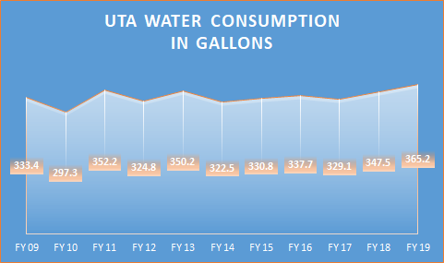
Figure 2. Annual water consumption at UTA from fiscal year 2009-2019

Material Consumption and Waste Data

Food Data
Two types of food data were collected: food purchase data and food waste data. The UTA has several food outlets, some owned directly by UTA and others owned privately by other companies. The data collection boundary was set such that only food outlets in a radius of 1.5 miles from the epicentre of UTA, and which have a UTA student, staff and faculty walk in of 90%, were considered. The 90% walk in was based on the manager’s data provided for the research study. Of the food outlets included within the boundary, only three have data available – Connection Café, Starbucks and Pie Five – so only these three were included in the report. Old School Pizza, New York Eats, etc., were excluded, despite these being some hotspots for UTA student and staff. This was due to a lesser percentage of UTA community walk in; these places had a lot of external community population walking.
Pie Five and Starbucks had food consumption data by weight as provided by their outlet managers. Food data produced by Chartwells group (food manager at UTA for 2019) for Connection Café was given in total dollars spent on food raw materials and products. A sorting program was formulated with the help of Python computer programming language to separate this large data source. The dollar values were converted into respective case weights in pounds (references for the conversions are provided at the end of the report).
SIMAP estimates GHG emissions associated with growing and transporting food, based on EPA national average data.

3.4.5.2 Refrigerant Losses
Chlorodifluoromethane, or difluoromonochloromethane, is a hydrochlorofluorocarbon (HCFC) employed in space conditioning applications at the Thermal Energy Plant on campus. This colourless gas is better known as HCFC-22, R-22. The losses of R-22 were obtained for the fiscal year 2017 to 2019 from the Office of Facilities Management and entered for HCFC-22 into SIMAP. Refrigerants HCFC, HFC 134a HCFC 22 and HCFC 22 410A were also included.

3.4.5.3 Recycling
SIMAP inputs include all paper waste which is collected officially by both UTA and third-party companies (Balcones and Republic Services). It calculates the GHG emissions from producing the paper, transporting the paper, and recycling the paper. Paper collection data was provided by the Office of Sustainability for the fiscal year 2017 to 2019. Paper waste and shredded paper waste are sent to various waste recycling companies for rebates.
Although other recyclable wastes (including plastic bottles and aluminium cans) are collected at UTA and transferred to Balcones recycling company, SIMAP only includes recycling of paper waste, so other recyclables were excluded from the study. SIMAP does not have any offsets or sinks for recycling activities. Offsets are operations or activities that the organization undertakes to compensate for damage to the environment.

3.4.5.4 Composting Waste Data/Offsets/Sinks
Although UTA composts grass clippings and leaves, SIMAP only estimates emissions from composting of food waste, so only food waste composting was included in this study. The composting program overseen by UTA’s Office of Sustainability accepts only pre-consumer food waste produced by the UTA campus. The post-consumer food waste is taken to a third-party company for composting processes. The weights of the composted material were obtained from the Recycling Coordinator for offsets in SIMAP.

3.5 Method for Forecasting Future Emissions
The research study estimated the future growth and decreases of emissions, student enrollment and building area with time, based on exponential smoothing forecasting. This method of forecast was used in Microsoft Excel and is based on the AAA version (additive error, additive trend and additive seasonality) of the Exponential Triple Smoothing (ETS) algorithm, which smooths out minor deviations in past data trends by detecting annual patterns and confidence intervals. There was a constant confidence interval of 95% to have a uniformity in the forecast results for each prediction.

4.0 Results of Emissions Inventory
4.1 Transportation Survey Results
787 survey responses were received, of which 670 were completed. The 670 respondents included 263 students, 47 faculty, and 360 staff. Table 3 shows the distribution of commute modes among survey participants. This distribution was input into SIMAP software to determine the overall emissions due to commuting at UTA.

Table 3. Distribution of commute modes among UTA students, faculty, and staff
Type | Automobiles % | Carbon free modes (Walk/Bike/Skateboard) % | Public Train % | Public bus/UTA shuttle %
Staff | 98.05 | 1.66 | 0.27 | 0.00
Students | 59.31 | 37.65 | 0.00 | 3.04
Faculty | 100.00 | 0.00 | 0.00 | 0.00

4.2 Carbon Inventory Results
4.2.1 UTA Emissions due to Water Consumption
Table 4 shows UTA water consumption and GHG emissions according to EPA’s GHG emissions calculator. Within a timeframe of 2010 to 2019 (10 years), UTA’s gross square footage (GSF) per full-time equivalent student increased by 24%, but the GHG emissions due to water consumption only increased by 18%. This slower rate of increase for water consumption may be due to UTA’s water conservation initiatives on campus.
As shown in Table 4, greenhouse gas emissions from water consumption are forecast to increase slightly from 2020 to 2022. It is estimated in the time frame of 2020 to 2022, there would be a 12% increase in campus space and a significant increase in student population but the increase in water consumption is only 7%. This may be due to UTA’s increasing commuting student population and a decrease in residential or on-campus students; it could also be due to sustainable measures to control water consumption.

Table 4. Greenhouse gas emissions due to UTA water consumption

Fiscal Year | Water consumed  in million gallons (10⁶) | MTCDE© due to water consumed | Gross square footage per FTE* | Gallons Consumed  per GSF per FTE* | MTCDE© due to water consumed per GSF per FTE
FY 10 | 297 | 533 | 4.9 | 61 | 8.7
FY 11 | 352 | 631 | 5.2 | 68 | 9.3
FY 12 | 325 | 582 | 5.8 | 56 | 10.4
FY 13 | 350 | 627 | 5.8 | 60 | 10.5
FY 14 | 323 | 578 | 5.7 | 57 | 10.1
FY 15 | 331 | 593 | 5.7 | 58 | 10.2
FY 16 | 338 | 605 | 5.7 | 59 | 10.3
FY 17 | 329 | 590 | 5.7 | 58 | 10.2
FY 18 | 348 | 623 | 5.7 | 61 | 10.2
FY 19 | 365 | 654 | 6.1 | 60 | 10.9
FY 20** | N/A | 640 | N/A | N/A | N/A
FY 21** | N/A | 646 | N/A | N/A | N/A
FY 22** | N/A | 656 | N/A | N/A | N/A
FTE*- Full time equivalent Student, Faculty, and Staff
FY**- Emissions forecast in MTCDE for future years
GSF°- Gross square footage
MTCDE©- Metric Tons of Carbon Dioxide Emissions
Terminology used in this report is described in Appendix A

4.2.2 UTA Emission Results from SIMAP, 2017-2019
Table 5 provides SIMAP estimates of UTA GHG emissions for 2017 to 2019, with the exception of emissions from water consumption, discussed in the previous section. Annual GHG emissions from water consumption were at most 656 MTCDE, which is very small compared to the emission estimates in Table 5 (18,000 MTCDE and greater). Of the 3 scopes in Table 5, the largest amount of emissions comes from electricity purchased at UTA (Scope 2). Figure 3 shows the distribution of emissions from the 3 scopes for 2019. 51% of emissions are due to electricity consumption.

Table 5. UTA GHG emissions by scope, 2017 - 2019

Fiscal Year | Emissions based on | CO₂  (kg) | CH₄  (kg) | N₂O (kg) | GHG  MTCDE
2017 | Direct campus emissions (e.g. stationary fuel) (Scope 1) | 17,398,826 | 1,696 | 62 | 18,059
2017 | Indirect campus emissions (electricity consumption) (Scope 2) | 54,116,025 | 4,076 | 590 | 54,386
2017 | Indirect transportation emissions (e.g. commuting) (Scope 3) | 30,955,631 | 1,466 | 868 | 31,479
2017 | Total Emissions | 102,470,482 | 7,238 | 1,520 | 103,924
2018 | Direct campus emissions (e.g. stationary fuel) (Scope 1) | 19,430,327 | 1,900 | 63 | 19,832
2018 | Indirect campus emissions (electricity consumption) (Scope 2) | 50,902,593 | 3,606 | 492 | 51,134
2018 | Indirect transportation emissions (e.g. commuting) (Scope 3) | 27,135,977 | 1,324 | 779 | 27,671
2018 | Total Emissions | 97,468,897 | 6,830 | 1,334 | 98,637
2019 | Direct campus emissions (e.g. stationary fuel) (Scope 1) | 21,600,672 | 2,121 | 64 | 22,052
2019 | Indirect campus emissions (electricity consumption) (Scope 2) | 51,566,537 | 3,653 | 498 | 51,801
2019 | Indirect transportation emissions (e.g. commuting) (Scope 3) | 27,049,268 | 1,314 | 772 | 27,467
2019 | Total Emissions | 100,216,477 | 7,088 | 1,334 | 101,320
Terminology used in this report is described in Appendix A.

Figure 3. UTA GHG emissions by source, 2019
4.2.3 UTA Emission Inventory Estimates, 2005-2022
Figure 4 summarizes UTA emissions (total and for each of the 3 scopes) from 2005 through 2022. Estimates from Table 5 for 2017-2019 are included, along with emissions from past inventories and projections for Years 2020-2022. Emissions due to stationary fuel and mobile sources (except commuting) (Scope 1) decreased from 2005 to 2017. This decrease was due at least in part to UTA contracting out bus transportation services. Scope 1 (Direct campus emissions) increased from 2017 to 2019, with additional increase projected for 2020 to 2022. The increase was due to the increased use of natural gas on campus for heating. Campus natural gas consumption increased by 26% from 2016 to 2019, from 314 million cubic feet (MMCF) to 399 MMCF.

Figure 4. GHG emissions for fiscal years 2005 to 2019, along with forecast until 2022

As shown in Figure 4, between 2016 and 2019, greenhouse gas emissions for electricity consumption (Scope 2) decreased by 13% (from 60,032 MTCDE to 51,801 MTCDE), although campus square footage increased by 7% during this same period. The quantity of power purchased increased 3.2% from 118,223 MWh to 122,022 MWh from 2017 to 2019 but emissions due to purchased power decreased by 4.7% from 54,386 MTCDE to 51,801 MTCDE. UTA’s purchased electricity is acquired from the Electric Reliability Council of Texas (ERCOT). Table 6 shows the distribution of various power sources in the ERCOT mix from 2017 to 2019. Decreased use of coal and increased use of solar and wind reduced overall CO₂ emissions from ERCOT’s power mix during this period, which would have reduced UTA’s emissions associated with electricity.

Table 6. Distribution of electricity sources for the ERCOT mix³
Year | Units | Bio-mass | Coal | Gas | Gas-CC | Hydro | Nuclear | Other | Solar | Wind | Total Electricity
2017 | % | 0.15% | 32% | 5% | 34% | 0.23% | 11% | 0.00% | 0.63% | 17% | 100%
 | MWh | 177 | 37,831 | 5911 | 40,196 | 272 | 13,005 | 0.0 | 745 | 20,098 | 118,223
2018 | % | 0.14% | 25% | 6% | 38% | 0.21% | 11% | 0.00% | 0.86% | 19% | 100%
 | MWh | 169 | 30,113 | 7227 | 45,771 | 253 | 13,250 | 0 | 1036 | 2286 | 120,451
2019 | % | 0.10% | 20% | 7% | 40% | 0.24% | 11% | 0.56% | 1.10% | 20% | 100%
 | MWh | 122 | 24,404 | 8542 | 48,809 | 293 | 13,422 | 683 | 1342 | 24,404 | 122,022
Resource for ERCOT mix- http://www.ercot.com/gridinfo/generation

Note that in Figure 4, Indirect Transportation Emissions (Scope 3) are included for the first time in 2017. They show a decrease from 2017 to 2019, and a projected decrease from 2020 to 2022. Figure 5 shows UTA’s enrollment for fiscal years 2017 – 2019. Enrollment for Fall, Spring, and Summer were combined so that trends by year could be observed; plotting enrollment by semester would obscure trends, due to Spring enrollment being typically lower than Fall, and Summer being lower than Spring. In-class enrollment decreased 6.3% from 2017 to 2019, while online enrollment increased. A decrease in Indirect Transportation Emissions is consistent with a decrease in in-class enrollment.

Figure 5. Enrollment history for UTA from 2017 to 2019, along with emissions from commuting
Total emissions in Figure 4 decreased by 2.5 % from 2017 to 2019. This reduction was due to several factors, such as cleaner purchased electricity from ERCOT increased online education population. This decrease is especially noteworthy given that the overall building area at UTA increased by 7% during this time frame.
Figure 6 shows total emissions per GSF (gross square footage) at UTA from 2010 to 2019. GHG emissions per GSF 2010 remain approximately the same over this period. The increase from 2016 to 2017 was due to inclusion of Indirect Transportation Emissions (Scope 3) emissions for the first time in 2017. During the period from 2010 to 2019, UTA’s total gross square footage (GSF) increased from 6,421,914 to 7,224,010, an increase of 12.5%. The emissions per GSF per FTE has decreased by 4.2% from 0.01445 MTCDE per GSF to 0.01384 MTCDE from 2010 to 2019.

Figure 6. UTA greenhouse gas emissions per gross square foot

Figure 7 shows UTA greenhouse gas emissions per full-time equivalent (FTE) student from 2017-2019, along with projections for 2020-2022. According to Figure 7, GHG emissions per FTE student for 2019 were slightly lower than for 2017. This reduction was likely due to an increase in distance learning students and decrease in in-person class students at UTA, which decreased the commuting and utility usage emissions. Between 2017 and 2019, UTA in-class student enrollment decreased by 6% and online class enrollment increased by 9%. This decrease in in-class enrollment affected not only mobile emissions (Scope 1) but also stationary fuel combustion (Scope 1), purchased electricity (Scope 2), and commuting emissions (Scope 3). Fewer in-person students mean less use of shuttle services, natural gas, and electricity.

Figure 7. UTA greenhouse gas emissions per full-time equivalent student

4.2.4 Comparison of UTA Carbon Emissions with Other Universities
Table 7 compares UTA’s GHG emissions with those of other universities. The average GHG per FTE was 11.7 (excluding UTA). UTA’s emissions of 2.0 GHG per FTE student were substantially below average.

Table 7. Comparison of UTA’s 2019 GHG emissions per full time equivalent student with several universities around the world
University | Metric tons CO₂-eq. (MTCDE) per FTE student
The University of Texas at Arlington | 2.0
University of Cape Town¹ (Pablo Yañez, 2020) | 4.0
Norwegian University of Science and Technology (Pablo Yañez, 2020) | 4.6
University of Delaware (Pablo Yañez, 2020) | 7.9
University of Pennsylvania (Pablo Yañez, 2020) | 13.1
Yale University¹ (Pablo Yañez, 2020) | 24.6
Massachusetts Institute of Technology (Pablo Yañez, 2020) | 36.4
National Autonomous University of Mexico (Pablo Yañez, 2020) | 1.5
Western University (Alghamdi, 2019) | 1.7
Overall mean (excluding UTA) | 11.7

5.0 Recommendations for Reducing GHG Emissions
The American College & University Presidents' Climate Commitment (ACUPCC) recommends all American universities to measure their GHG emissions annually and develop an action plan to become a carbon neutral campus in the future. This section discusses two ideas for further reducing GHG emissions from UTA: solar panel installation and afforestation.
5.1 Solar panel installation
5.1.1 Idea
According to the GHG inventory results above, the highest contributor to the carbon footprint at UTA was found to be Scope 2 (Indirect Campus Emissions, electricity from external source purchase). Production of renewable electricity on campus by solar panels or PV cells can reduce this contribution. Panels can be placed on unused building rooftops.

5.1.2 Method and software
Helioscope, a geospatial software tool (https://www.helioscope.com/), was used to estimate solar energy output. The software uses GIS to determine the location of the project along with the terrain details and includes factors such as solar insolation. The software gives a wide range of solar panel choices according to the total investment or maximum efficiency with minimum space provided.
The software includes shader models, which the software uses to assess the amount of solar energy efficiency drop due to shade from nearby buildings over the entire year at the location. The shader and irradiance data are processed with the project rooftop area, along with the type of solar panels; thus, the overall electricity output is estimated.
The GHG emissions offset for the electricity produced by this solar panel design was based on EPA’s carbon emissions calculator (https://www.epa.gov/energy/greenhouse-gas-equivalencies-calculator).
Software inputs and outputs include:
Inputs:
- Boundary for the building roof (using aerial photo)
- Type of panel to be installed - Panel used for the study: TSM-PD14 320 (May 16), Trina Solar
- Orientation of the panels or azimuth angle - The azimuth angle (see Figure 8) is the compass direction from which the sunlight is coming. The azimuth angle is important to capture a maximum of sunlight and therefore produce a maximum of energy. For this study, the panels were oriented to the south for maximum energy output.
- Lookouts and obstructions
- Type of wiring and transformers
- Angle of inclination or tilt angle - To obtain the most energy from solar panels, they need to point them in the direction that captures the most sun. The tilt angle (Figure 8) is the angle at which the panel is tilted when facing the sun.

Outputs:
- Area and number of solar panels,
- Performance ratio and power output. Performance ratio (PR) is the ratio of measured output to expected output for a given reporting period based on the system name-plate rating of the solar panel.
A sample solar panel design output is shown in Figure 9.

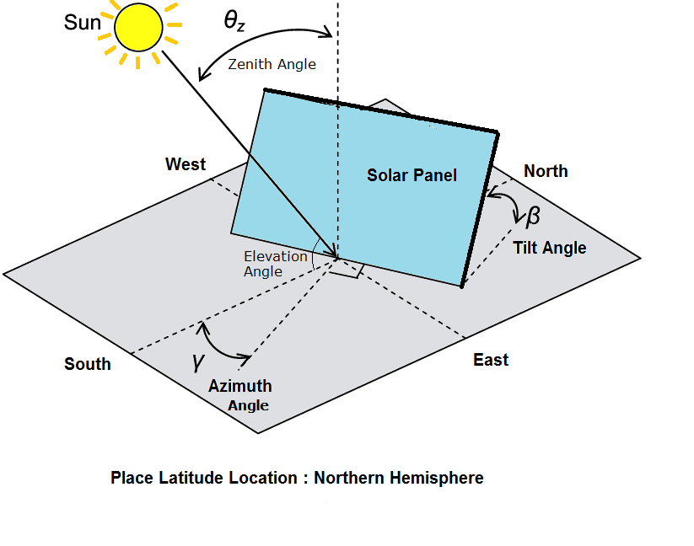
Figure 8. Azimuth angle and tilt angle of a solar panel (GoGreenSolar, 2021)

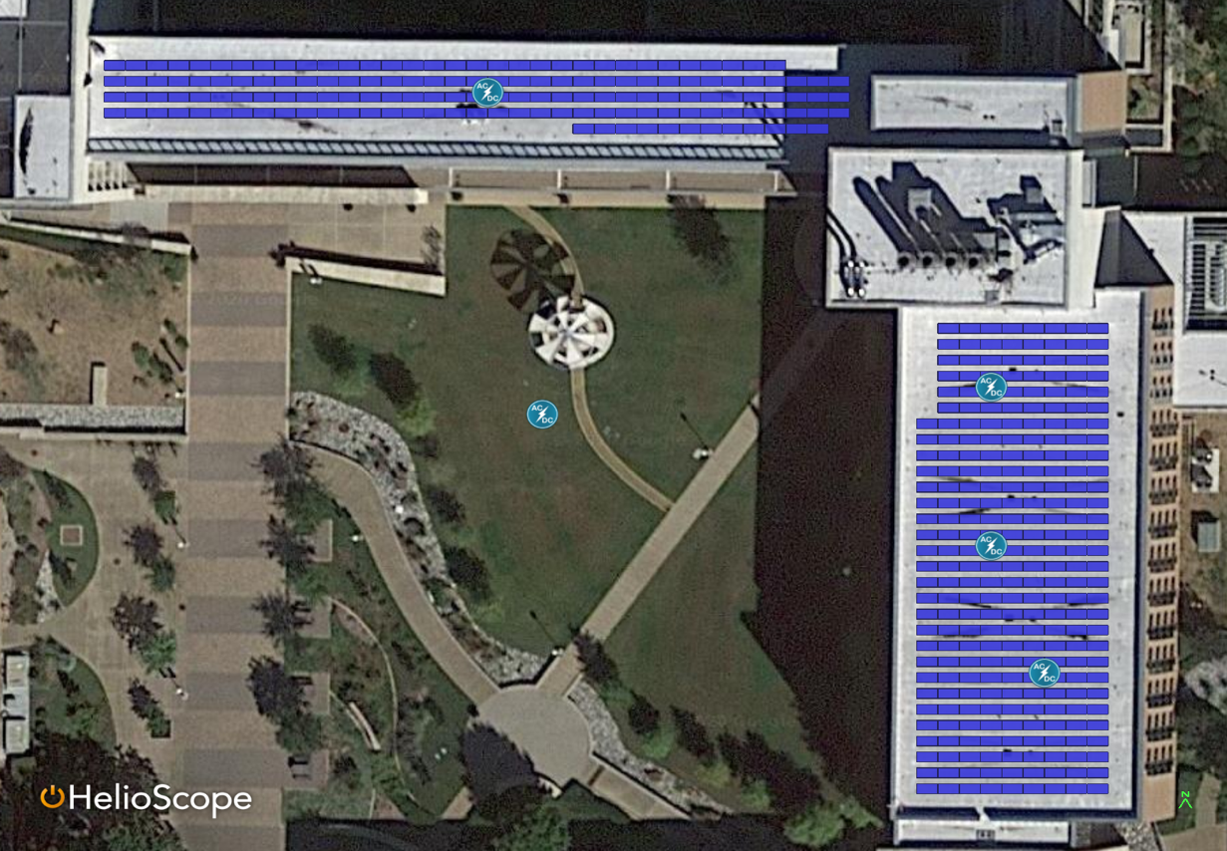
Figure 9. Aerial photo with designed solar panels at ERB
The panels were set at various angles from 0° up to 90° to find the best possible energy output from each panel. After trial and error, it was found that a fixed tilt (10°) for maximum power output. A 0-degree angle was better in energy output, but the number of panels were reduced in this design thereby reducing the overall solar energy output. The 90-degree angle also had a good energy output but there should be a double panel design to accomplish this design.
The fourteen (14) buildings chosen for the study were selected based on the total available roof area and the building’s assumed electricity consumption. The major buildings with extensive classroom and laboratory activity and greater building space were considered. The buildings were also selected based on their height; it was assumed that there will be greater solar insolation in high rise buildings due to less tree cover over the roof tops.
Investment, savings, and years for return: The investment was calculated based on costs of the solar panel module, wiring material, and inverter. This calculation was determined by a manual method because the software does not give any investment outputs. According to investment tax credit, 22% of the investment will be returned as tax credits and rebates for both commercial and residential solar powered buildings⁸. Factors such as labor and installation were excluded because they are variable according to the contractor and type of materials used. Maintenance costs were also excluded.
Annual savings were calculated based on the average electric rates in Tarrant County, Texas according to UTA’s geographic location. The average electric rates were multiplied by the expected power output from the solar panels. Total returns were calculated based on the number of years taken for the annual savings to reach the capital investment for each building.
There was an interest calculation performed for the investment based on engineering economics. The investment was subdivided into 1 year and a fraction of the second year. The interest rate was assumed to be 5% of the principal investment on the solar panels.

5.1.3 Results
Table 8 summarizes results of the evaluation of installing solar panels on 14 buildings at UTA. The installation would reduce annual GHG emissions by 3301 MTCDE, which is 6.4% of Indirect Campus Emissions due to electricity consumption (Scope 2). The investment would cost $2.9 million, but would save $1.6 million annually in electricity costs, for a pay-back time of 1.7 years.

Table 8. Analysis of solar panel installation on UTA rooftops
Building | Area  (ft²) | Power output (MWh) | Number of solar modules | Annual savings ($) | Investment  ($) | Investment at the end of returns year (5% interest)  ($) | Total years for return | Total reduction in MTCDE | Percent reduction in UTA’s emissions due to purchased electricity
Aerodynamics Building | 9,154 | 82 | 164 | 28,872 | 36,111 | 38475 | 1.3 | 58.5 | 0.11%
UTA Bookstore | 12,076 | 108 | 215 | 37,800 | 72,136 | 79143 | 1.9 | 76.5 | 0.15%
Davis Hall | 11,937 | 109 | 217 | 38,045 | 72,867 | 79945 | 1.9 | 77.2 | 0.15%
University Center | 58,813 | 673 | 1344 | 235,445 | 408,978 | 444347 | 1.7 | 477 | 0.92%
Engineering Research Building | 25,699 | 256 | 512 | 89,635 | 182,576 | 201290 | 2.0 | 181 | 0.35%
Mavericks Activity Center Swimming pool | 22,320 | 210 | 424 | 73,465 | 131,948 | 144061 | 1.8 | 149 | 0.29%
Mavericks Activity Center | 107,185 | 1189 | 2387 | 416,150 | 719,094 | 781281 | 1.7 | 843 | 1.63%
Science & Engineering Innovation & Research Building | 42,233 | 511 | 1020 | 178,850 | 305,283 | 331684 | 1.7 | 362 | 0.70%
The Commons at UTA | 14,280 | 154 | 305 | 53,725 | 99,765 | 109456 | 1.9 | 109 | 0.21%
UTA College of Nursing and Health Innovation | 29,824 | 229 | 456 | 80,010 | 137,507 | 149398 | 1.7 | 162 | 0.31%
UTA Business Building | 18,502 | 190 | 378 | 66,570 | 123,744 | 135763 | 1.9 | 135 | 0.26%
UTA Central Library | 28,906 | 250 | 497 | 87,360 | 156,078 | 170405 | 1.8 | 177 | 0.34%
UTA Testing Building | 31,877 | 352 | 770 | 123,340 | 238,167 | 261301 | 1.9 | 249 | 0.48%
Wolf Hall UTA | 27,013 | 346 | 628 | 120,960 | 202,572 | 220090 | 1.7 | 245 | 0.47%
Total | 439,819 | 4,659 | 9,317 | 1,630,226 | 2,886,826 | 3,146,640 | 1.7(Average) | 3301.2 | 6.37%

5.2 Afforestation at UTA
5.2.1 Idea:
Afforestation would involve introducing trees and tree seedlings to UTA's areas that have previously not been forested. Studies also show that planting trees near buildings will reduce energy consumption due to the cooling effect the trees provide during summers. Trees also will reduce noise pollution to an extent, along with dust and soot damage to building paints.
5.2.2 Method:
The current afforestation area available and current distribution of various geographical information such as roads, building area, soil/ground, trees, and grass at UTA was approximated with the help of i-tree canopy (https://canopy.itreetools.org/). I-tree canopy estimates tree cover and tree benefits for a given area with a random sampling process that classifies ground cover types. i-Canopy tree used around 1000 sampling points (shown in Figure 10) inside the input boundary and determined what cover was present at each exact location.

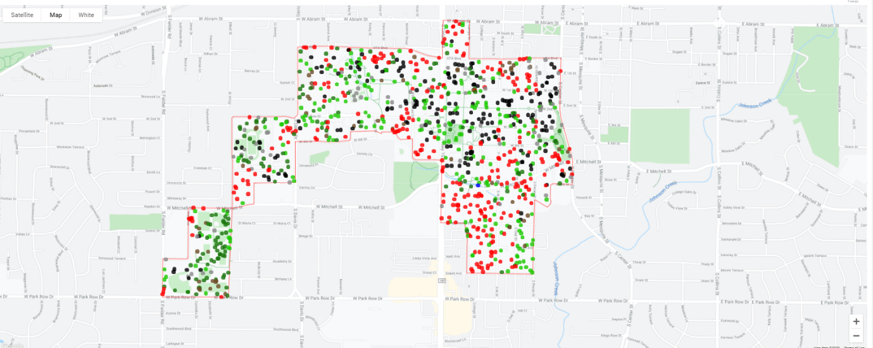Figure 10. i-Canopy tree sampling points at UTA
Note - Colors in Figure 10 are based on the legend provided in Figure 11.

5.2.3 Results
Table 9 and Figure 11 present i-tree canopy results for UTA. The top two cover categories are impervious roads, which include both asphalt roads and concrete pavements, and tree/shrubs. Using the tree/shrub cover areas from Table 9, i-Canopy tree determined the annual carbon sequestration and its monetary value, as shown in Table 10.

Table 9. Cover areas based on i-canopy outputs using 2019 UTA total GSF area
Type of cover | Total geographic points taken | Percent of cover | Cover area at UTA (square feet)
Grass/Herbaceous | 155 | 15.5% | 1,131,389
Impervious Buildings | 193 | 19.2% | 1,408,927
Impervious Other | 70 | 7.0% | 511,139
Impervious Roads | 292 | 29.1% | 2,131,699
Soil/Bare Ground | 52 | 5.2% | 379,327
Tree/Shrub | 240 | 23.9% | 1,752,372

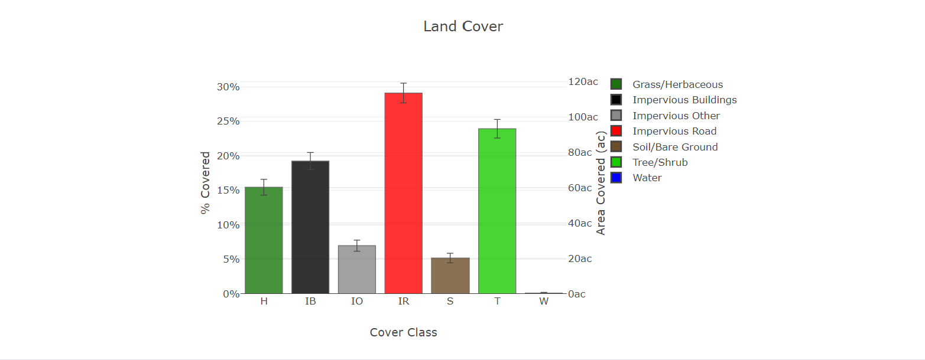Figure 11. Cover distribution at UTA

Table 10. Estimated tree benefits - carbon
Description | Carbon (tons) | CO₂ Equiv. (tons ) | Value (USD)
Sequestered annually in trees | 127 | 467 | $10,869
Stored in trees (Note: this benefit is not an annual rate) | 3,201 | 11,737 | $272,972
Notes: Currency is in USD and rounded. Standard errors of removal and benefit amounts are based on standard errors of sampled and classified points. Amount sequestered is based on 1.365 T of Carbon, or 5.005 T of CO₂, per ac/yr and rounded. Amount stored is based on 34.281 T of Carbon, or 125.697 T of CO₂, per ac and rounded. Value (USD) is based on $85.28/T of Carbon, or $23.26/T of CO₂ and rounded. (English units: tons (2,000 pounds), ac = acres)

In addition to estimating carbon sequestration, i-Canopy tree uses the tree/shrub cover area to estimates the amount of traditional air pollutants - carbon monoxide, nitrogen dioxide, ozone, sulfur dioxide, particulate matter (PM) 10 and PM 2.5 - removed from atmosphere. Maximum removal was estimated for ozone and PM 10, as shown in Table 11. Breathing elevated concentrations of ozone can trigger a variety of responses, such as chest pain, coughing, throat irritation, and airway inflammation. It also can reduce lung function and harm lung tissue. Ozone can worsen bronchitis, emphysema, and asthma, leading to increased medical care. PM10 is small enough to penetrate deep into the lungs. These particles can adversely impact respiratory and cardiovascular systems.

Table 11. Estimated tree benefits - traditional air pollution
Abbreviation | Air Pollutant | Amount removed annually (lb) |  | Value (USD)
 |  | Mean | Standard Error | Mean | Standard Error
CO | Carbon Monoxide | 96 | 5 | $47 | $3
NO₂ | Nitrogen Dioxide | 493 | 28 | $105 | $6
O₃ | Ozone | 4,289 | 241 | $3,542 | $199
SO₂ | Sulfur Dioxide | 122 | 7 | $8 | $0
PM10* | Particulate Matter <10 microns | 968 | 55 | $2,185 | $123
PM2.5 | Particulate Matter <2.5 microns | 167 | 9 | $4,301 | $242
Total |  | 6,136 | 345 | $10,188 | $574

Notes: Currency is in USD and rounded. Standard errors of removal and benefit amounts are based on standard errors of sampled and classified points. Air Pollution Estimates are based on these values in lb/ac/yr @ $/lb/yr and rounded:
CO 1.033 @ $0.49 | NO₂ 5.280 @ $0.21 | O₃ 45.936 @ $0.83 | SO₂ 1.308 @ $0.07 | PM10* 10.366 @ $2.26 | PM2.5 1.793 @ $25.70 (English units: lb = pounds, ac = acres)

i-Canopy tree also estimates avoided runoff as well as other hydrological values, as shown in Table 12. The avoided runoff is the water runoff used by the trees. i-Canopy tree provides a monetary value only for avoided runoff and not for other factors like evaporation, interception, transpiration, potential evaporation and potential evapotranspiration.

Table 12. Estimated annual tree benefits - Hydrological
Abbreviations | Benefits | Amount (kgal) | ±SE | Value (USD) | ±SE
AVRO | Avoided Runoff | 994 | ±56 | $8,886 | ±500
E | Evaporation | 4632 | ±261 | N/A | N/A
I | Interception | 4632 | ±261 | N/A | N/A
T | Transpiration | 24,866 | ±1,400 | N/A | N/A
PE | Potential Evaporation | 81,572 | ±4,592 | N/A | N/A
PET | Potential Evapotranspiration | 63,453 | ±3,572 | N/A | N/A
Note Table 12: Currency is in USD and rounded. Standard errors of removal and benefit amounts are based on standard errors of sampled and classified points. Hydrological Estimates are based on these values in kgal/ac/yr @ $/kgal/yr and rounded:
AVRO 10.650 @ $8.94 | E 49.602 @ N/A | I 49.602 @ N/A | T 266.294 @ N/A | PE 873.575 @ N/A | PET 679.535 @ N/A (English units: kgal = thousands of gallons, ac = acres)

6.0 Conclusions and Future Work
6.1 Conclusions
- The major contributors to UTA’s 2019 GHG emissions were:
- Indirect Campus Emissions (electricity consumption): 51%,
- Indirect Transportation Emissions (e.g. commuting): 27%,
- Direct Campus Emissions (e.g. stationary fuel): 21%.
- UTA’s 2019 emissions were 2.0 metric tons of carbon dioxide equivalents (MTCDE) per full-time equivalent (FTE) student, which compares favorably with other universities. Emissions for 8 other universities world-wide ranged from 1.5 to 36.4 MTCDE per FTE student, with an average of 11.7.
- UTA emissions decreased from 2017 to 2019, despite increased student enrollment and a 7% increase in building area. Although UTA consumption of electricity increased during this period, emissions from electricity decreased, due to reduced coal generation and increased wind power. In addition, emissions from commuting decreased, due to a 9% increase in on-line enrollment, coupled with a 6% decrease in on-campus enrollment.
- The transportation survey found that 38% of students use carbon-free modes, compared to an estimated 100% carbon-based mode of commute by faculty.
- Several options were explored for reducing emissions from electricity consumption, the major contributor to GHG emissions at UTA. It was found that implementation of solar panels on 14 major UTA buildings would reduce emissions due to purchased electricity by 6.32%. The initial investment would pay for itself in savings in 1.7 years.
- It was found that about 23.9% of UTA’s campus is covered with trees, which absorb 467 tonnes of CO₂ emissions annually. Traditional air pollutants are also removed, providing an estimated $10,000 in benefits. UTA’s trees also provide benefits of almost $9000 per year in terms of avoided runoff. Planting the 20.7% of UTA’s land currently covered by soil or grass would approximately double the tree benefits at UTA.

6.2 Recommendations for future work
Future work will examine emissions reductions due to the COVID 2019 pandemic in 2020 and 2021 at UTA.
The Office of Sustainability is formulating its own Excel-based software to aid in tracking UTA carbon emissions in the coming years. Emission factors will be taken from the US Environmental Protection Agency (EPA) and other appropriate sources. The software will be based on Excel and will be stored online for all departments like the Office of Facilities Management and the Office of Sustainability to input data on a monthly basis. Results will be presented in user-friendly tables and graphs.

- References
Alghamdi, Abdulaziz; Haider, Husnain; Hewage, Kasun; Sadiq, Rehan. (2019). “Inter-University Sustainability Benchmarking for Canadian Higher Education Institutions: Water, Energy, and Carbon Flows for Technical-Level Decision-Making.” Sustainability. 1-26. 10.3390/su11092599.
GoGreenSolar. (2019). “Optimize your solar production,” https://blog.gogreensolar.com/2019/07/optimize-your-solar-production.html, accessed 4/21.
Icopal- noxite. (2011). “Nitrogen oxide (NO_{x} ) Pollution.” http://www.icopal-noxite.co.uk/nox-problem/nox-pollution.aspx, accessed 3/21.
Keystone 10 Million Trees Partnership. (n.d.) “All about Trees,” http://www.tenmilliontrees.org/trees/ , acessed on 3/23/2021.
Pablo Yañez, A. S. (2020). "Carbon Footprint Estimation in a University Campus: Evaluation and Insights." Sustainability, Vol. 2, p. 3.
United Nations Environment Programme. (2019). "Why nitrogen management is key for climate change mitigation," https://www.unep.org/news-and-stories/story/why-nitrogen-management-key-climate-change-mitigation, accessed on 03/07/2021.
U.S. Department of Energy. (2020.) "Homeowner’s Guide to the Federal Tax Credit for Solar Photovoltaics," https://www.energy.gov/sites/prod/files/2020/01/f70/Guide%20to%20Federal%20Tax%20Credit%20for%20Residential%20Solar%20PV.pdf, acessed on 4/17/2021.

References for SIMAP software tool
Alaska Climate Research Center
Annual Energy Review 2004. Energy Information Administration, U.S (United States). Department of Energy. Appendix A
Annual Energy Review 2005. Energy Information Administration, U.S. Department of Energy.
Definitions for the types of paper: Paper-Types.pdf [12/7/2018]
Draft Inventory of U.S. Greenhouse Gas Emissions and Sinks: 1990-2006. February 2008. Annex 2, page A-43, Table A-32.
Draft Inventory of U.S. Greenhouse Gas Emissions and Sinks: 1990-2006. February 2008. Annex 3, page A-98, Table A-70.
Draft Inventory of U.S. Greenhouse Gas Emissions and Sinks: 1990-2006 (February 2008); Section 8.2, p8-8 - 8-9
Draft Inventory of U.S. Greenhouse Gas Emissions and Sinks: 1990-2006 (February 2008); Section 8.2, p8-13 - 8-14
Emissions and Generated Resource Integrated Database (eGRID), Data Years 1996-2000, Version 2.01. US EPA Office of Atmospheric Programs. Prepared by E.H. Pechan & Associates, Inc.
Emissions and Generated Resource Integrated Database (eGRID2010), Data Year 2007, Version 1.1. US EPA Office of Atmospheric Programs.
Energy Tips #15, Office of Industrial Technologies, U.S. Department of Energy.
Environmental Defense Fund Paper Calculator. Online at http://www.edf.org/papercalculator/ accessed 4/26/2008
For 1990-2013 used the Annual Round-Trip Fares and Fees: (Domestic, International) chart. Years between 2005 and 2017, from Statistica.
GREET Model 1.5a, Argonne National Laboratory, US (United States) Department of Energy
Hawaii State Climate Office
Historical Climatological Series 5-1 and 5-2: State-population weighted heating and cooling degree days (base 65 Deg F)
Inventory of U.S. Greenhouse Gas Emissions and Sinks: 1990-2001 (April 2003) EPA 430-R-03-004; Annex E
Inventory of U.S. Greenhouse Gas Emissions and Sinks: 1990-2001 (April 2003) EPA 430-R-03-004; Annex L & M
Inventory of U.S. Greenhouse Gas Emissions and Sinks: 1990-2001 (April 2003) EPA 430-R-03-004; Annex N
Inventory of U.S. Greenhouse Gas Emissions and Sinks: 1990-2005 (April 2007) EPA 430-R-07-002; Annex 6.1 Table A-228
Inventory of U.S. Greenhouse Gas Emissions and Sinks: 1990-2005 (April 2007) USEPA #430-R-07-002; Annex 5, A-279
IPCC (Intergovernmental Panel on Climate Change) 4th Assessment Report
IRS (Internal Revenue Service) Business Milage Reimbursement Rate
Solid Waste Management and Greenhouse Gases: A Life-Cycle Assessment of Emissions and Sinks. 3rd EDITION, September 2006. Section 5, page 70, show 5-1.
Solid Waste Management and Greenhouse Gases: A Life-Cycle Assessment of Emissions and Sinks, 3rd EDITION, September 2006, Section 4
Solid Waste Management and Greenhouse Gases: A Life-Cycle Assessment of Emissions and Sinks. 3rd EDITION, September 2006. Section 5, page 70, exhibit 5-1.
Solid Waste Management and Greenhouse Gases: A Life-Cycle Assessment of Emissions and Sinks, 2nd EDICTION, EPA530-R-02-006, May 2002
Solid Waste Management and Greenhouse Gases: A Life-Cycle Assessment of Emissions and Sinks, 2nd EDICTION, EPA530-R-02-006, May 2002
The Climate Registry, General Reporting Protocol, v1.1 Accessed 11/08
The Climate Registry, General Reporting Protocol, v1.1 Accessed 11/08
U.S. Bureau of Economic Analysis, National Income and Product Accounts Tables, Table 1.1.9 Implicit Price Deflators for Gross Domestic Product
U.S. Data projections. Industrial sector national forecasted energy prices. US Department of Energy, Energy Information Administration, Annual Energy Outlook, 2007, Supplemental Tables, Table 3. (Values for 2000-2003 are taken from AEOs 2003-2006)
U.S. Department of Energy, Energy Information Administration, Annual Energy Review, Table 8.4.b - Consumption for Electricity Generation by Energy Source: Electric Power Sector, 1949-2006
U.S. Department of Energy, Office of Energy Efficiency and Renewable Energy, Alternative Fuel Price Reports, May 2000 - October 2007
U.S. Department of Transportation, Bureau of Transportation Statistics, National Transportation Statistics 2005. BTS05-08
U.S. Department of Transportation, Bureau of Transportation Statistics, National Transportation Statistics 2002. BTS02-08 (4-20)
U.S. Energy Information Administration, Annual Energy Outlook 2007, Year-by-Year Reference Case Tables, Table 19 Macroeconomic Indicators
United States Department of Commerce, National Institute of Standards and Technology, Guide for the Use of the International System of Units (SI)
Updated State-level Greenhouse Gas Emission Coefficients for Electricity Generation 1998-2000. Energy Information Administration, Office of Integrated Analysis and Forecasting, Energy Information Administration, U.S. Department of Energy, April 2002
Updated State-level Greenhouse Gas Emission Coefficients for Electricity Generation 1998-2000. Energy Information Administration, Office of Integrated Analysis and Forecasting, Energy Information Administration, U.S. Department of Energy, April 2002
Updated State-level Greenhouse Gas Emission Coefficients for Electricity Generation 1998-2000. Energy Information Administration, Office of Integrated Analysis and Forecasting, Energy Information Administration, U.S. Department of Energy, April 2002

Appendix A
Table A.1. Descriptions of terminologies
Terminology | Description
Gross MTCDE | Total greenhouse gas (GHG) emissions including all activities at UTA
Offsets MTCDE | A GHG emissions offset is a reduction in emissions of carbon dioxide or other greenhouse gases made to compensate for emissions made elsewhere.
Compost MTCDE | GHG emissions due to composting
Non-Additional Sequestration (MTCDE) | Change in GHG emissions due to carbon capture at UTA
Biogenic (MTCDE) | Biogenic emission sources are emissions that come from natural sources, mainly due to natural occurrences like combustion, harvest, digestion, fermentation, decomposition, or processing of biologically based materials.
Net MTCDE | The remaining GHG emissions after all offsets are deducted from the gross GHG emissions.
FTE student | A measurement equal to one student enrolled full time for one academic year. Total FTE enrollment includes full time plus the calculated equivalent of the part-time enrollment. For example, two half-time students add up to one FTE student.

Appendix B
Terminology used in this Appendix are described in Appendix A
Table B.1. Net metric tonnes of carbon dioxide emissions per gross square foot at UTA
Fiscal year | Net MTCDE per GSF
2010 | 0.01445
2016 | 0.01266
2017 | 0.01606
2018 | 0.01448
2019 | 0.01384

Table B.2 Overall GHG emissions per FTE in-class student
Fiscal Year | CO₂ (kg) | CH₄ (kg) | N₂O (kg) | Gross MTCDE | Offsets MTCDE | Compost MTCDE | Non-Additional Sequestration (MTCDE) | Biogenic (MTCDE) | Net MTCDE
2017 | 2,098 | 0 | 0 | 2.13 | 0 | 0 | 0 | 0 | 2.13
2018 | 1,969 | 0 | 0 | 1.99 | 0 | 0 | 0 | 0 | 1.99
2019 | 2,009 | 0 | 0 | 2.03 | 0 | 0 | 0 | 0 | 2.03

Table B.3 Overall GHG emissions per weighted population
Fiscal Year | CO₂ (kg) | CH₄ (kg) | N₂O (kg) | Gross MTCDE | Offsets MTCDE | Compost MTCDE | Non-Additional Sequestration (MTCDE) | Biogenic (MTCDE) | Net MTCDE
2017 | 3,111 | 0 | 0 | 3.15 | 0.00 | 0.00 | 0.00 | 0.00 | 3.15
2018 | 3,044 | 0 | 0 | 3.08 | 0.00 | 0.00 | 0.00 | 0.00 | 3.08
2019 | 3,142 | 0 | 0 | 3.18 | 0.00 | 0.00 | 0.00 | 0.00 | 3.18

Table B.4 GHG emissions for Stationary fuel (1), Electricity and energy consumption (2), and Commute fuel (3) at UTA
Fiscal year | Stationary fuel (1) | Electricity and energy consumption (2) | Commute fuel (3) | Total emissions
 | In MTCDE | In MTCDE | In MTCDE | In MTCDE
2005 | 25,522 | 58,456 | N/A | 83,978
2010 | 21,092 | 54,857 | N/A | 75,949
2016 | 21,079 | 60,032 | N/A | 81,112
2017 | 18,059 | 54,386 | 31,479 | 103,924
2018 | 19,832 | 51,134 | 27,671 | 98,637
2019 | 22,052 | 51,801 | 27,467 | 101,319
2020 (Forecast) | 23,991 | 50,002 | 24,995 | 98,987
2021 (Forecast) | 25,970 | 48,553 | 22,846 | 97,369
2022 (Forecast) | 27,948 | 47,105 | 20,697 | 95,751

