CAPPA Spring 2017 Graduates
May 12, 2017
The College of Architecture, Planning and Public Affairs is proud to announce its graduating class for Spring 2017.

Doctoral Dissertations
Saad Alquhtani - UPPP
Chair: Dr. Ard Anjomani
Dissertation: Socioeconomic and Spatial Impacts of Rail Transit Stations on the Surrounding Areas in Dallas-Fort Worth Metropolitan Area
Mohamed Bireima - UPPP
Chair: Dr. Rod Hissong
Dissertation: The Cultural Advantage of Cities: Exploring the Cultural Industries as a Source for Economic Growth
Victor U. Ibewuike - UPPP
Chair: Dr. Ard Anjomani
Dissertation: Improving Public Transit Services: Does Collaborative Transit Services Among Public Transit Providers Make Them More Efficient?
Zoranna Jones - PUAD
Chair: Dr. Colleen Casey
Dissertation: African Americans, STEM, and Entrepreneurship: Factors that Influence African Americans to Pursue Entrepreneurship
Sajjadieh Khajouei - UPPP
Chair: Dr. Rod Hissong
Dissertation: Urban Form and Social Sustainability in Neighborhood-Level
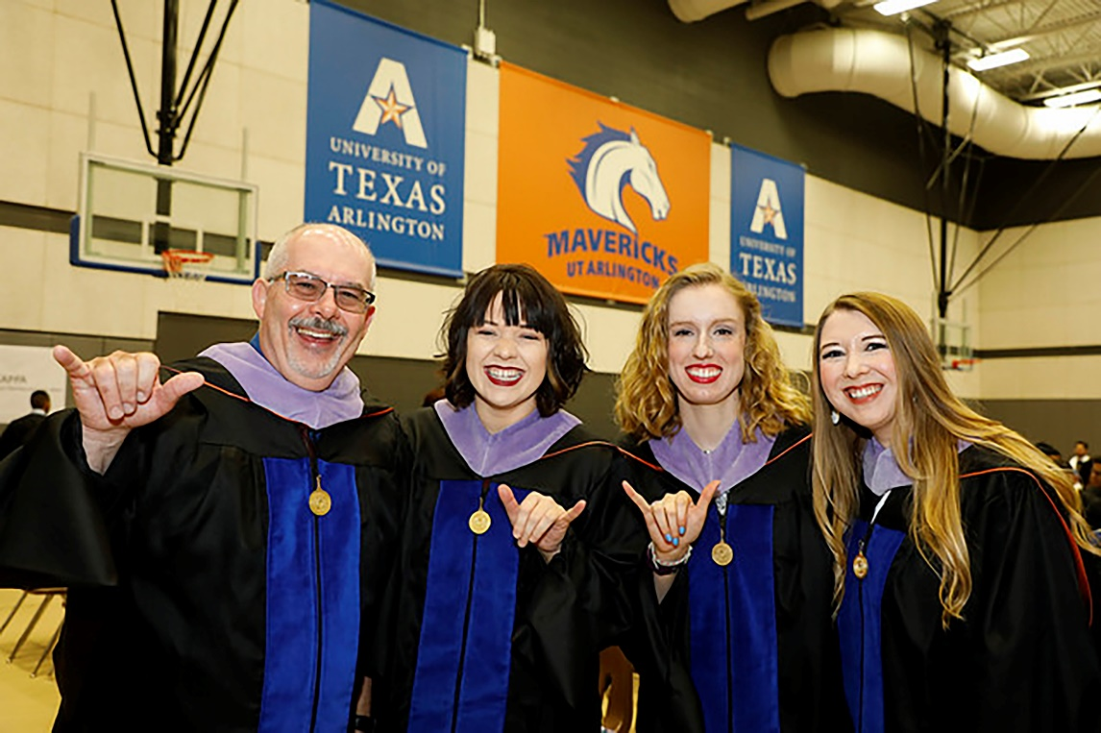

Graduates

School of Architecture
Luis Aguirre – BS. ARCH
Mujtaba Ahmad – BS. ARCH
Sergio Alvarado – BS. ARCH
Alla Alzaitoun – M.ARCH
Collin Anderson – BS. ARCH
Halima Arevalo – M.ARCH
Justin Ashby – BS. ARCH
Sandra Benitez – BS. ARCH
Joseph Boring – M.ARCH
Alexander Bowman – BS. ARCH
Braison Boykin – BS. ARCH
Joshua Brown – M.ARCH
Jason Butsko – M.ARCH
Jennifer Callejas – BS. ARCH
Daniela Cantu – M.ARCH
Deisy Carrasco – BS.ARCH
Jesus Cortes – BS.ARCH
Carlos Cutting – M.ARCH
Afnan Dahduli – BS.INTD
Robert Driskill – BS.ARCH
Ikram Eloualid – M.ARCH
Efren Estrada – M.ARCH
Tajiri Fernandez – BS.ARCH
Marcus Finneburgh – BS. ARCH
Adam Fogel – BS.ARCH
Maura Forno – BS.INTD
Zachary Frost – BS.ARCH
David Garcia – M.ARCH
Christian Gentry – BS.ARCH
Glenn Grant – M.ARCH
Julia Green – M.ARCH
Erik Guerrero – BS.ARCH
Christopher Harkins – BS.ARCH
Heather Harris – M.ARCH
Brannon Heake – BS.ARCH
Matthew Heeter – BS.ARCH
Brandy Hensley – BS.INTD
Javier Hernandez – BS.ARCH
Elvie Ibarra – M.ARCH
Benjamin Jay – M.ARACH
Freddy Jove – BS.ARCH
Summer Kalahiki – BS.INTD
Stanislav Karmalyuk – BS.ARCH
Edlyn Laco – BS.INTD
Christopher Laskoski – M.ARCH
Tania Lecona – BS.ARCH
Fernando Longoria – BS.ARCH
Miquel Lopez – BS.ARCH
Daniel Luedecke – BS.ARCH
Erin Majors – BS.INTD
Ricardo Marin – M.ARCH
Saul Martinez – BS.ARCH
Madalyn Melton – BS.ARCH
Elio Mendez-Gonzalez – BS.ARCH
Cosette Meyer – BS.ARCH
Jordan Milner – BS.INTD
Shahabedin Mirtavousimahyari – BS.INTD
Antonio Molina Bendeck – BS.ARCH
Angela Monge – BS.ARCH
Jordan Moses – M.ARCH
Adrian Munoz – M.ARCH
Quan Ngo – BS.ARCH
Thuy Nguyen – M.ARCH
Yoonah Noh – BS.ARCH
Nicholas Oliver – M.ARCH
Jenny Ordonez – BS.ARCH
Jose Oviedo – BS.INTD
Kevin Park – BS.ARCH
Cesar Paulin – M.ARCH
Roja Rastegar – M.ARCH
Sadia Rattani – BS.INTD
Ana Reyes – M.ARCH
Andres Reyna Lipchak – M.ARCH
Jesse Rhodes – BS.ARCH
Garrett Rodriguez – M.ARCH
Stewart Schuetze – BS.ARCH
Prarthan Shah – BS.ARCH
Behrad Shahlaee – BS.ARCH
Omar Soto – BS.ARCH
Stephanie Sottana-Gatica – BS.INTD
Ugur Tan – BS.ARCH
Justin Thairintr – BS.ARCH
George Tobar – BS.ARCH
Roxanne Torres – BS.ARCH
Lam-Jonathan Tran – BS.ARCH
Jocelyn Valles – BS.ARCH
Oswaldo Valverde – BS.ARCH
Daniel Williams – BS.ARCH
Ying Zhang – BS.ARCH

Department of Planning and Landscape Architecture
Saad Alquhtani – UPPP
Mohamed Bireima – UPPP
Colby Collins – M.CRP
Robyn Curtis – M.CRP
Jory Dille – M.CRP
Leonelle D’Souza – M.CRP
Sherry Fabricant – M.LA
Victor U. Ibewuike - UPPP
Lindsay Jackson – M.CRP
Ayeh Sajjadieh Khajouei - UPPP
Chad Paulson – M.LA
Danielle Stellrecht – M.CRP
Amanda Van Wermeskerken – M.CRP
Anthony Wade – M.LA

Department of Public Affairs
Daniel Antwiler – M.PA
Floyd Burton – M.PA
Eric Clay – M.PA
Jason Cockerham – M.PA
Shawna Fields – M.PA
Sasha Greene – M.PA
Mellita Hayes – M.PA
Zoranna Jones – PUAD
Andrew Malkowski – M.PA
Lindsay Matthew – M. PA
Brittni McComb – M.PA
Kelly McWilliams – M.PA
Jessica Mock – M.PA
Julius Moss – M.PA
Rachelle O-Neil – M.PA
Onochie Onyegbule – M.PA
Annette Porterfield – M.PA
Rachel Reis – M.PA
Dannie Smith – M.PA
Amanda Valdez – M.PA
Whitney Vandiver – M.PA
Hillory White – M.PA
View video of the ceremony.
Congratulations to all our graduates, and the very best of luck with all your future endeavors!

