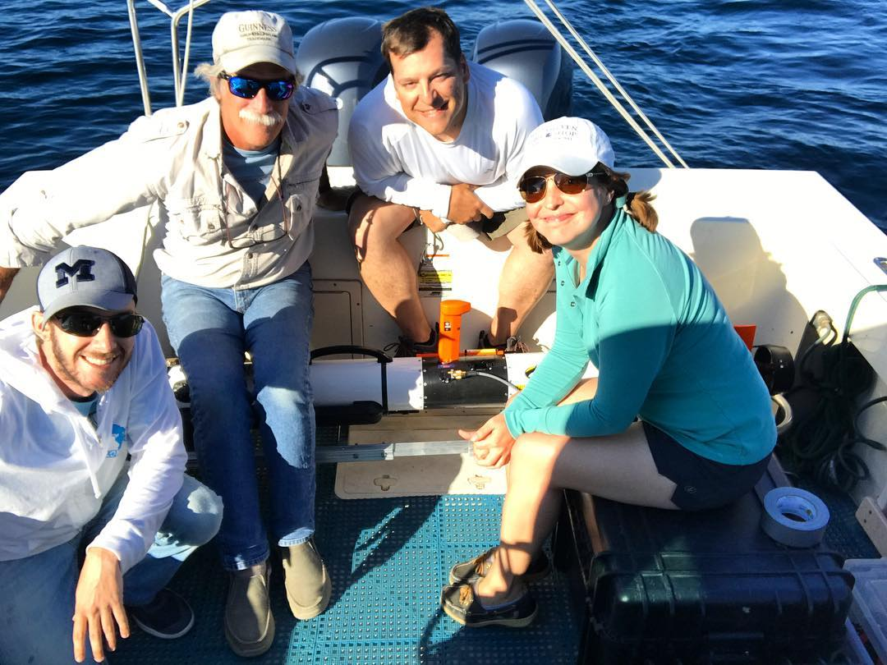
2021 Underwater Archaeology Fieldschool
Thunder Bay National Marine Sanctuary, Lake Huron, Alpena, Michigan
June 1 – 15
ANTH 4398, 3 Hours.

This fieldschool will take place in Alpena, Michigan in the Thunder Bay National Marine Sanctuary. Students will get the unique experience of underwater archaeological survey and exploration – and see firsthand how, where, and why archaeologists search underwater. This is an intensive training course in the methods of underwater and nautical archaeology. Through lectures and hands-on training students will gain experience in a series of techniques for surveying the sea floor, including sonar and remote operated vehicles. Students will also learn to identify, document, and map the remains of wooden shipwrecks.

While this class is concerned with submerged archaeological materials, student diving is not part of curriculum and as such no prior experience with SCUBA is required. Enrollment is limited.

Cost & Logistics:
Class will meet Monday-Saturday, June 1-15. Students will be staying in furnished townhouse style apartments at Alpena Community College. The cost per students will be 3 hours tuition (you will enroll in ANTH 4398 in the Summer 1st Five Weeks semester) + a $1200.00 course fee which includes all necessary archaeological equipment, food, and housing + travel (students will need to arrange travel to Michigan).

Deadlines:
Apply for the class by March 1st
Register for the class in MyMav and pay the $1200 course fee by May 15th

Payment by check required, make check out to: University of Texas at Arlington and write “Sociology/Anthropology” in the note section. Deliver to Mark Graves in the Sociology and Anthropology Front Office, UH 430.

Contact Professor Ashley Lemke for more information, or questions: ashley.lemke@uta.edu

Space is limited. Preference will be given to Anthropology majors, students with the most undergraduate hours, those who have taken Introduction to Archaeology, etc.

Department of Sociology and Anthropology
2021 Underwater Archaeological Field School, Michigan
June 1 - 15
ANTH 4398, 3 Hours

APPLICATION

Email to Dr. Lemke, ashley.lemke@uta.edu

First name:
Middle name:
Last name:
Birthdate:
Street Address:

City/State/Zip Code:
Email:
Phone:
Emergency Contact (Name, relationship to student, address, telephone number, email):

Dietary Restrictions:

Health (mental & physical) information (including any/all medications):

Sickness-accident insurance is required for participation in the field school. Provide your insurer’s name here and attach proof of insurance (scanned insurance card/policy):

Preparatory course work (Prior experience is not necessary, but list any/all anthropology or archaeology courses, fieldwork, or laboratory experience you have taken or conducted):

Please provide a personal statement of interest and experience in archaeology (200-500 words):

