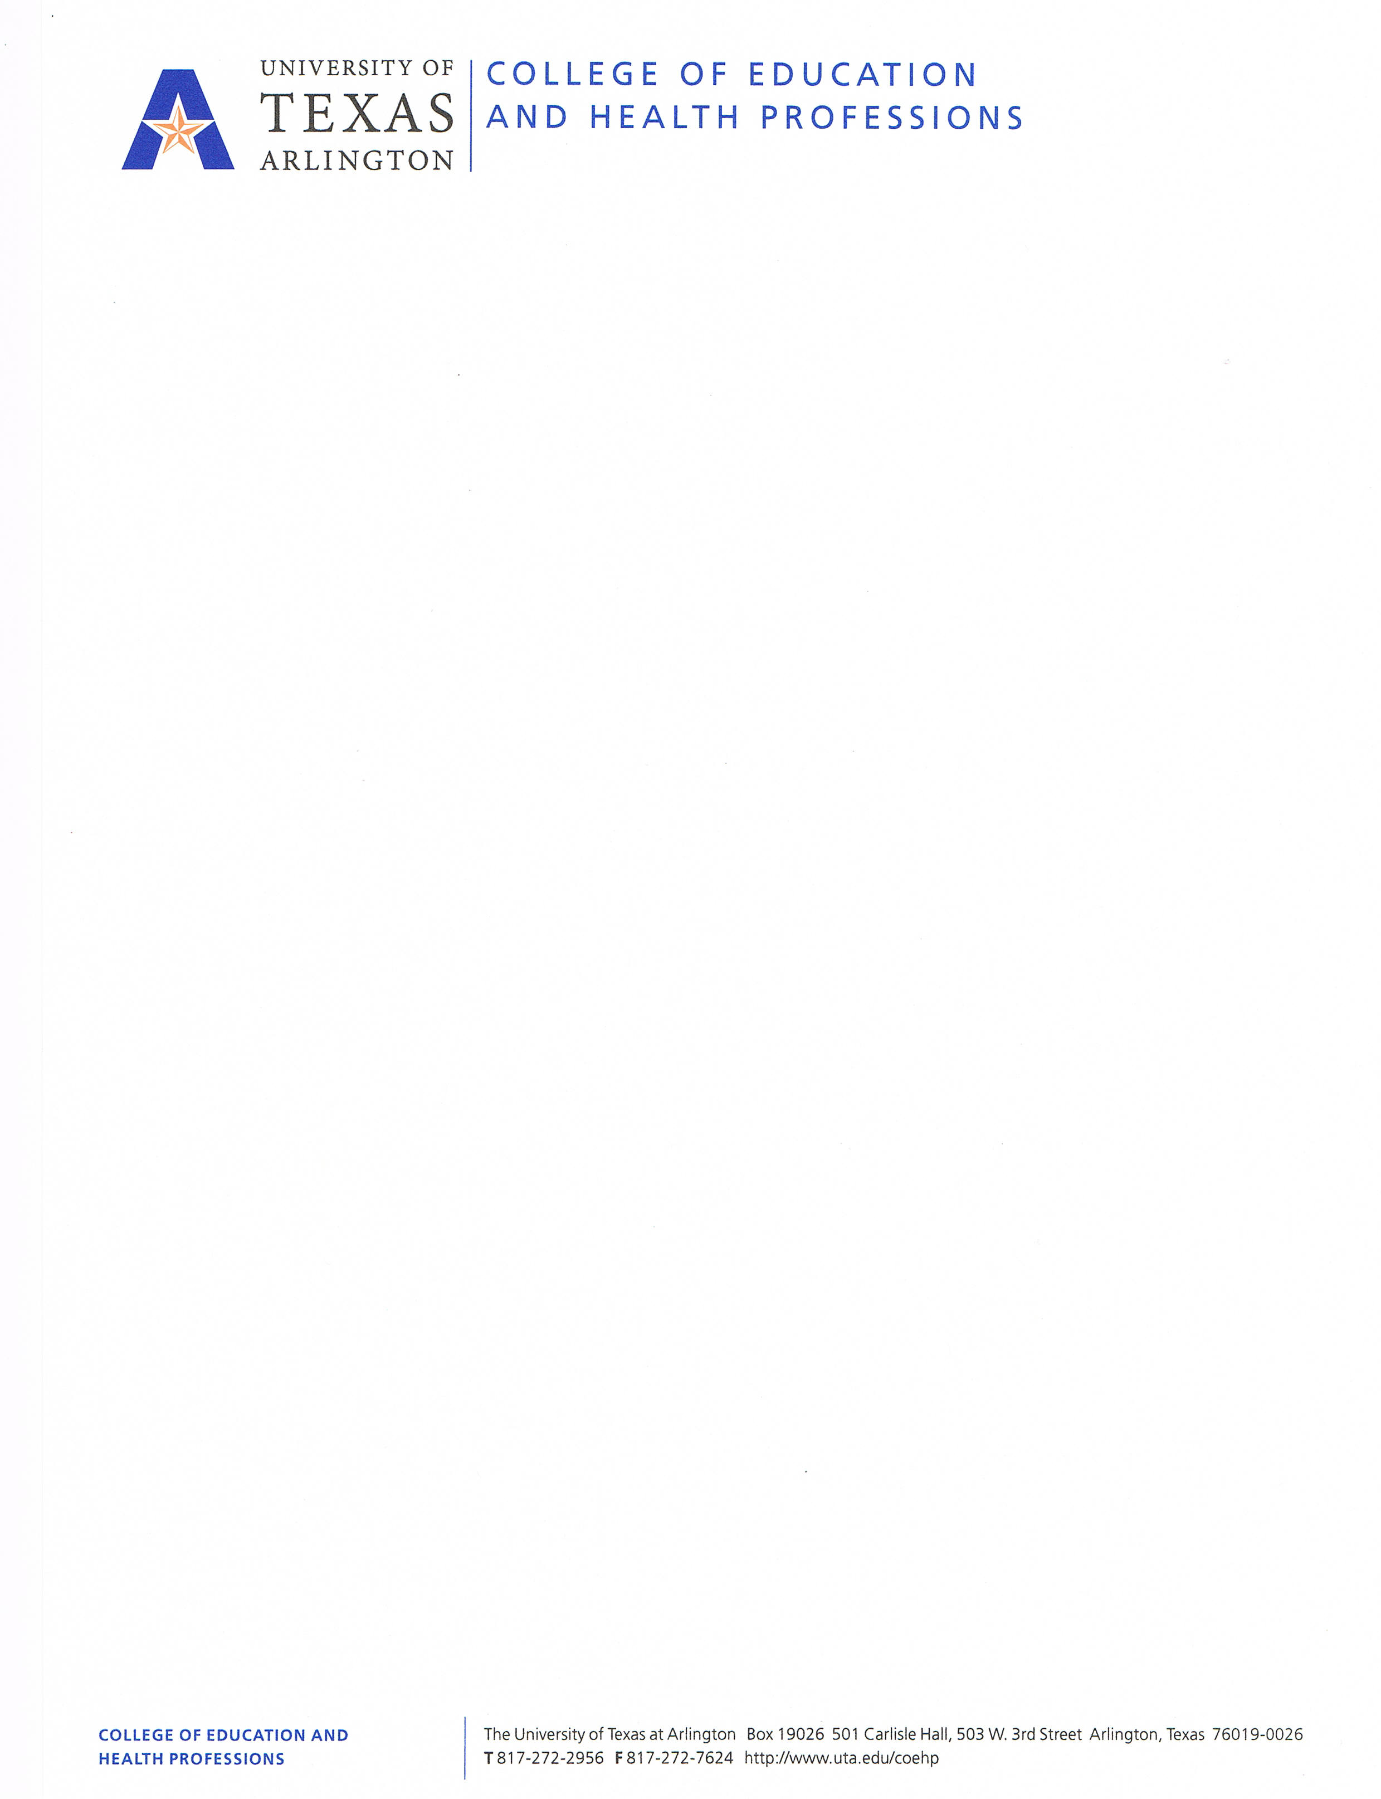

ORIENTATION CLEARANCE FORM
Students Entering the Education Program in Fall Cohorts

A copy of this form is available on the advising website: www.uta.edu/coehp/undergradadvising

NAME: ___________________________________________________________

10-DIGIT STUDENT ID: 1 0 0 ___ ___ ___ ___ ___ ___ ___

THESE ARE COURSES FOR WHICH YOU WILL BE GRANTED CLEARANCE AFTER ORIENTATION

EC-6 Generalist EC-6 Bilingual EC-6 Generalist/ESL Mid-Level
ELED 4317 BEEP 3381 BEEP 3381 EDML 4300
EDUC 4316 ELED 4317 ELED 4317 EDML 4350
EDTC 4301* EDUC 4316 EDUC 4316 LIST 4343*
LIST 4373* BEEP 4305 EDTC 4301* MATH 4350 if needed
LIST 4374* EDTC 4301* LIST 4373*
LIST 4376* LIST 4373* LIST 4376*
LIST 4376*

* These courses are optional for fall. You will be cleared to register for them, but you may choose
to wait to take them next spring or summer.

By signing this form, I acknowledge the following:
- I will be cleared to register within two (2) business days. The advisor leading the orientation session will send an e-mail notification once students are cleared.
- I will not be able to register until the date specified in my MyMav account.
- My clearance for the above courses is contingent upon my ability to meet and maintain the GPA, THEA and course completion standards set by the Education program as discussed at orientation and as stated on the reverse side of this form. My academic standing will be reassessed at the end of spring and summer.
- My clearance today is only for summer and fall, and I understand I must seek spring registration clearance later this year. Students will be able to request spring clearance either via the online Clearance Request Form or in an advising appointment later in the year.

SIGNATURE: _________________________________________________ DATE: _____________________

NOTE: If you are not able to register for your Education courses on your registration date, it is likely that MyMav is not recognizing your clearance. Simply empty your ‘shopping cart’ in MyMav, log off, then log back on before attempting to register again. Starting from scratch helps MyMav recognize your clearance. Please try this before contacting an advisor with registration problems.

THIS SECTION FOR ADVISOR ONLY

Education Program Policies & Procedures

GPA and THEA Requirements
- Students must have a minimum GPA of 3.0 (2.75 for students beginning education courses in, and before, Fall 2013) to be admitted to the Education program and must maintain a minimum GPA of 3.0 (or, 2.75 if Fall 2013 or before) once admitted to the program.
- The Education program may include courses taken for college credit at other institutions when calculating GPA for admission. Submitting official transcripts from all other colleges/universities attended will assist in the accurate calculation of GPA.
- Students must successfully complete each Education course with a grade of 'C' or better and must maintain a GPA of 3.0 (or, 2.75 if Fall 2013 or before) in Education coursework to continue in the program. Earning grades of 'D' or 'F' in Education courses or allowing the Education GPA to drop below 3.0 (or, 2.75 if Fall 2013 or before) will prevent students from taking further Education courses, other than to grade replace. Additionally, earning grades of 'Incomplete' in any Education courses will prevent students from continuing in the program until grades are assigned for the courses. Due to course sequencing, students may have to wait one year before taking Education courses again.
- Students must take the THEA exam and have scores equal to or higher than 270 Reading*, 230 Math and 220 Writing to be admitted into the Education program.

Probation, Dismissal and Suspension
- Students on academic probation at The University of Texas at Arlington will not be eligible to be admitted to the Education program.
- Students who have been suspended from The University of Texas at Arlington or any other university or program for reasons other than academic reasons may not be admitted or readmitted to an educator preparation program in the College of Education and Health Professions.
- Persons dismissed from any position in any public school district at any time before seeking admission to any Education program/degree may not be eligible to be admitted to the Education program. Additionally, dismissal from any position in any public school district at any time during the completion of a degree/program while in the Education program may be grounds for dismissal from the program.

Field Experience and Certification
- Field experience begins in the fall semester. Students must apply for placement by submitting an application to the Office of Professional Development in early Fall. Exact dates are given when fall classes begin.
- Students must have all core, content and pre-Field work Education courses completed before beginning their second year (Field Based Experience semester).
- Partnerships with specific school districts and schools have been established to host the College of Education and Health Professions student teachers. We work closely with specific schools to build strong mentoring relationships between teachers and students, and therefore place all students in partner school settings. Students are not able to select the district or school for their placement.
- Criminal History Background Checks are required for anyone participating in courses requiring placement in any school district. The inability to complete mandatory field experience due to a background check can prevent students from passing courses and continuing in the program. Students with questions regarding Criminal Record Checks should check online at the State Board website for more information: www.sbec.state.tx.us/SBECOnline/investdisc/faq.asp .
- Students must pass all appropriate state exams and wait for all appropriate grades and/or degrees to be posted before applying for state certifications with the State Board for Educator Certification/Texas Education Agency. Students must apply within six months of the completion of their residency/practicum/program before being certified to teach in the State of Texas.

Policies Specific to Education Majors: EC-6 Generalist, EC-6 Bilingual, Mid-Level
- Students may only have a certain number of core/content hours remaining when beginning the certification coursework sequence. The remaining core/content hours must be completed in the first year of the Education program before the Field Based Experience semester.
  - EC-6 Generalist: 12 hours; EC-6 Bilingual/ESL: 12 hours; Mid-Level: 18 hours
- Students may only begin the certification coursework sequence in the fall and cannot take classes out of the order given on their degree worksheet. The Education program takes two academic years to complete.
- Mid-Level: Students must maintain a minimum GPA of 2.75 in each of their content areas.

Student Responsibilities

It is the responsibility of advisors to effectively communicate to students Education program admission requirements, degree requirements, and university and Education program policies and procedures. They are available to answer questions through scheduled individual or group meetings and/or e-mail. They will assess your academic performance and monitor and accurately document your progress. With this in mind, please understand your responsibilities as a student, outlined below.

- Accept responsibility for your academic decisions, plans and progress.
- Be knowledgeable about university and Education programs, policies and procedures (www.uta.edu/catalog).
- Make contact with an advisor every semester for clearance. Clearance information is sent to the Listserv every semester.
- Understand that only in an appointment can your file be accurately evaluated to assess your academic progress.
- Come prepared to each appointment with questions or materials for discussion and ask questions if you do not understand an issue or have a specific concern.
- Read your UT Arlington e-mail and use it as the official means of communication with UT Arlington faculty and staff. Subscribe to the advising Listserv to receive important announcements and information: http://www.uta.edu/coehp/undergradadvising/.
- Enroll in the courses you and the advisor agreed upon based on your educational objectives.
- Follow through when referred to appropriate campus resources.
- Understand and accept COEHP Professional Dispositions: http://www.uta.edu/coehp/_downloads/dispositions.pdf

I understand and agree to abide by the Education program Policies, Procedures and COEHP PROFESSIONAL DISPOSITIONS. I am aware of my responsibilities as an Education student.

SIGNATURE: _________________________________________________ DATE: _____________________

