How to Access and Upload Student Feedback Surveys

Table of Contents
How to Access Your Student Feedback Surveys (SFS) 1
How to Upload Your SFS into DM 1

How to Access Your Student Feedback Survey (SFS)

- Login to SmartEvals
- Download the PDF of your SFS, including the student comments for the course you are trying to upload
- If you are missing a course(s) from your SFS reports, fill out this form here

How to Upload Your SFS into DM

- Login to DM
- Click on Activities in the blue bar across the top
- Select Scheduled Teaching, about halfway down the screen
- Then select the course you want to upload the SFS results into
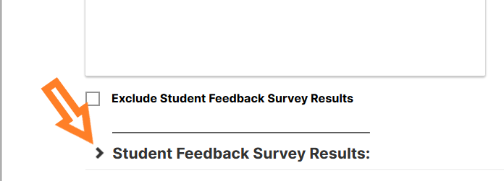
- Scroll to the very bottom of the screen and click on the arrow for the Student Feedback Survey Results

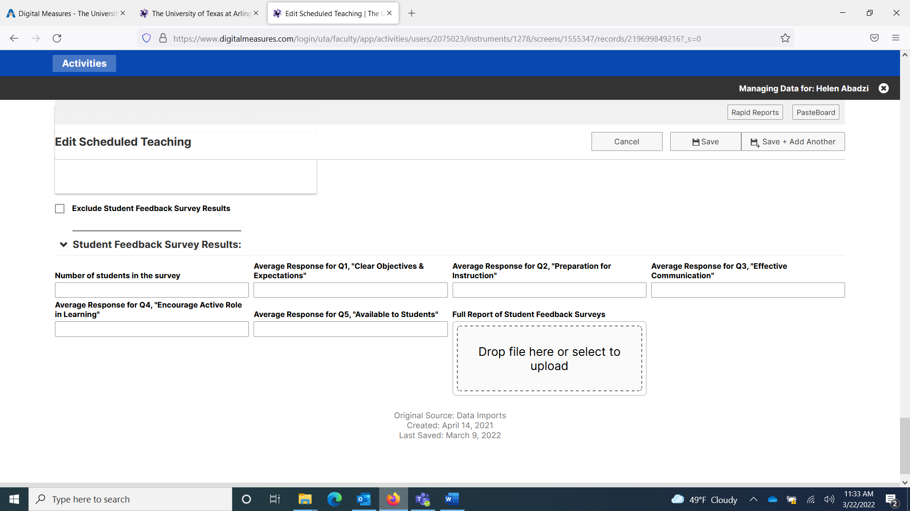
- Input your results into the correct fields, and then drag and drop the full report into the box

- Click Save at the top right-hand corner
