How to Upload Your CV into DM

Table of Contents
How to Upload Your CV 1

How to Upload Your CV

- Login to Digital Measures (DM)
- Click on Activities in the blue bar across the top
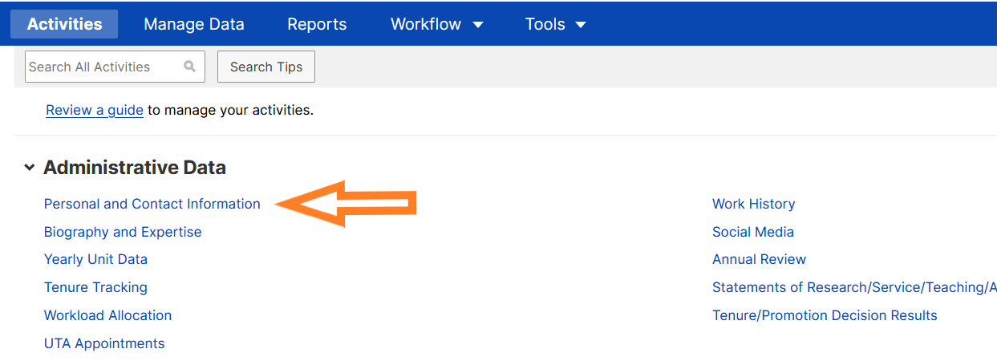
- Under Administration Data, click on Personal and Contact Information

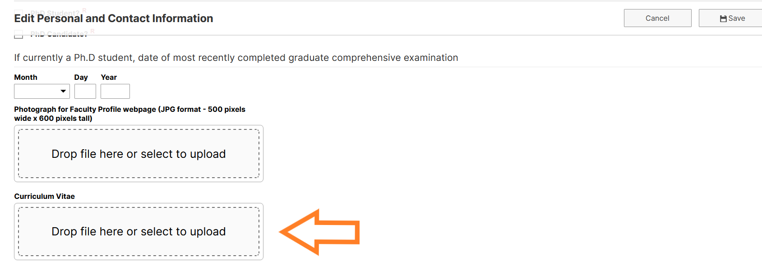
- Scroll down to the very bottom of the screen and upload your CV

- Click Save at the top right-hand corner

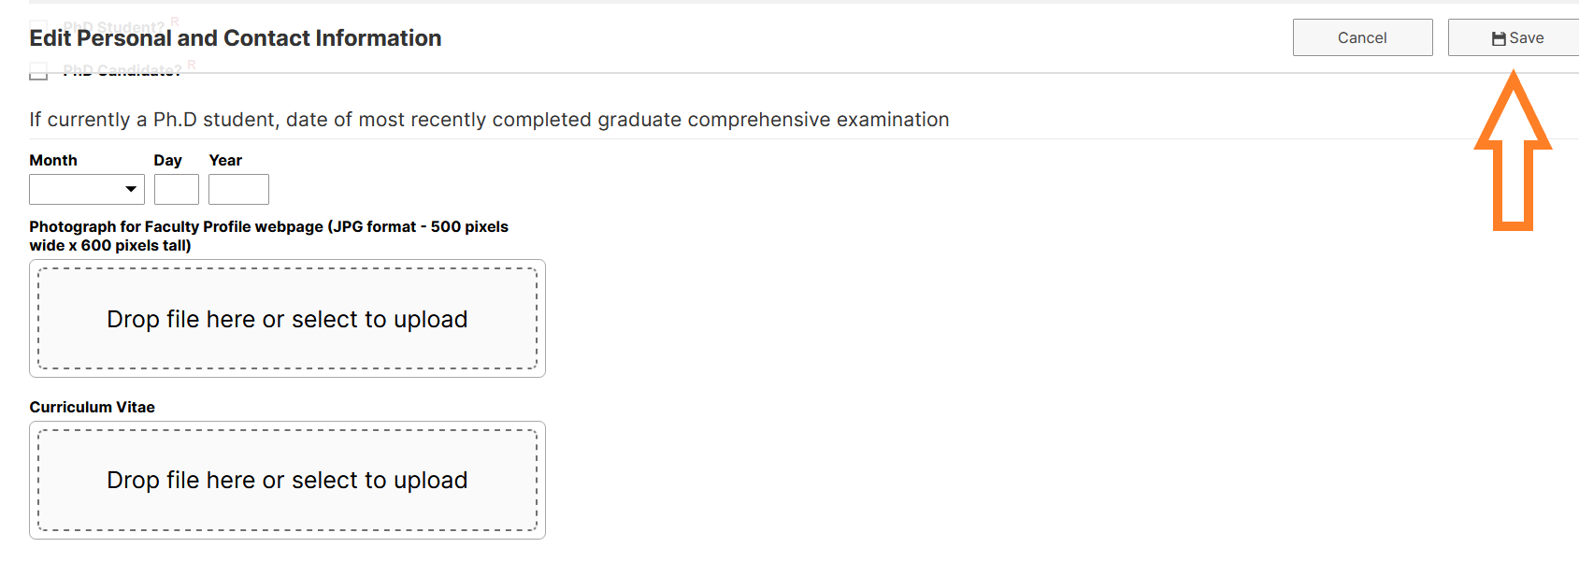
*Note: That file will then appear in your next Faculty Annual Review report. It will not update the information in Digital Measures.

