How to Upload Your Syllabus

Table of Contents
How to Create Your Syllabus 1
How to Upload Syllabus into Canvas 2
How to Upload a Syllabus for Multiple Sections 3
How to Upload a Syllabus Directly into Digital Measures 4

How to Create Your Syllabus

Download and Complete the Syllabus Template
- Download the Syllabus Template from the Course Syllabus Template page
- Complete the Syllabus Template by filling in your specific course information.
  - Remember to follow the color-coded information (remove red text, blue text is optional, and black text is required)
  - If you need to add additional sections to the syllabus, make sure to use the proper Heading Styles in Word (see FAQ for “How do I ensure my syllabus is formatted for accessibility?” at the bottom of the UTA Course Syllabus page)
- Save the Syllabus Template

How to Upload Syllabus into Canvas

- Login to Canvas 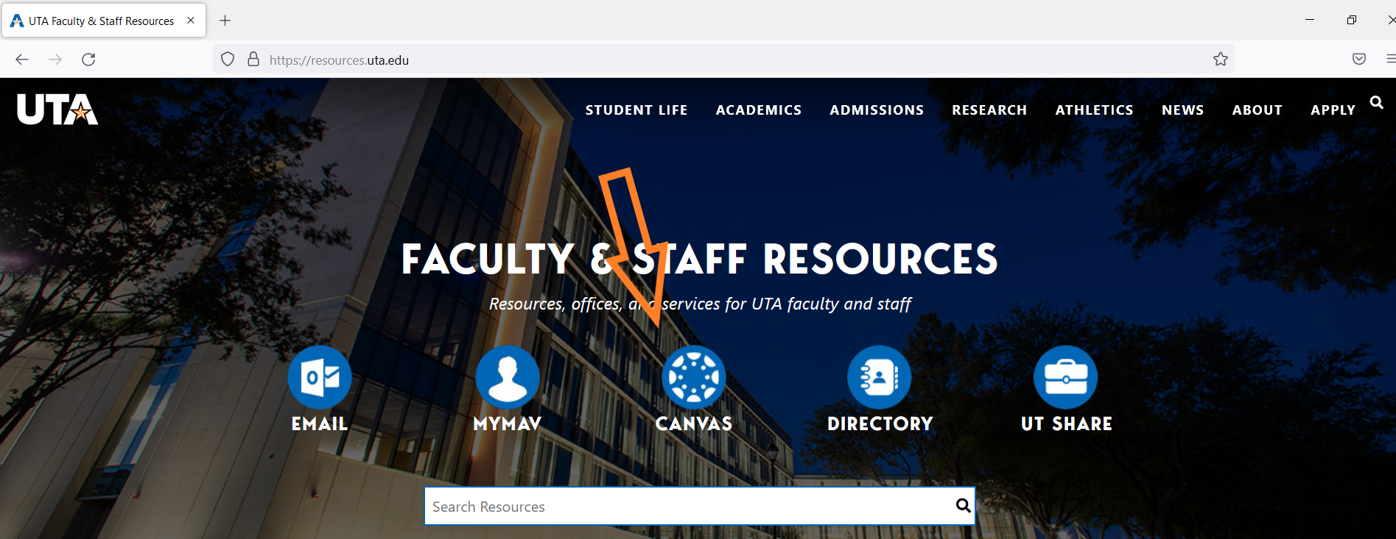
- In Course Navigation, click the Syllabus link
- From the left-hand course menu, click the Upload Syllabus link
Note: This link is only available to those in the Teacher role
- Click the + Add Syllabus button
- Navigate to where you saved the syllabus on your computer and click Open
- You will receive a Success message. Click Close
The syllabus you just uploaded will now appear in three places: (1) the Syllabus link in course, (2) into Digital Measures, and (3) your Faculty Profile page

How to Upload a Syllabus for Multiple Sections

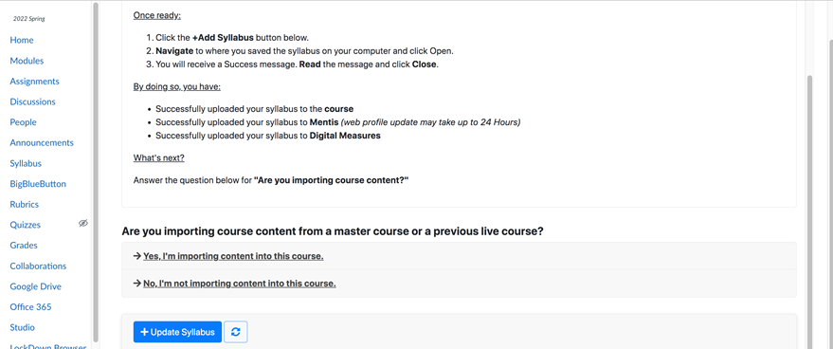

If you combine the courses before adding your syllabus, then the syllabus will only be added to the parent course. You will then have to manually upload them into DM.

How to Upload a Syllabus Directly into Digital Measures

- Login to DM (Digital Measures)
- Go to Activities in the blue bar at the top
- Then go to Scheduled Teaching under the Teaching section, about halfway down the screen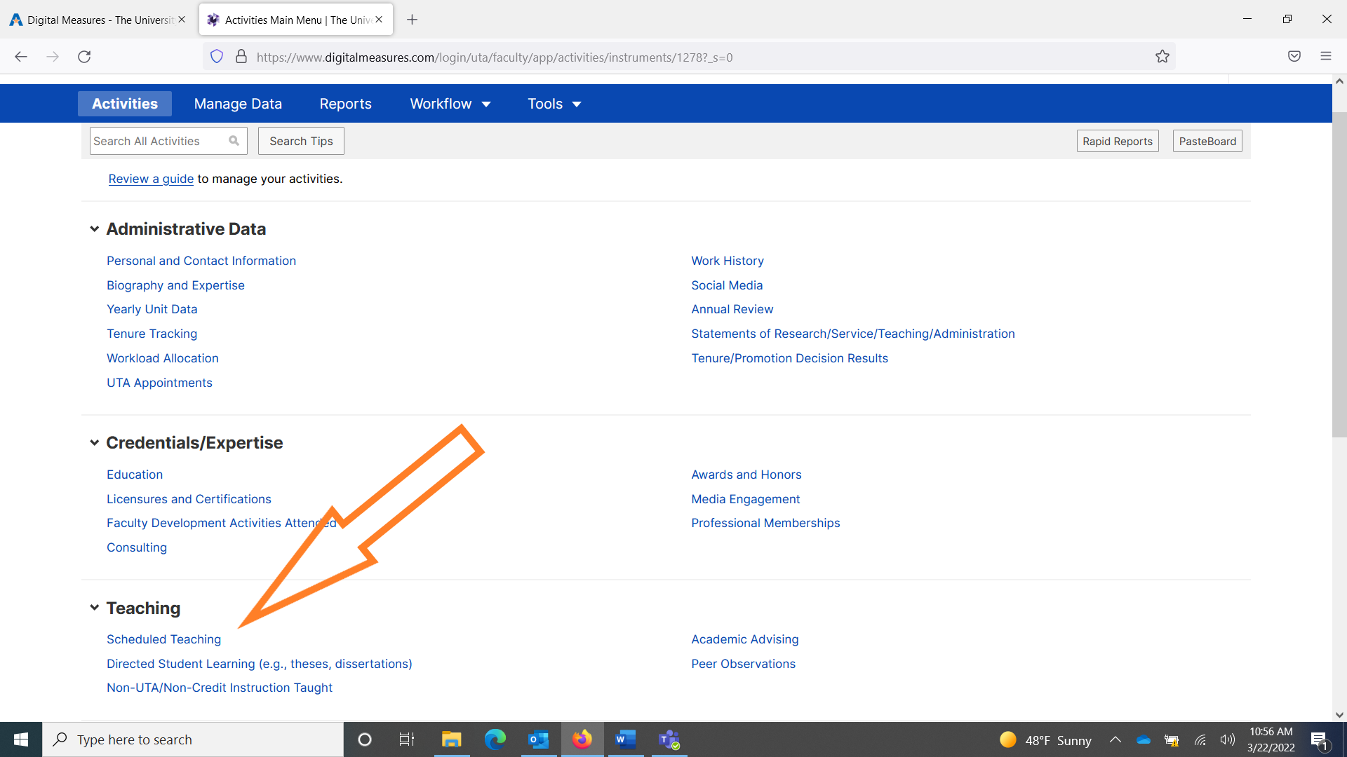
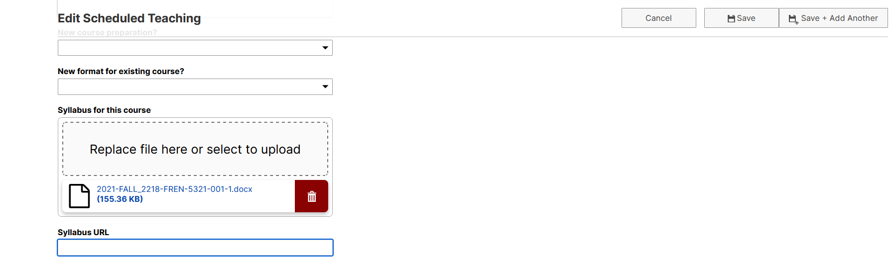
- Navigate to the course that you want to upload your syllabus to. Scroll down about halfway until you find the Syllabus for this Course section and there will be a field for you to drag and drop your syllabus.
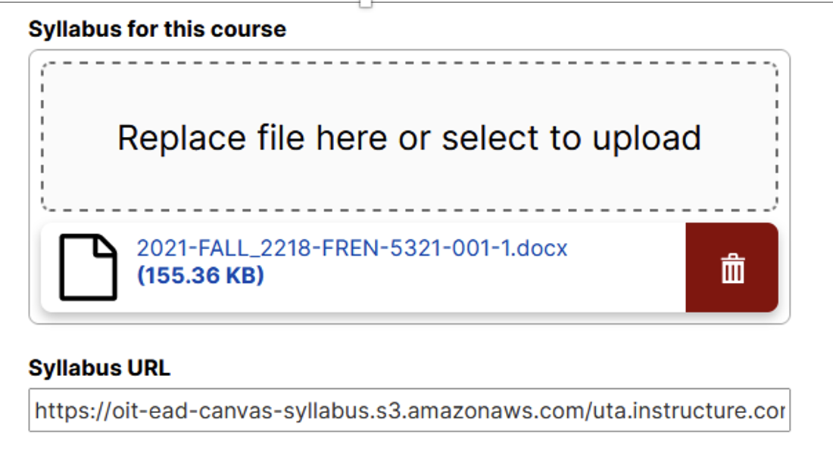
  - If you uploaded a syllabus into Canvas, then there will already be a Syllabus URL link and you do not need to drag your syllabus into this course. It is not necessary to have both of these filled out, you just need one
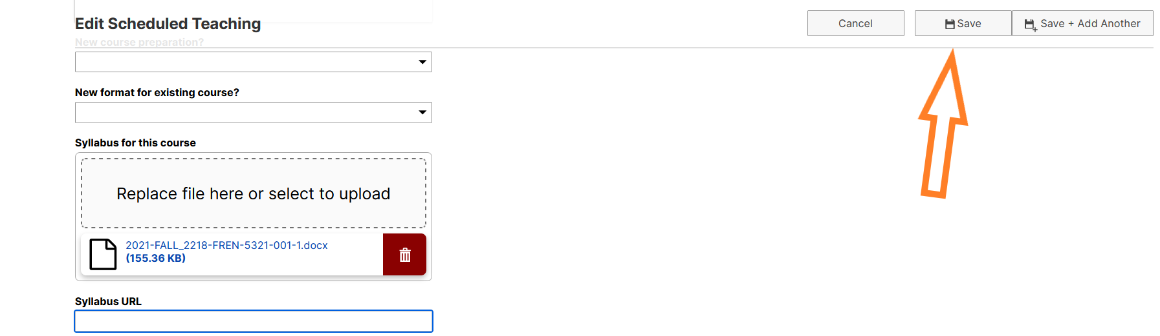
- Click Save at the top right-hand corner

