PSYC 4357-001: HEALTH PSYCHOLOGY
Fall 2021

Instructor Information

Instructor
Dr. Amandeep Dhaliwal

Office Number
LS 426

Office Telephone Number
817-272-2281

Email Address
amandeep.dhaliwal@uta.edu
All emails must be sent via canvas using UTA email address.

Faculty Profile
https://mentis.uta.edu/explore/profile/amandeep-dhaliwal

Office Hours
Wednesday: 11 AM – NOON or by appointment

Course Information

Section Information
PSYC 4357-001 (81124)

Time and Place of Class Meetings
This is a face-to-face lecture in ERB 142. Class will meet every Tuesday and Thursday from 9:30 AM – 10:50 AM.

Description of Course Content
This course provides a broad introduction to health psychology and its interface with the medical world. The course provides a balanced presentation of the important issues in the field, as well as specific content topics that are especially relevant today to better understand health and illness. Offered as BIOL 4357, HEED 4357, and PSYC 4357. Students seeking science requirement credit must enroll in BIOL 4357; students seeking Certification in Health must enroll in HEED 4357. Prerequisite: PSYC 1315 or BIOL 1333 or BIOL 1441 or BIOL 2457; junior standing recommended.

Student Learning Outcomes

Instructional goals are directed toward enabling students to recognize and recall basic facts and understand major concepts and terminology in the field of health psychology. Exams will focus on students understanding of concepts and ability to translate conceptual knowledge into application in real world scenarios.
Upon completion of this course, students will:
- Be familiar with key psychological theories relating to health decisions.
- Understand the basic principles of psychological research.
- Have a basic understanding when reading and evaluating psychology articles
- Understand how psychology can be applied to our everyday lives.

Required Textbooks and Other Course Materials

Health Psychology: An Introduction to Behavior and Health (9th edition) by Linda Brannon, Jess Feist, John A. Updegraff.

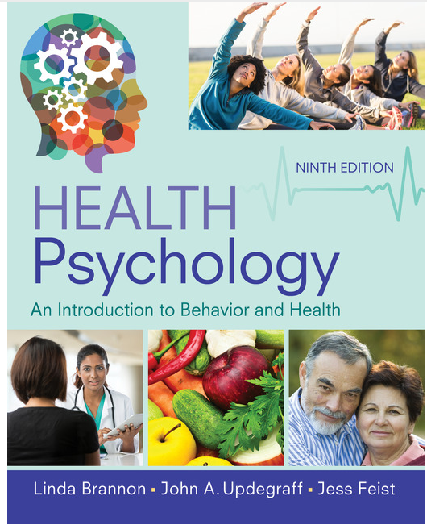

Descriptions of major assignments and examinations
There will be three exams (2 term exams plus a final). The exams will cover lectures, videos and assigned textbook readings. All three exams will be administered via Canvas. All exams are equally weighted. Please note: Exams grades will not be curved.

There will be one term paper (see Course Schedule) worth 100 points. Details regarding term paper will be given in the classroom.

Technology Requirements
Students are required to download Respondus LockDown Browser for completing exams. Instructions on lockdown browser will be provided in class prior to examination.

Grading Information

Grading
The course grade will be based on percentage of the exam grades and term paper, equally weighted. Plus any extra credit points that apply. There are 400 total points possible in the course.

Exam 1: 100 points
Exam 2: 100 points
Final Exam: 100 points
Term Paper: 100 points

The grade for each exam will be based on the % correct of the exam questions. The minimum percent points for a letter grade are (A=90, B= 80, C=70, D= 60. F= below 60.)

Make-up Exams
If an event arises that prevents a student from taking an exam, makeup exam requests must be made within five days of the missed exam. Requests will be approved only with a university approved excuse and documentation. Examples include documented funeral attendance, religious holidays, and illness (See student handbook!!). A note from a friend or family member does not constitute appropriate documentation.

Institutional Information
UTA students are encouraged to review the below institutional policies and informational sections and reach out to the specific office with any questions. To view this institutional information, please visit the Institutional Information page (https://resources.uta.edu/provost/course-related-info/institutional-policies.php) which includes the following policies among others:
- Drop Policy
- Disability Accommodations
- Title IX Policy
- Academic Integrity
- Student Feedback Survey
- Final Exam Schedule

Additional Information

Face Covering Policy
While the use of face coverings on campus is no longer mandatory, all students and instructional staff are strongly encouraged to wear face coverings while they are on campus. This is particularly true inside buildings and within classrooms and labs where social distancing is not possible due to limited space. If a student needs accommodations to ensure social distancing in the classroom due to being at high risk they are encouraged to work directly with the Student Access and Resource Center to assist in these accommodations. If students need masks, they may obtain them at the Central Library, the E.H. Hereford University Center’s front desk or in their department.

Attendance
At The University of Texas at Arlington, taking attendance is not required but attendance is a critical indicator of student success. Each faculty member is free to develop his or her own methods of evaluating students’ academic performance, which includes establishing course-specific policies on attendance. As the instructor of this section, I will take attendance from time to time and students will earn 5 extra credit points for attending on the day of attendance. However, while UT Arlington does not require instructors to take attendance in their courses, the U.S. Department of Education requires that the University have a mechanism in place to mark when Federal Student Aid recipients “begin attendance in a course.” UT Arlington instructors will report when students begin attendance in a course as part of the final grading process. Specifically, when assigning a student a grade of F, faculty report must the last date a student attended their class based on evidence such as a test, participation in a class project or presentation, or an engagement online via Canvas. This date is reported to the Department of Education for federal financial aid recipients.

Emergency Exit Procedures
Should we experience an emergency event that requires evacuation of the building, students should exit the room and move toward the nearest exit. When exiting the building during an emergency, do not take an elevator but use the stairwells instead. Faculty members and instructional staff will assist students in selecting the safest route for evacuation and will make arrangements to assist individuals with disabilities.

Academic Success Center
[Required for all undergraduate courses] The Academic Success Center (ASC) includes a variety of resources and services to help you maximize your learning and succeed as a student at the University of Texas at Arlington. ASC services include supplemental instruction, peer-led team learning, tutoring, mentoring and TRIO SSS. Academic Success Center services are provided at no additional cost to UTA students. For additional information visit: Academic Success Center. To request disability accommodations for tutoring, please complete this form.

The English Writing Center (411LIBR)
The Writing Center offers FREE tutoring in 15-, 30-, 45-, and 60-minute face-to-face and online sessions to all UTA students on any phase of their UTA coursework. Register and make appointments online at the Writing Center (https://uta.mywconline.com). Classroom visits, workshops, and specialized services for graduate students and faculty are also available. Please see Writing Center: OWL for detailed information on all our programs and services.

Emergency Phone Numbers
In case of an on-campus emergency, call the UT Arlington Police Department at 817-272-3003 (non-campus phone), 2-3003 (campus phone). You may also dial 911. Non-emergency number 817-272-3381.

Course Schedule
(Note: As the instructor for this course, I reserve the right to adjust this schedule in any way that serves the educational needs of the students enrolled in this course. – Amandeep Dhaliwal)

Date | To be Covered
Thursday, August 26, 2021 | Chapter 1
Tuesday, August 31, 2021 | Chapter 1 & 2
Thursday, September 2, 2021 | Chapter 2
Tuesday, September 7, 2021 | Chapter 3
Thursday, September 9, 2021 | Chapter 3 & 4
Tuesday, September 14, 2021 | Chapter 4
Thursday, September 16, 2021 | Chapter 5
Tuesday, September 21, 2021 | Chapter 5 & 6
Thursday, September 23, 2021 | Chapter 6
Tuesday, September 28, 2021 | Chapter 6
Thursday, September 30, 2021 | EXAM 1
Tuesday, October 5, 2021 | Chapter 7
Thursday, October 7, 2021 | Chapter 7 & 8
Tuesday, October 12, 2021 | Chapter 8
Thursday, October 14, 2021 | Chapter 9
Tuesday, October 19, 2021 | Chapter 9 & 10
Thursday, October 21, 2021 | Chapter 10
Tuesday, October 26, 2021 | Chapter 11
Thursday, October 28, 2021 | Chapter 11 & 12
Tuesday, November 2, 2021 | Chapter 12
Tuesday, November 9, 2021 | EXAM 2 & TERM PAPER DUE (11:59pm)
Thursday, November 11, 2021 | Chapter 13
Tuesday, November 16, 2021 | Chapter 13 & 14
Thursday, November 18, 2021 | Chapter 14
Tuesday, November 23, 2021 | Chapter 15
Friday, November 26, 2021 | THANKSGIVING
Tuesday, November 30, 2021 | Chapter 15 & 16
Thursday, December 2, 2021 | Chapter 16
Tuesday, December 7, 2021 | Review
Tuesday, December 14, 2021 | FINAL (8am - 10:30 am)

