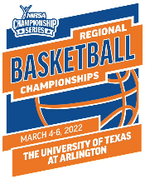
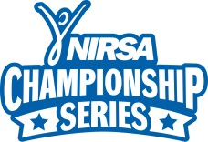
2022 NIRSA Regional Basketball

The University of Texas at Arlington - March 4-6, 2022
Tournament Registration Form

College/University Name: ____________
Team Name: Division (circle one): Men’s Women’s Unified
Team Rep Name: Team Rep Email Address:
Address: Phone: _______
City: State: ____ Zip:
All participants must comply with the NIRSA Championship Series eligibility guidelines. Players with questions about their eligibility or who have need for additional support are encouraged to contact the NIRSA Director of National Sport Programs Valerie McCutchan.

Incomplete forms or entries submitted without an entry form, entry fee, or Campus Recreation representative signature will NOT be accepted. An original player certification form with your institutions Registrar’s seal must be received by the entry deadline of insert date.

Please list players in ascending order by jersey number; Roster limit – 15 for Men’s and Women’s teams
Player | Jersey # | Participant Name | Former Collegiate Varsity Player | # of years on a collegiate varsity roster/squad list | # of years on a NIRSA roster | Email Address
1 |  |  | YES / NO
2 |  |  | YES / NO
3 |  |  | YES / NO
4 |  |  | YES / NO
5 |  |  | YES / NO
6 |  |  | YES / NO
7 |  |  | YES / NO
8 |  |  | YES / NO
9 |  |  | YES / NO
10 |  |  | YES / NO
11 |  |  | YES / NO
12 |  |  | YES / NO
13 |  |  | YES / NO
14 |  |  | YES / NO
15 |  |  | YES / NO

Coaches:

Entry Fee*: NIRSA Institutional Member: $insert fee Non-NIRSA Institutional Member: $insert fee

Payment Options: Check (Payable to insert info Credit Card #: Expiration date:

Entry Deadline: Received by: insert date Entry Status Notification: insert date

Send Completed Forms to: insert preferred method: mailing address, scan and email (include email address), fax, etc.

*Non-refundable, unless entry into the tournament is denied. In the event that the tournament is cancelled due to circumstances beyond control, entry fees will not be refunded.

